<https://developer.confluent.io/what-is-apache-kafka/>

The Fundamentals

**Kafka : -** is distributed commit log

As events happen in m/s application . These microservice put the events into logs .Apache kafka is a system for managing these logs . Kafka store these in orderly fashion and also write into disk

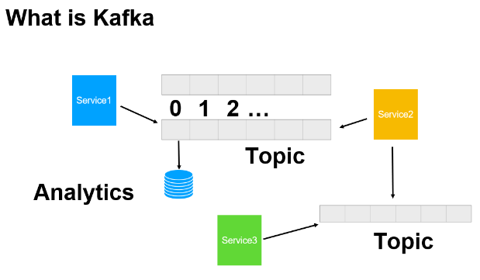

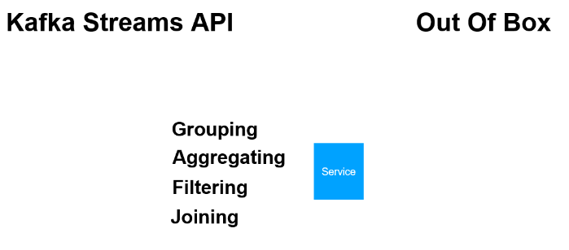

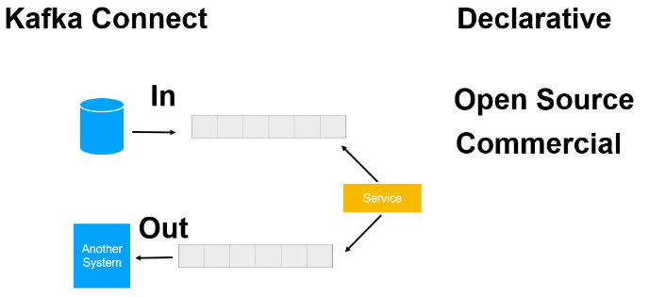

**Why Kafka**

**Advantages of using kafka**

1. It support multiple producer and consumer means , multiple producer can write to same topic and

Multiple consumer can consume message from the same topic

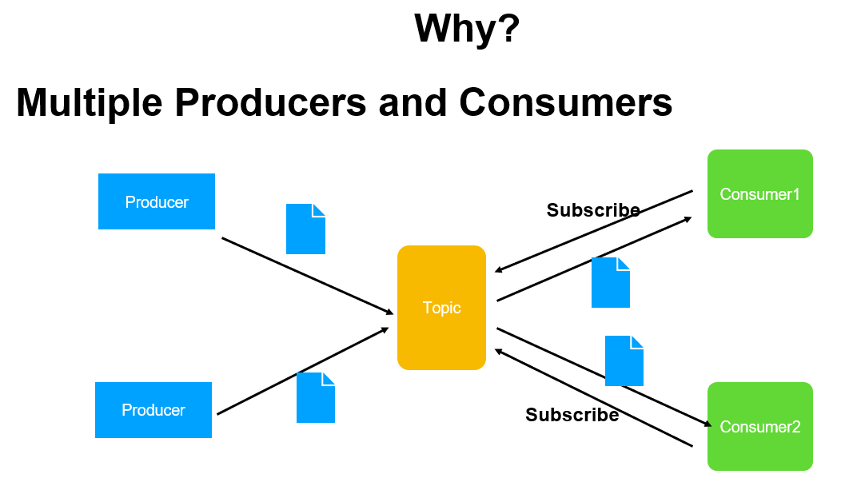

**Note :**

In kafka it retain the message if one consumer consume it and other consumer will get the same message

And process it own way

2-) kafka also support consumer group and partition that is within consumer application parallel consumer is running which can be part of consumer group and topic is divided into multiple partition and messages producer will go across these partition so that parallel processing is possible.

Kafka ensure that within consumer group the message is consume only once. There will be no duplication

Parallel consumer consuming the message

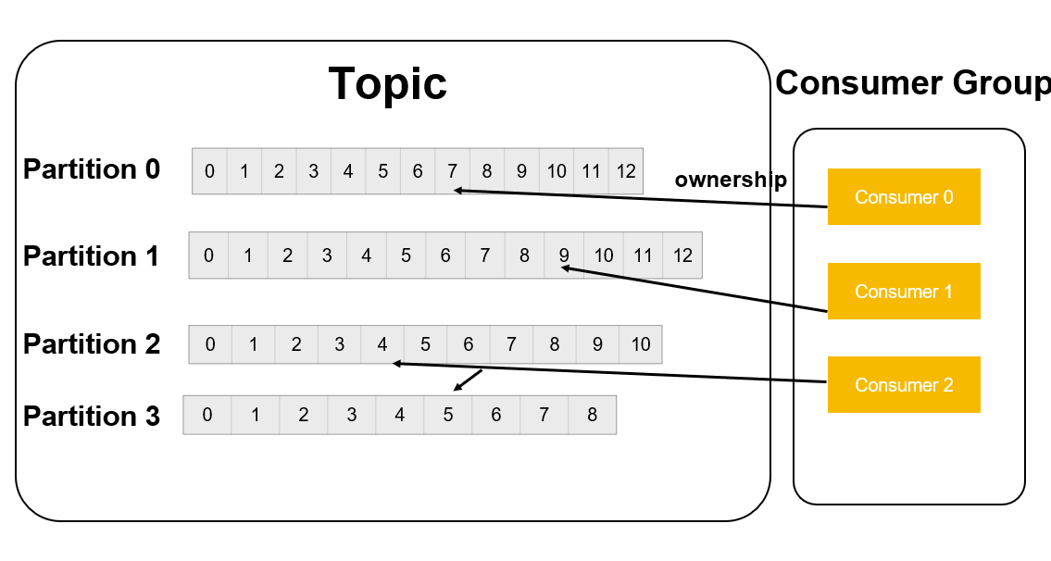

Across application same message will be consume by consumer and within application consumer of consumer group will consume distinct message

1. **It maintains Disk Based Persistence**

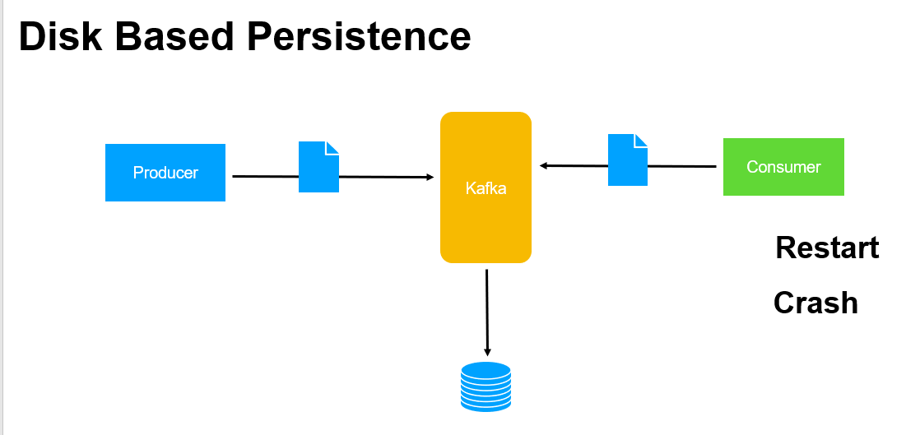

Even consumer crash or restart kafka store message in disk for temporary amount of time

1. **Scalability :**

if one broker goes down other will come up

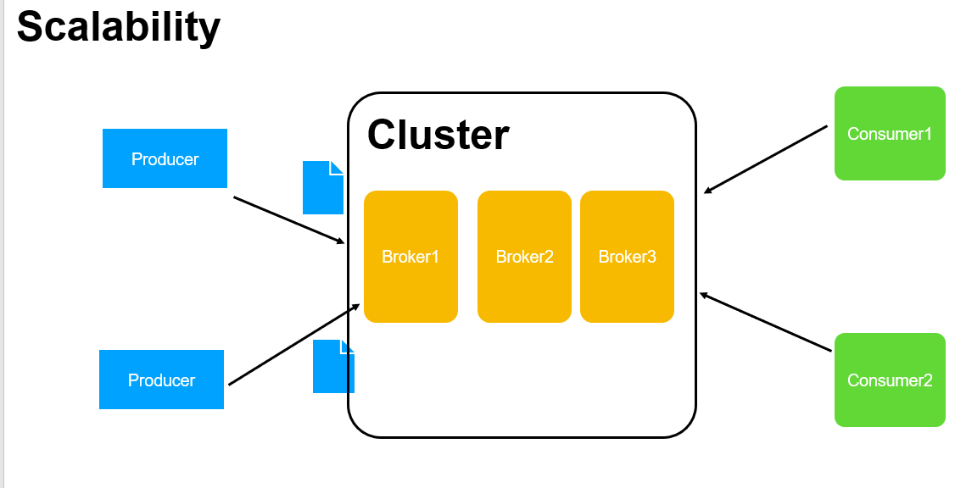

Note :--- due to all above feature performance clean is there

**Usecases**

**1-) Pub-sub**

Kafka can be use to exchange messages across m/s application this could be one m/s application sending notification to kafka topic

To which other ms application will subscribe and and consume the notification to take the appropriate action or one m/s producing lot of work and other m/s application consume this work get it done like order processing shipment etc

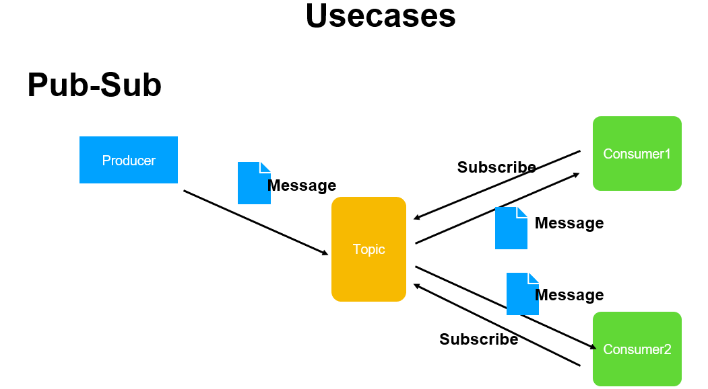

1. **Activity Tracking**

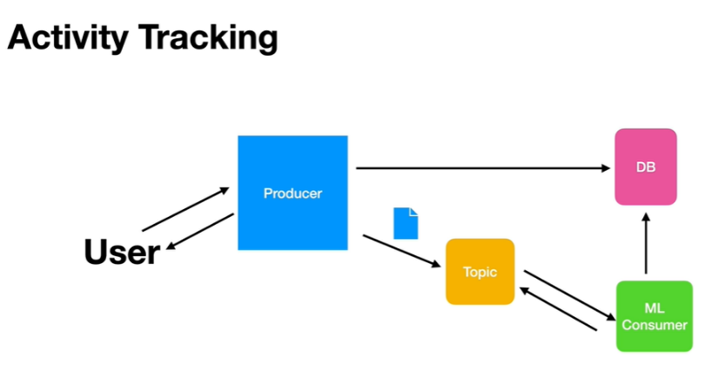

**3-Metrics and log aggregation**

As application produce metrics on regular basic or even logs all those can be aggregated and store in permanent storage for analysis

This can be done write away as the system produces logs and aggregated and put into system like elastic search and we can analyse right

Away if there is unwanted data related to security

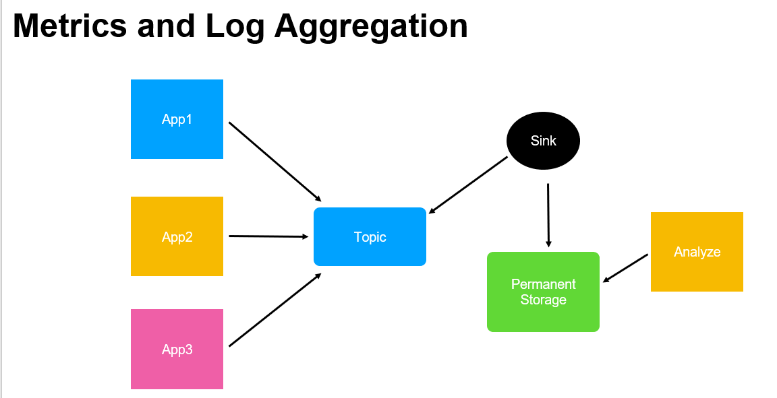

1. **Commit log**

We can also use kafka as commit log as d/b changes happen those changes can be stream on kafka topic and we can use this to analyse

If there is any unwanted thread or unwanted activity

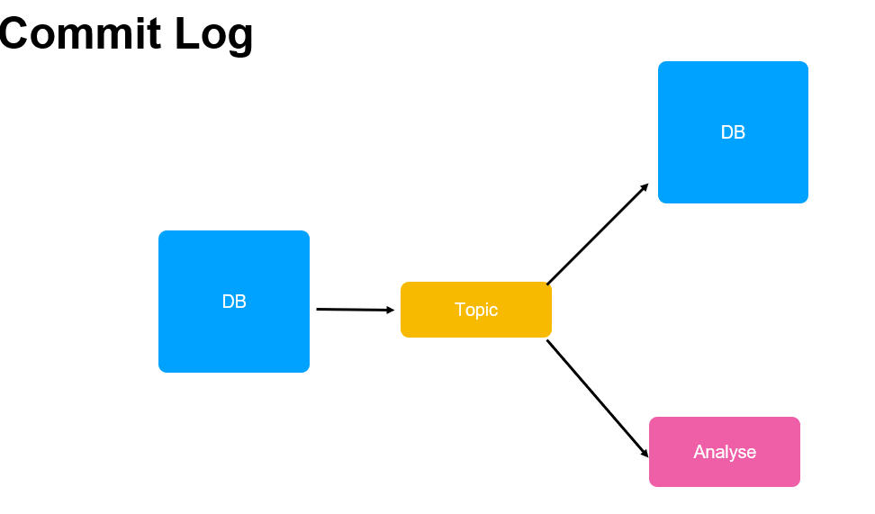

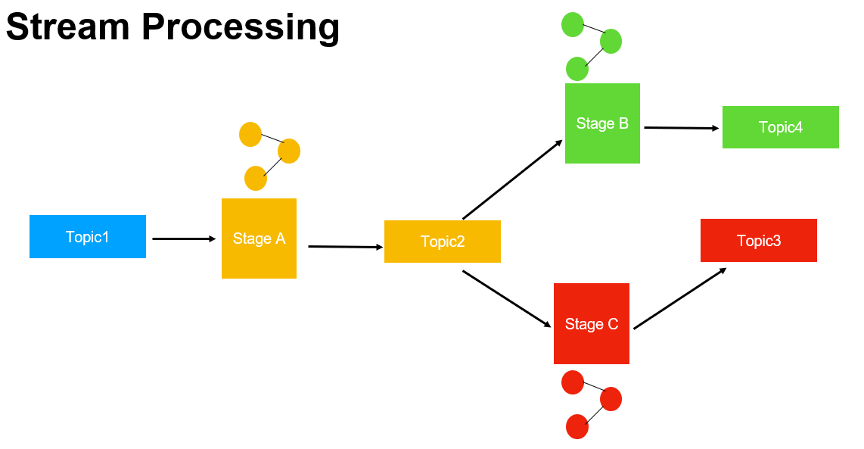

**Where is kafka being used**

Patient info can be monitored

Car, truck location

Based on customer interaction recommendation shown to him in hotel

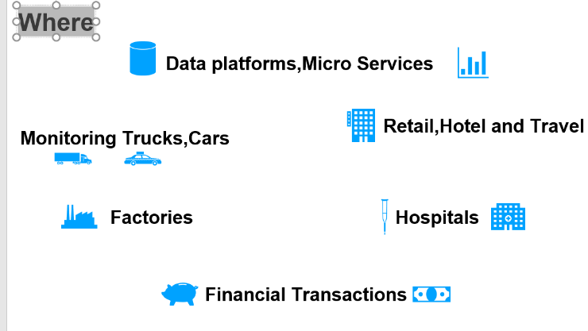

**Who is using kafka**

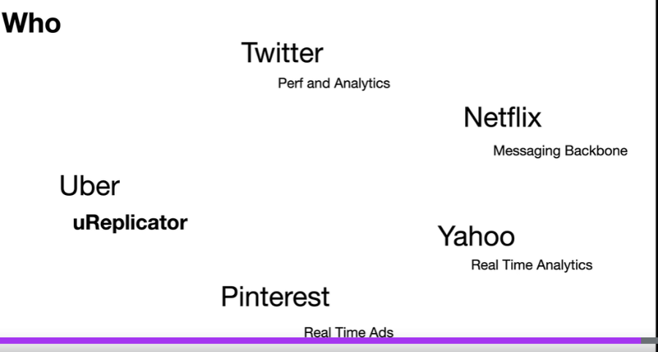

**Kafka Architectural components**

**Broker**

Kafka cluster is collection of kafka broker also referred as kafka server or nodes

Through the broker message is exchanged between producer and consumer.

Broker also ensure that message is persistent and durable.

We can increase number of broker to provide scalability and durability.

One of the broker will elected as cluster leader or controller. All the other broker will follow this leader

It is the responsibility of the cluster leader to manage the partition,replicas and other administrative operation

**A Broker** is a Kafka server that runs in a Kafka Cluster. Kafka Brokers form a cluster. The Kafka Cluster consists of many Kafka Brokers on many servers. Broker sometimes refer to more of a logical system or as Kafka as a whole.

A Kafka broker **allows consumers to fetch messages by topic, partition and offset**. Kafka brokers can create a Kafka cluster by sharing information between each other directly or indirectly using Zookeeper. A Kafka cluster has exactly one broker that acts as the Controller.

**Zookeeper :**

responsible for electing the cluster controller or leader. All the broker nodes will register themselves with zookeeper component when they come up.

And zookeeper will pick one of the nodes as cluster leader. If that broker goes down it will pick up another broker as cluster leader.

When we installed kafka it comes bundled with zookeeper

**Producers**

Is an application that produces data . The producer communicate with the cluster using tcp protocol and they connect with brokers directly

Start sending message to the topic. A producer can send message to multiple topic and a topic can receive message from multiple producer

**Consumer :-**

It is an application that consume message from one or more topic. Consumer coordinate among themselves as a group to balanced the load

And also track each other progress

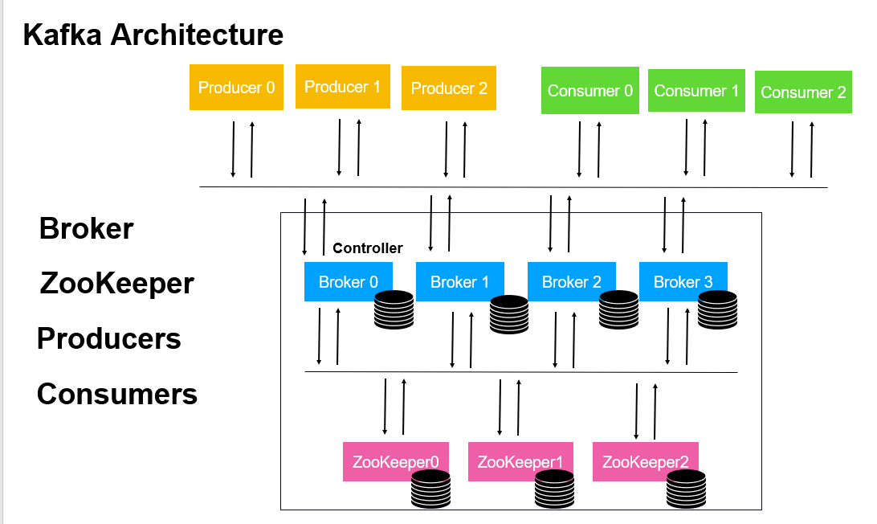

**Kafka Record**

The producer application creates an exchange data using **Record** in kafka.

There are **seven** attributes to a record

**Records are published into topics**. Topics are like channels where all the records are stored. Consumers subscribe to one or more topics to read its records. Kafka has a retention period, so it will store your records for the time or size you specify and can be set by topic.

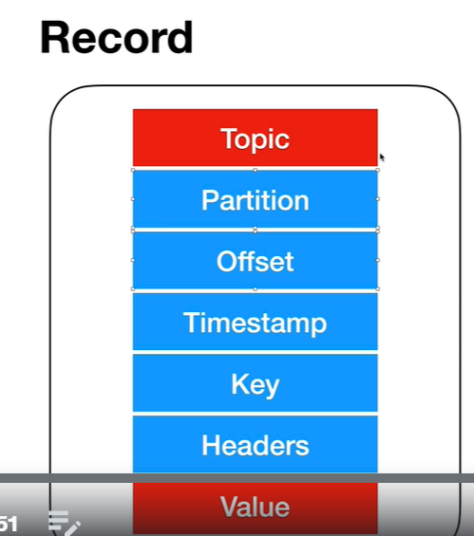

**Topic**: it is topic to which this record written to

**Partition** :- is 0 based index to which the record should be written. A record should always be associated only one partition

and partition number can be set by producer application and if it is not set, it will calculated based on the key that is provided in the record. A hash value will be calculated by using the key value and the result will be use as partition number to which the record should go to.

**Offset** :- 64 bit signed integer for locating the record within the partition

**Timestamp** :- can be set by the producer application and if it is not set producer api will set as current timestamp

**Key** :-- is used as hash algorithm and where the record should go to in partition . If the key value is not set then kafka will decide the partition number in round robin . We can even set same key for multiple producer. Using partition and offset we can uniquely identified a record.

**Header** :- just like http header

**Value** :- this is where payload of our message lies. It is array of bytes. It is one that contain our business data

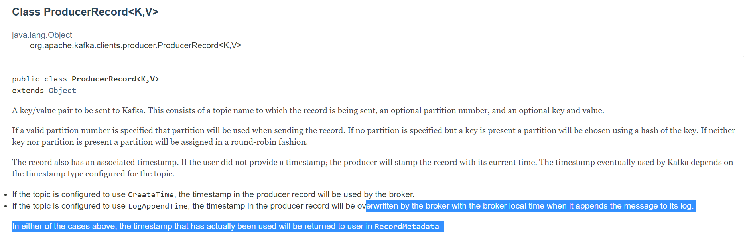

**Mandatory : topic and value**

**Topics Partition offset and replication**

* Message in kafka are written into topic and each topic can be divided into one or more partition.
* Partition is a single log of messages or records..
* Kafka assigned each partition a unique number and also each message or record is stored within the partition get offset value

this offset value is like array index it start from 0 for every partition and as the messages are stored it will be incremented.

* The partition number and the offset value uniquely identified a record and also kafka store the partition number and offset inside a message or record. Since message can go across partition the messaging order is not guaranteed where as messaging order within

The partition is maintained.

* The producer application can specify which partition the message should go into using the partition number. The producer will create a record using the partition number attribute it will in which partition the record will go into. Kafka will take the partition number and put that message into that partition

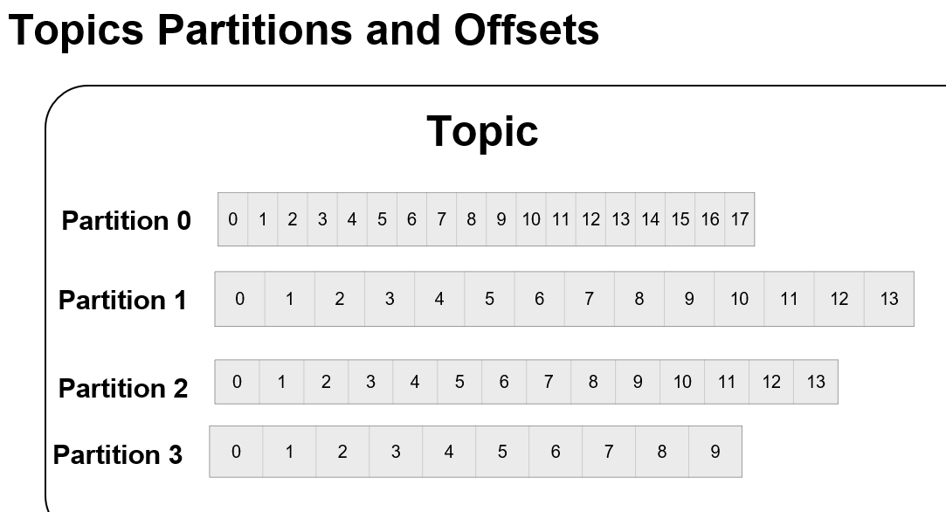

These partition can be scaled across broker. Instead of putting all partition in one broker , we can scale them across broker.

Here we have 4 partition across three broker . This will increase the performance and the application can be easily scaled

Along with this partition also support replication or duplication which give high availability. As we can see here partition 0 and 1 are present in broker 0 as well as broker 1.

Broker uses the concept of leader and follower here. Each partition will have leader and follower. Only if the broker with partition leader goes down then other broker with partition as follower will become a leader now.

Note :

If the replication factor is 1 there is no duplication the partition will be present on only broker. If the replication factor is 2 the partition will be duplicated across the broker. Then there will be one copy

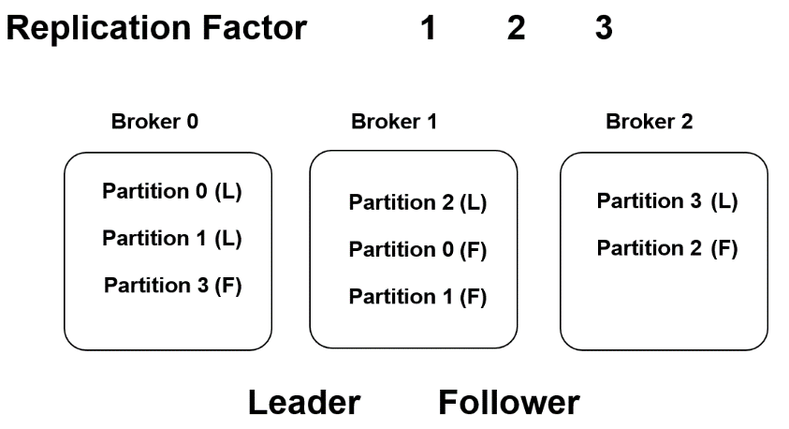

And also we can configure replication factor at cluster level as well

Consumer Group

Consumer group ensure that each partition will be consumed by only one consumer. Assigning a consumer to partition is called ownership by the consumer. If one consumer fails the remaining consumer can take over the partition the failed consumer was working with.

What is consumer group in Kafka?

A consumer group is **a set of consumers which cooperate to consume data from some topics**. The partitions of all the topics are divided among the consumers in the group.

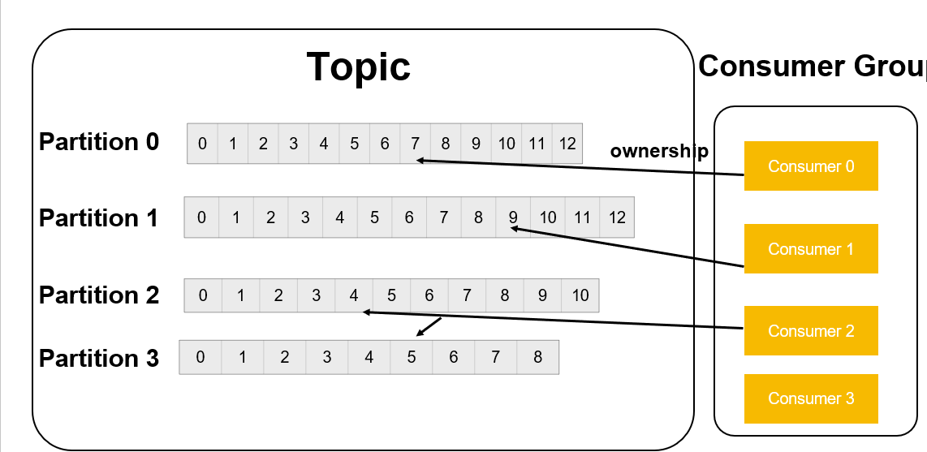

**Batching**

**KafkaProducer wont send one message at a time to kafka broker instead they batch them based on the topic and partition to which they have go to**

.

A batch is a collection of messages that should be written to same topic and partition . The larger the batch size the more message will be processed in give frame time. Batch size is also compressed make sure batch size is not too big or too small

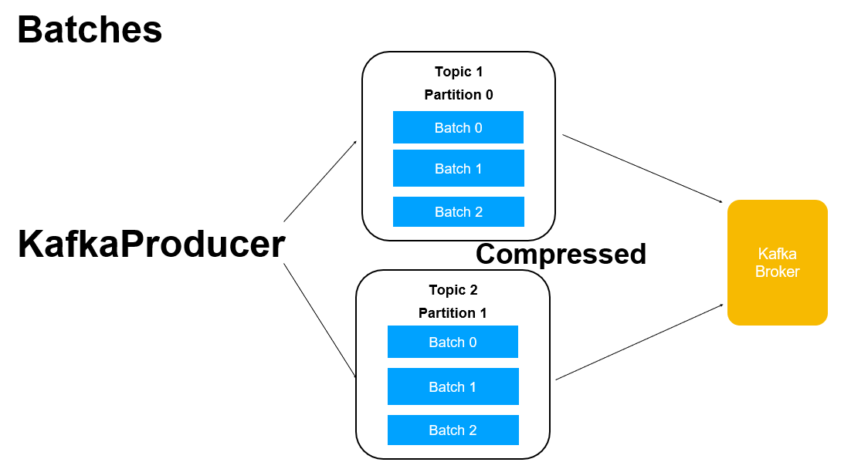

Kafka in action

Kafka download

<https://www.apache.org/dyn/closer.cgi?path=/kafka/3.2.0/kafka_2.13-3.2.0.tgz>

**To run this we need to add in path windows**

**Step 1:** ---C:\sw\kafka bharat\kafka_2.13-3.2.0\bin\windows

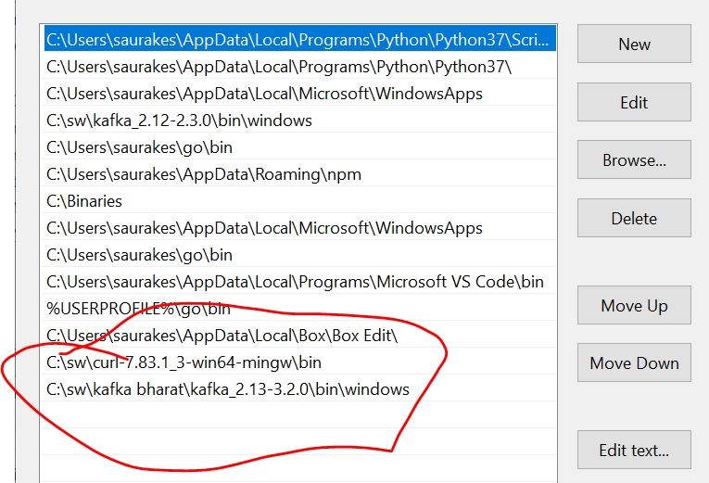

This is imp where zookeeper and other are there

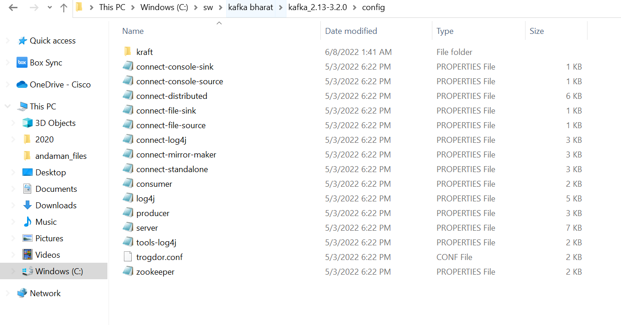

**Step 1: - run zookeeper --2181**

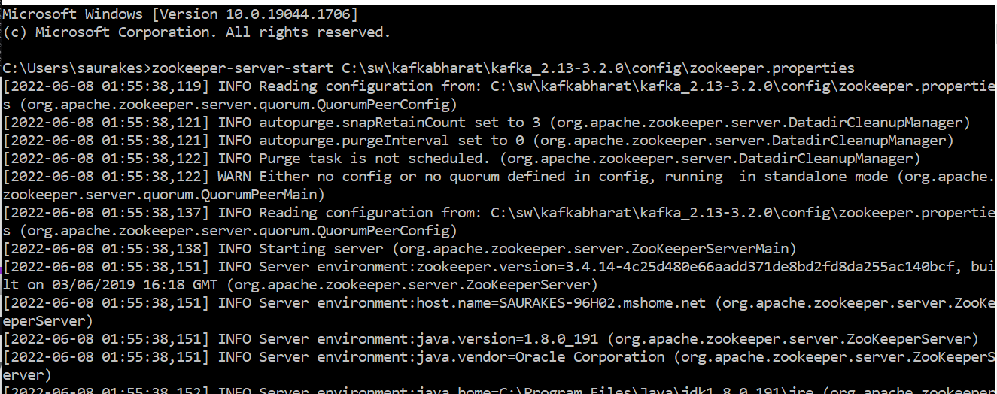

**Step 2 : run kafka broker**

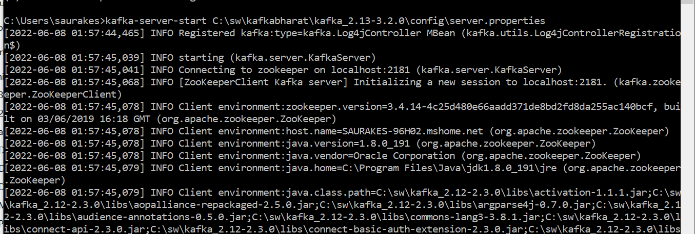

**Kafka broker will communicate to zookeeper**

**Kafka commandline**

**Command 1-**

**Bootstrap-server :** this is kafka server where it is up and running

**Default port number kafka** :9092

This topic is used by kafka internally to store the offset details

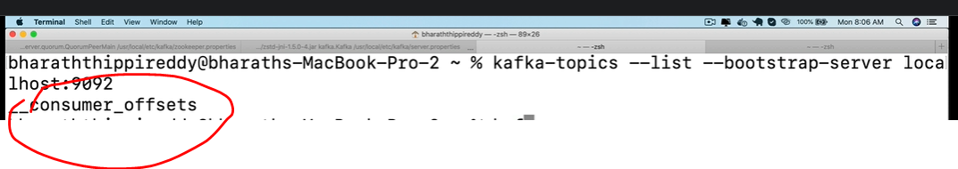

**Command 2** :- create topics of own

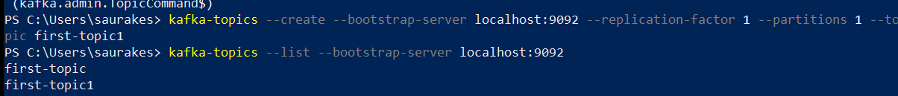

**Command 3:--- details of topic use describe command**



**Command 4 :- we can also use command line consumer and producer**

**Consumer :-** it start listening

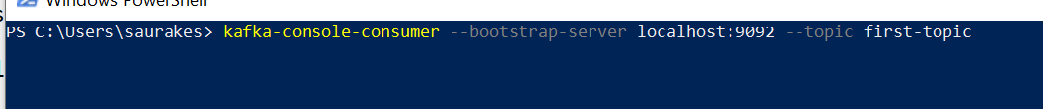

**Producer**



Send message a**s kafka**



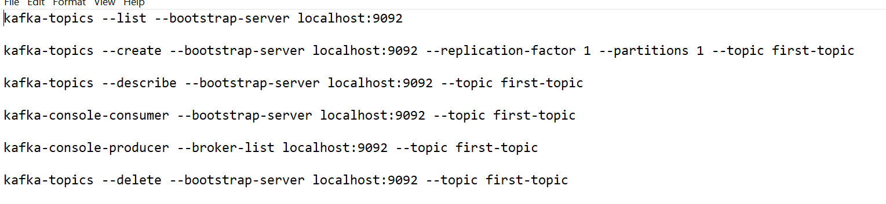

**Kafka API**

**Note :**

From kafka drop we are able to manage kafka broker. Kafka drop internally uses Admin API

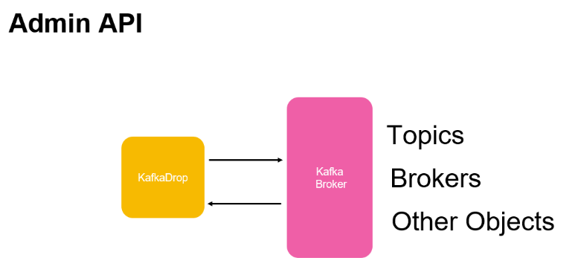

On producer side kafka will automatically do serialization and consumer side desrialization

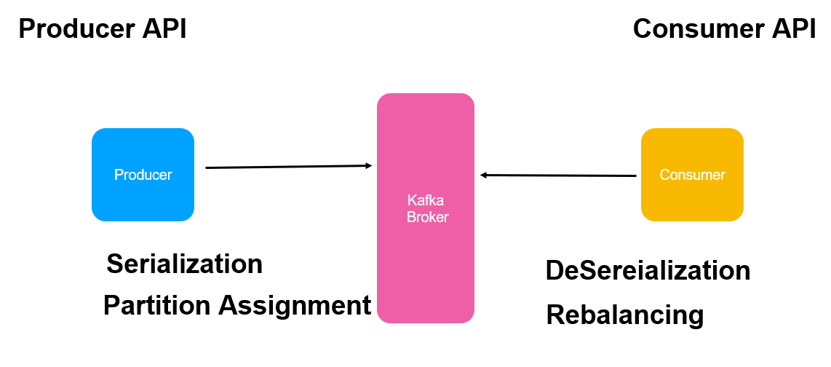

Read from one topic and write to some other topic continuous data flow

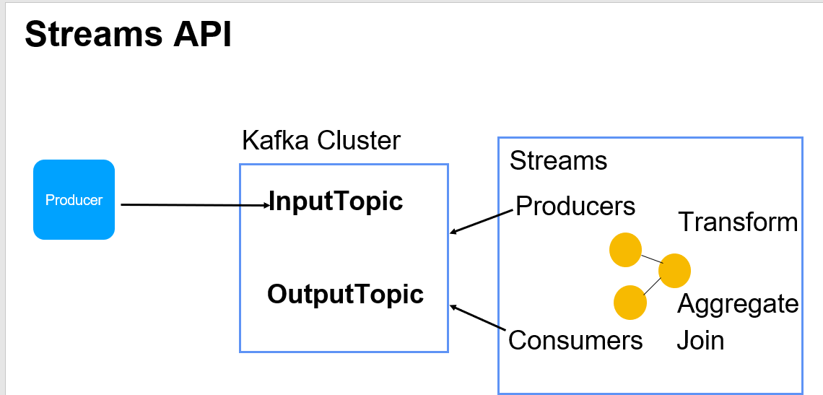

**Kafka connector** :- ready made connector that can integrate with data sources

it can integrate with data source like elastic search

Fetch data from kafka or push data to kafka

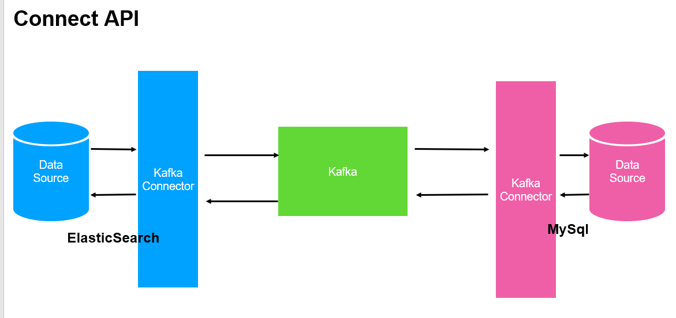

Create Producers and Consumers

Kafka Producer Workflows

Once we have ProducerRecord we invoke send() on producer. At this point it handover record to serializer.

The serializer will look for key and value in the record will convert then from our java types into bytes array then the record will be handed

Over to partitioner. The partitioner check if the record having partition number . At this point the producer know to which partition the record should go to. It will add a record to a batch that will go to particular topic and partition and separate thread will pick up these batches and send them to kafka broker. **Kafka broker will write message to appropriate topic** if it is successful it will return metadata to producer

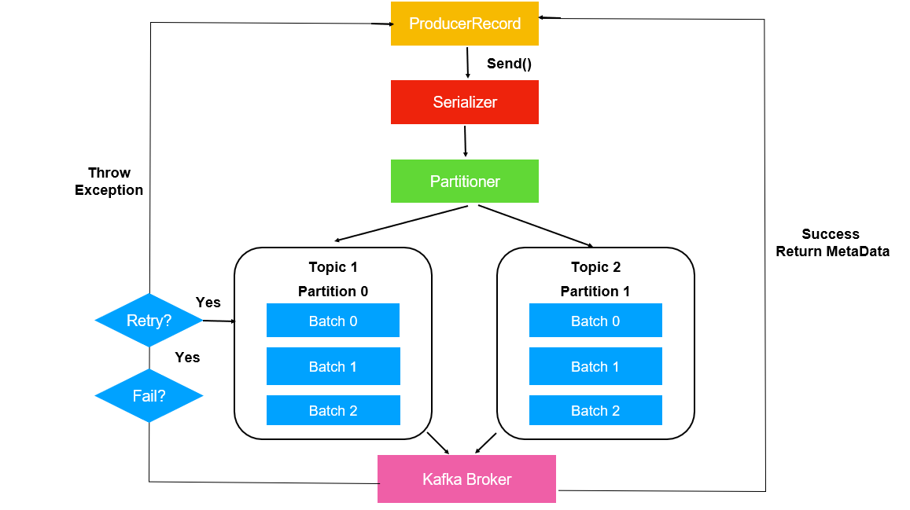

**Producer API WALKTHROUGH**

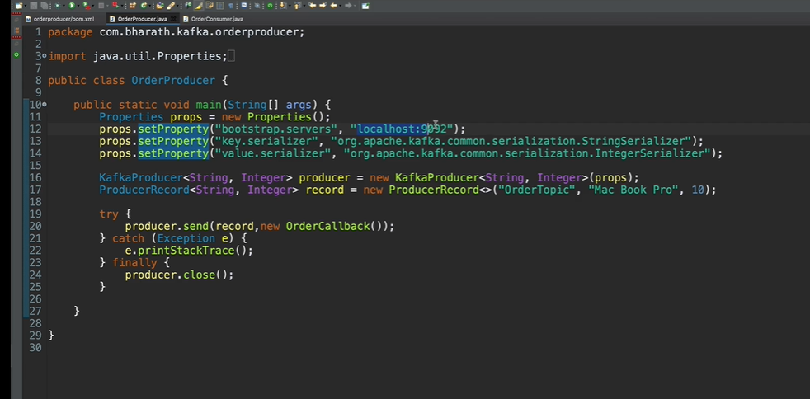

**Three property mandatory**

1. **Bootstrap.servers :** which is list of kafka brokers the producers should connect to
2. **Key.serializer :-** convert java type into byte array
3. **Value.serializer :-** convert value into byte array

Once we have producer we can invoke send method and give a record object. Record object represent message

Which is having key,value and topic

**Note :-**-producer.send() send the message to topic into three diff types

1. Simply send and don’t handle response

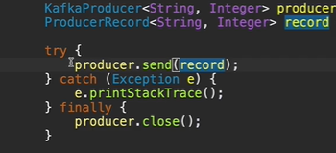

1. **Handle the response :** when data send to topic successfully we can handle response

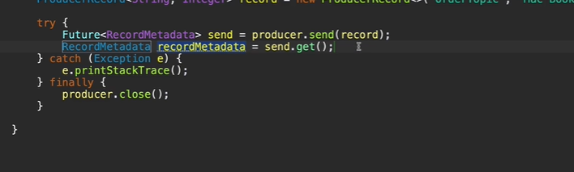

1. **Asynchronous way :-** whenever message come from broker it will invoke method

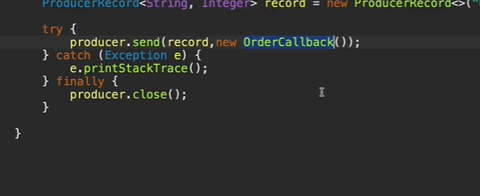

**Create a producer object**

Add kafka client dependency

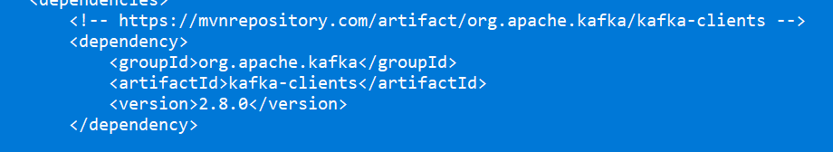

**Create a producer**

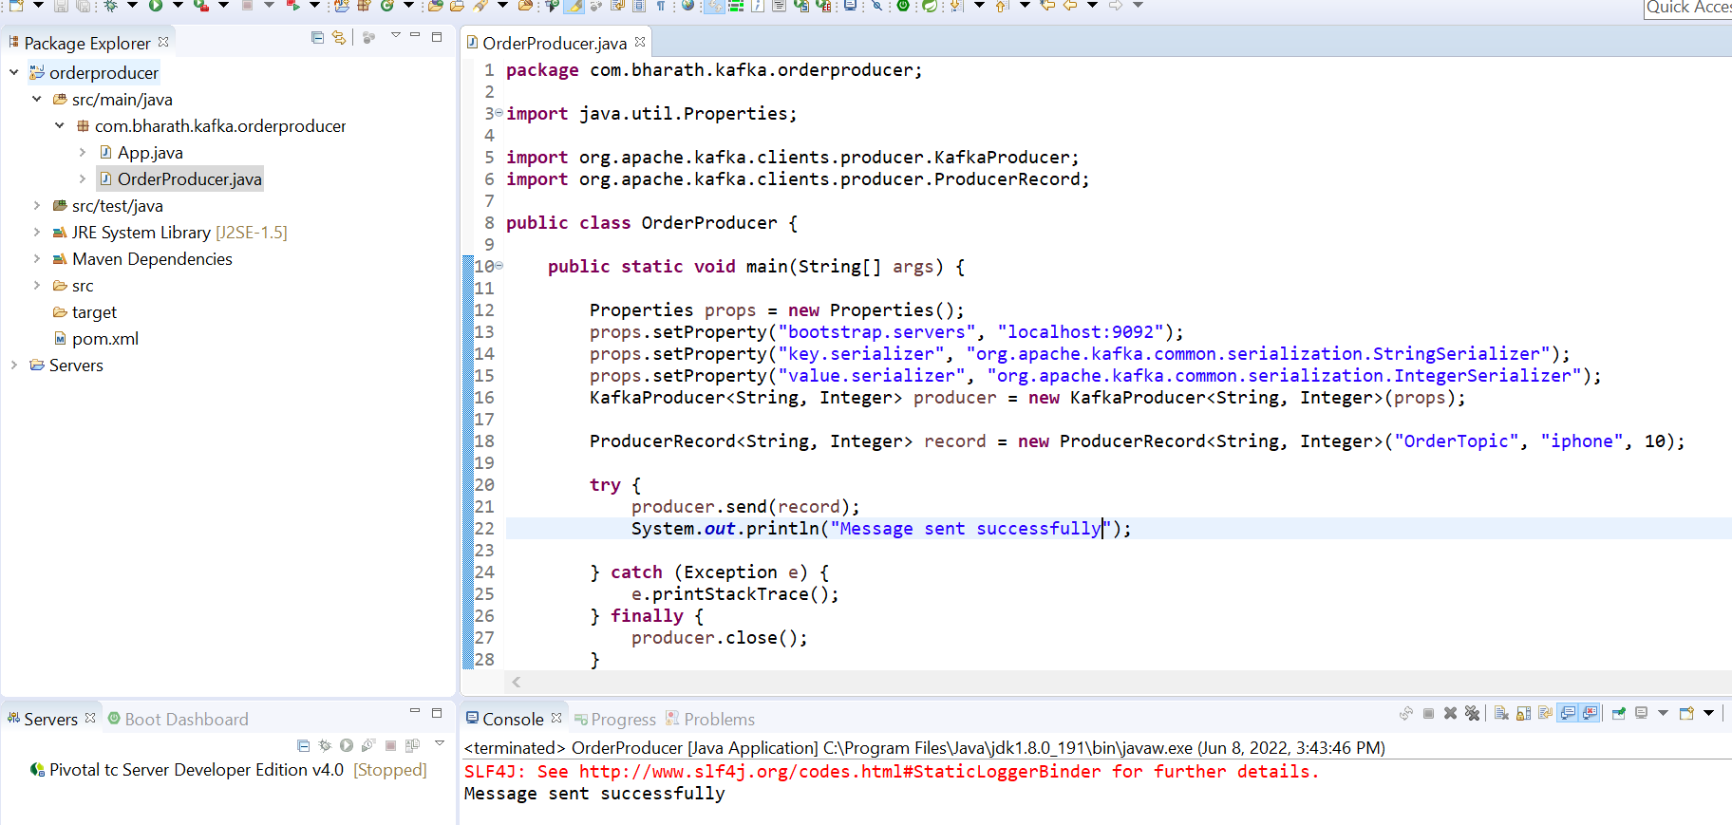

**Sync send**

We are waiting for record metadata when it is ready

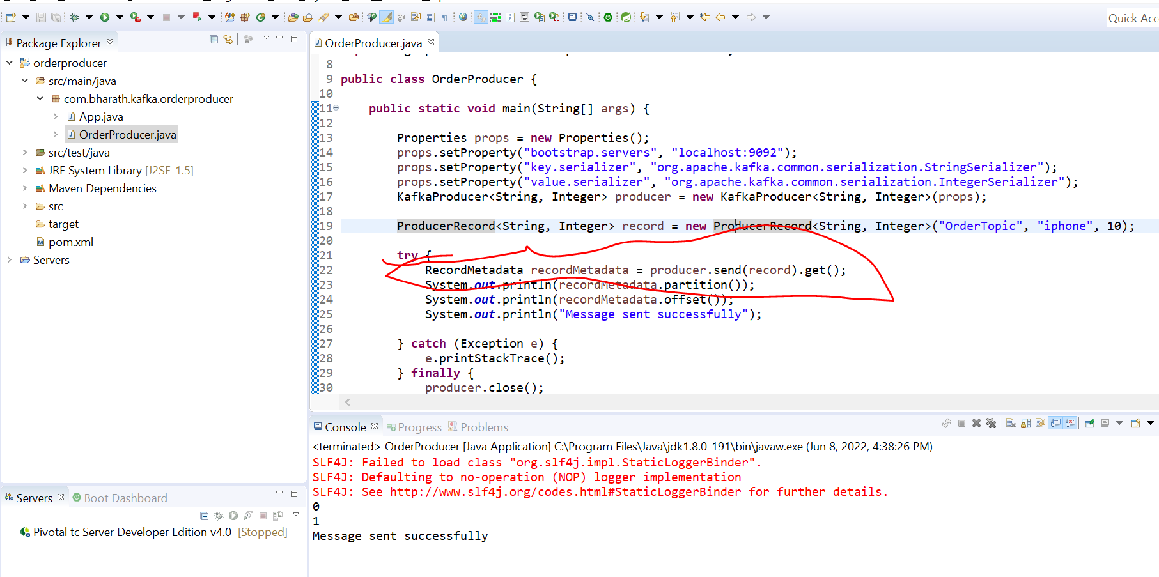

This is synchronous call we are waiting for response

**Async send**

**It will not wait**

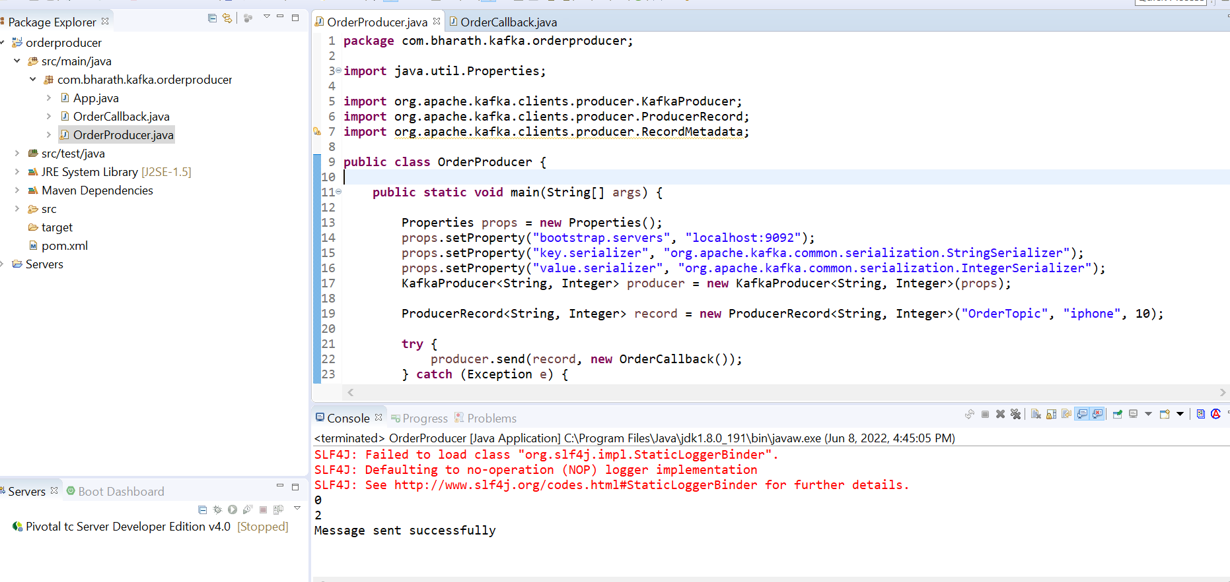

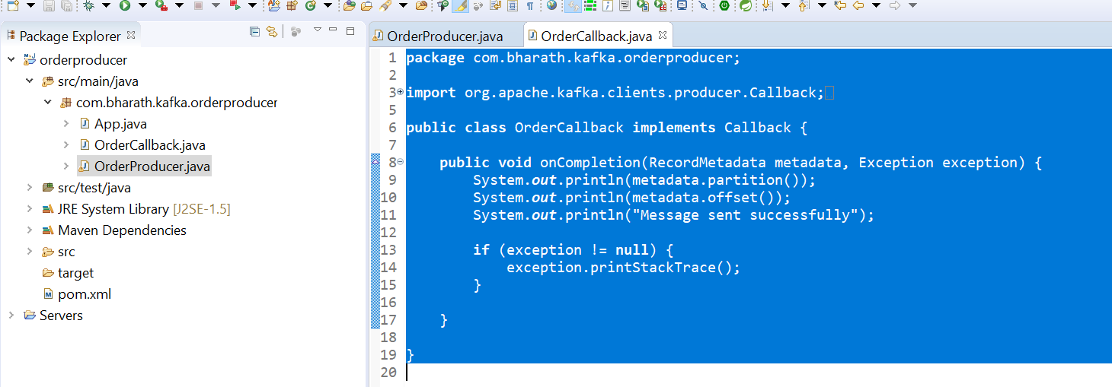

**API Walkthrough**

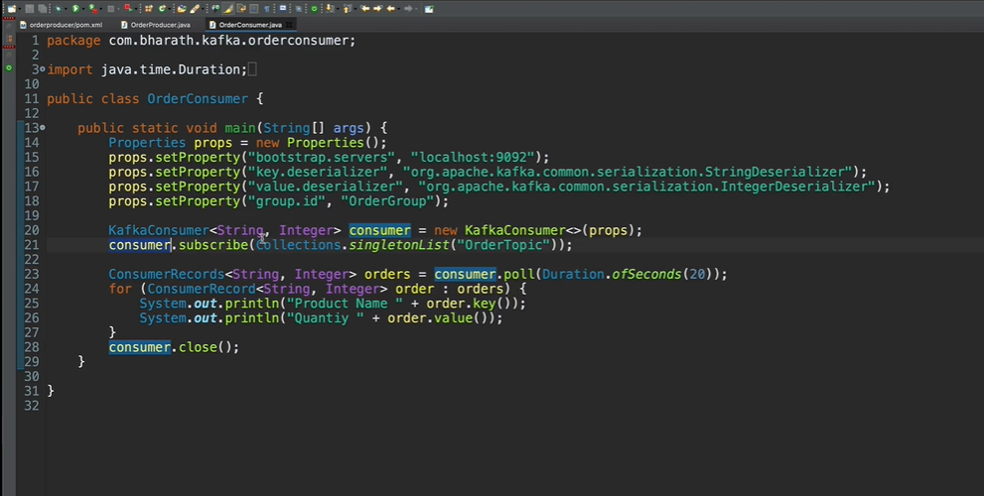

Consumer need group.id .

Every consumer will belong to particular group and it will consume same set of messages.

Once the consumer is create it need to subscribe to topic.

A consumer can subscribe to multiple topic

Consumer.poll :---- this is where consumer start polling thr topic for message

Poll does a lot of thing behind the scene. It does partition rebalancing . It does a data fetching and a lot more

**Create a consumer project**

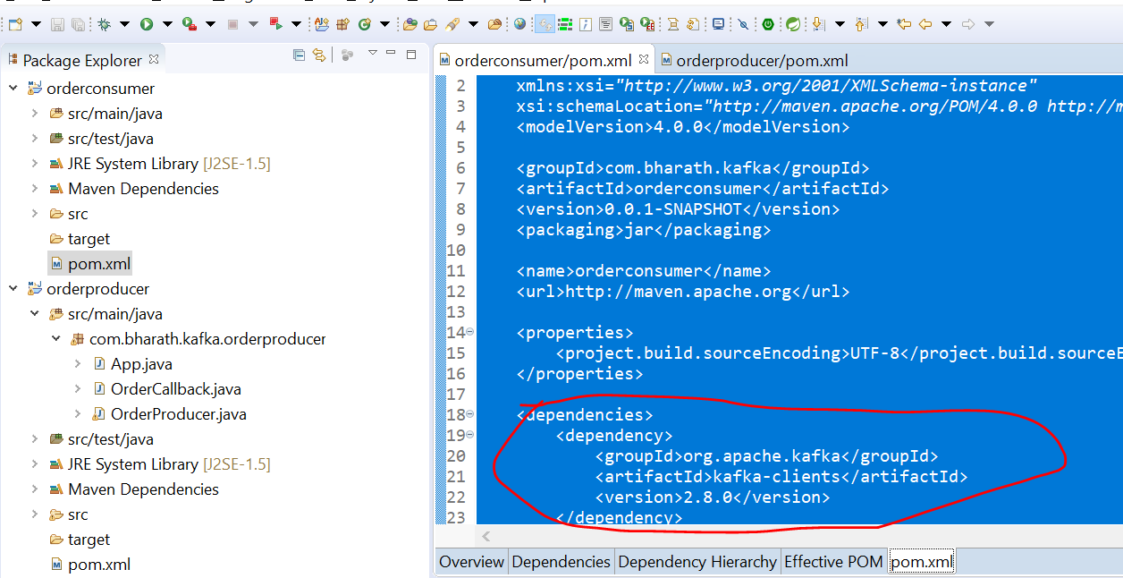

**Consumes Messages**

ConsumerRecords is a collection

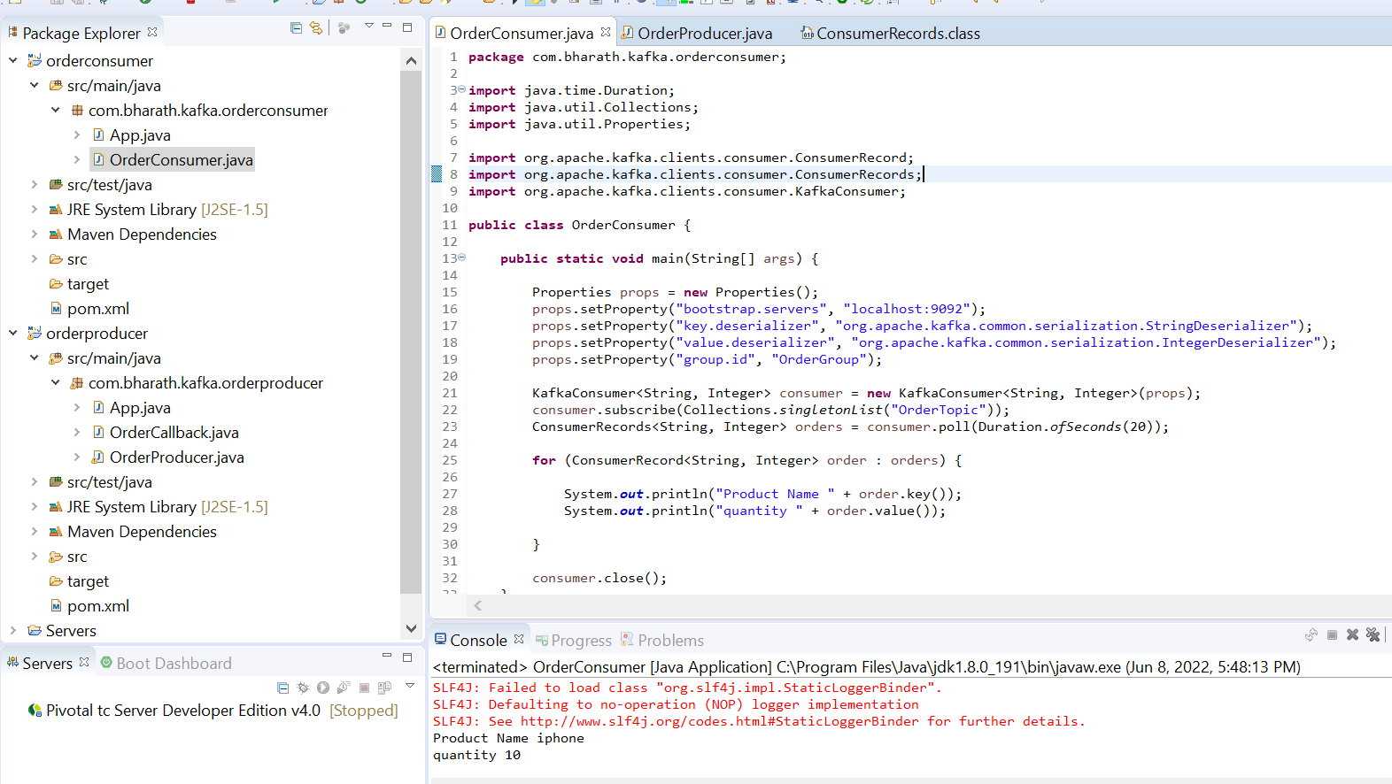

Use Custom Serializer and Deserializer

Note :

We can use custom serializer and deserializer to convert custom object into byte array

Create a Serializer

**Objective :**- create a custom serialize that can serialize java pojo

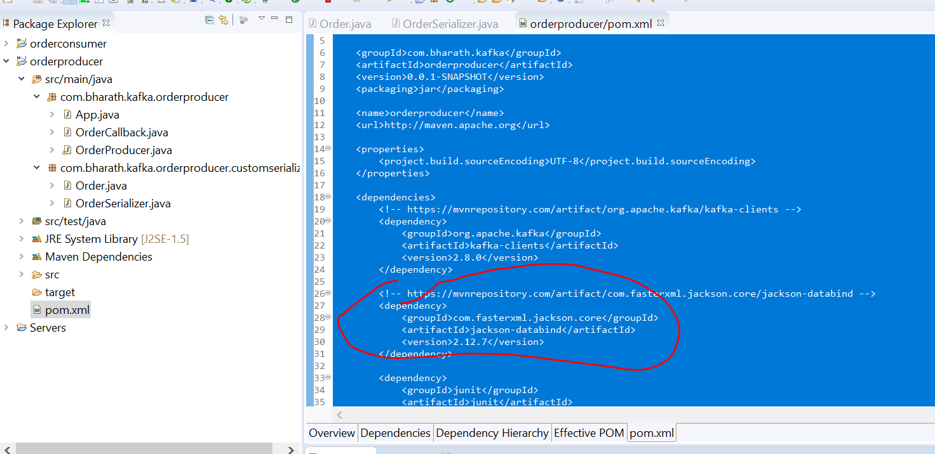

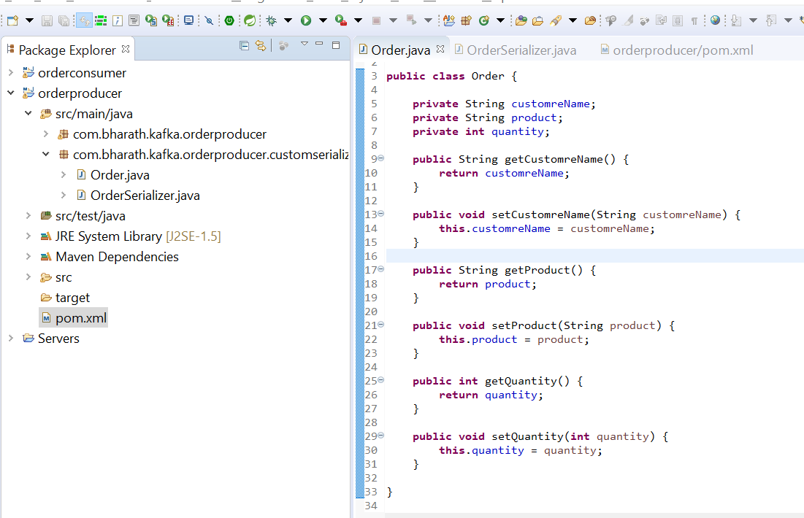

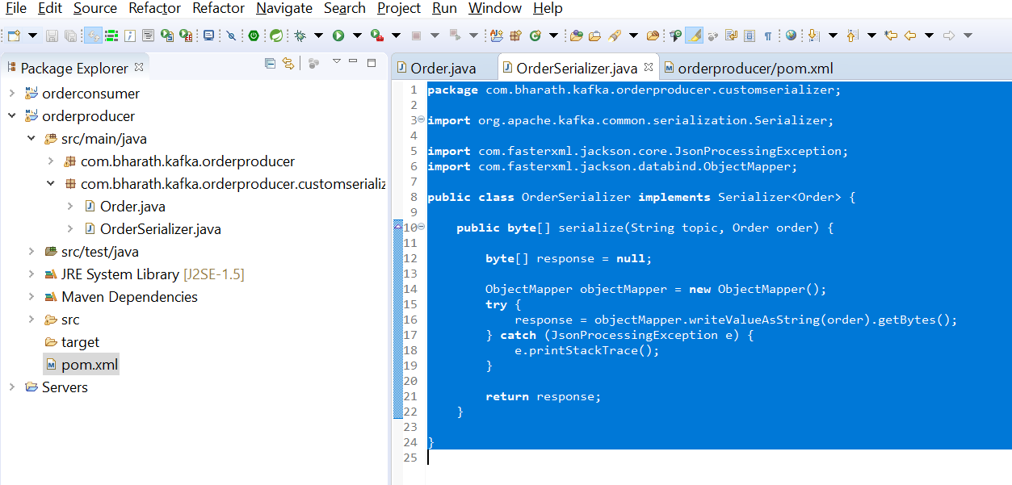

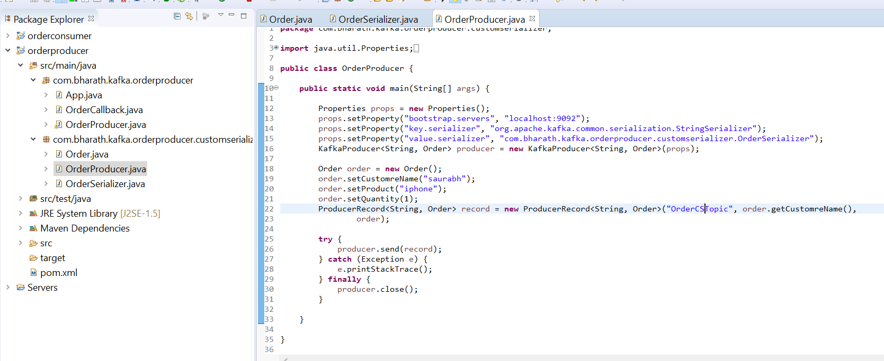

**Create a Deserializer**

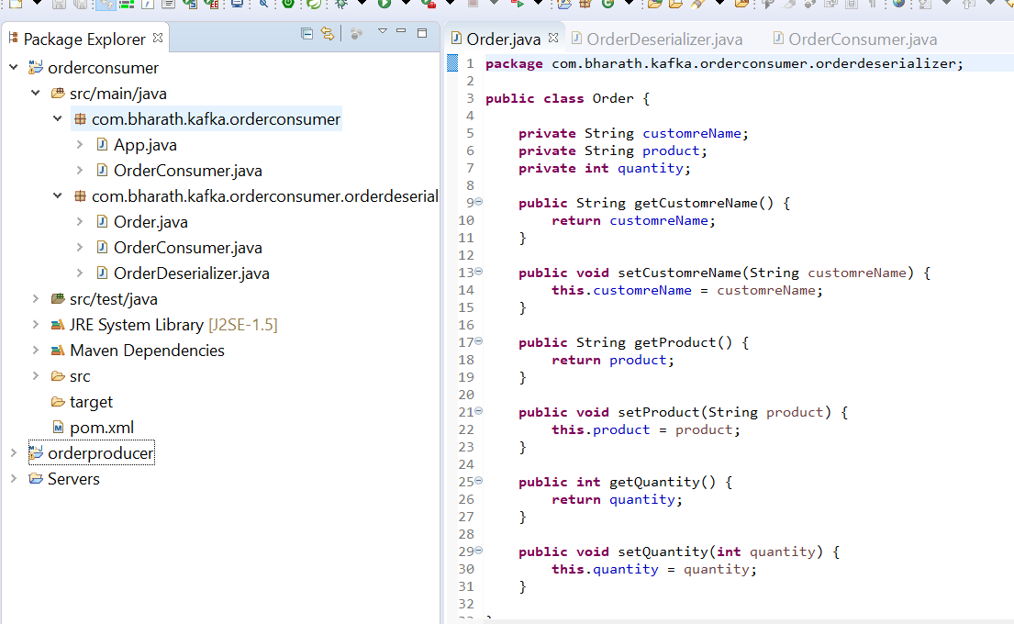

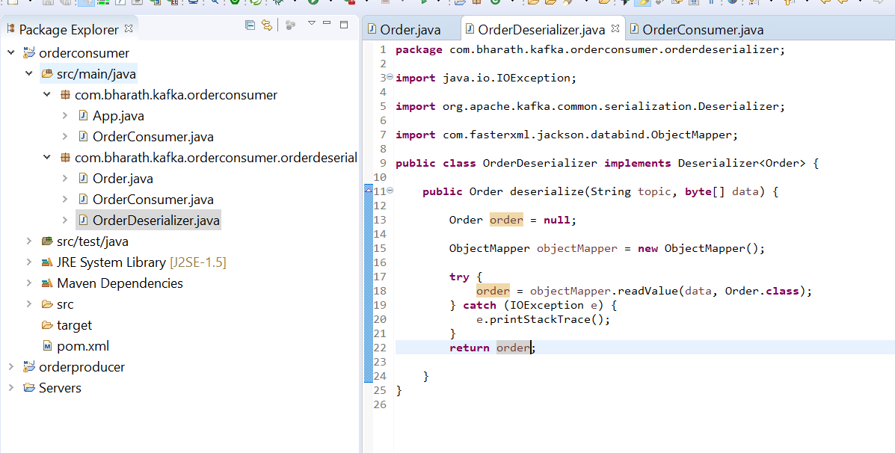

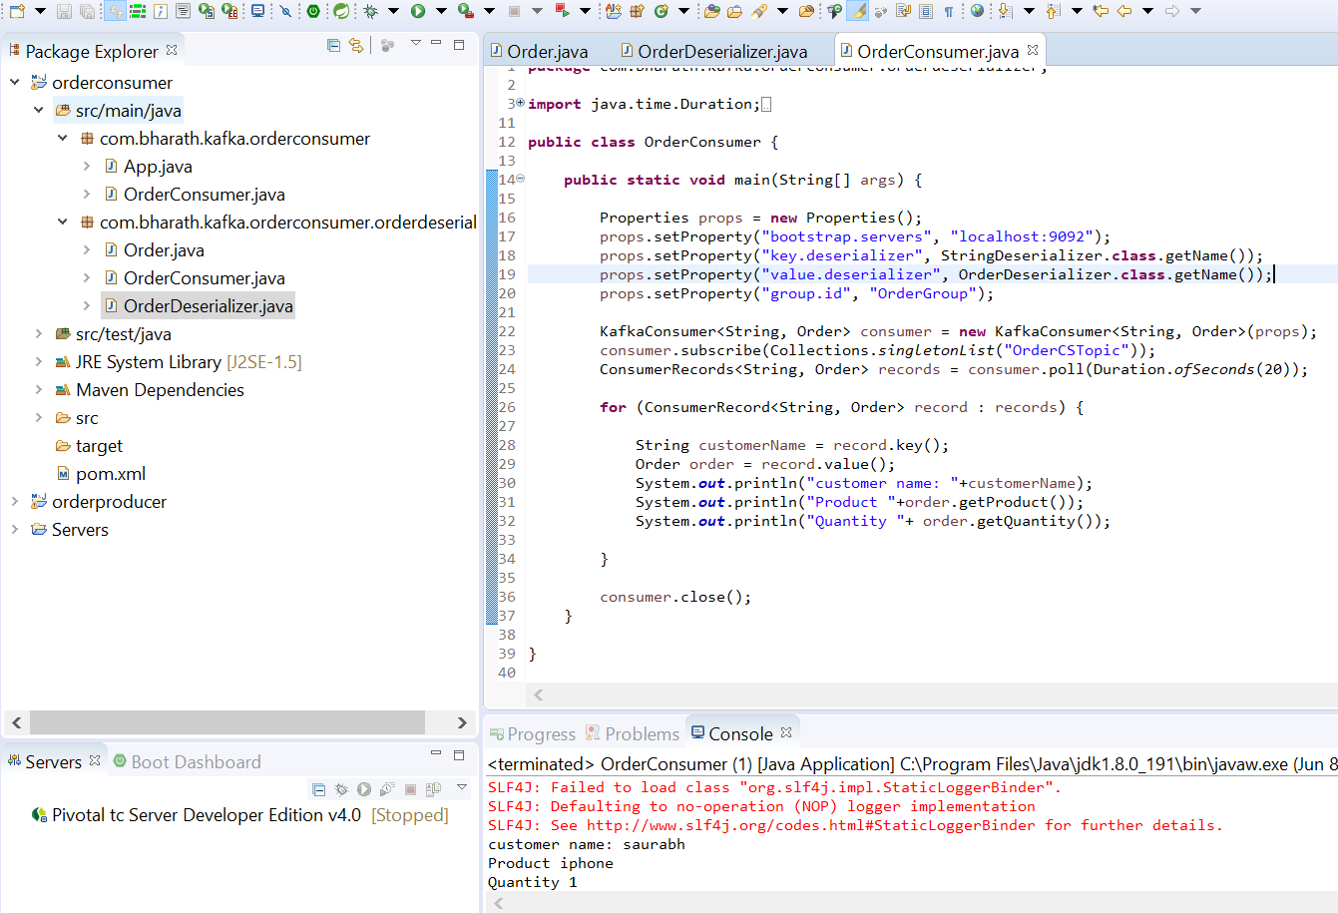

**Use Avro**

**In avro no need to write serializer**

Till now we learn custom serializer and deserializer of object type data in kafka

**Introduction**

We are going to learn **apache avro**. Once we start using avro we don’t need to create custom serializer and deserializer

kafkaAvroSerializer know how to serialize by looking into schema file

**Query :-**

**How producer and consumer will exchange a schema file will do by using schema registry.**

kafkaAvroSerializer will smart enough to push schema to schema registry

kafkaAvroDeSerializer will pull schema from schema registry and will do deserialization for us

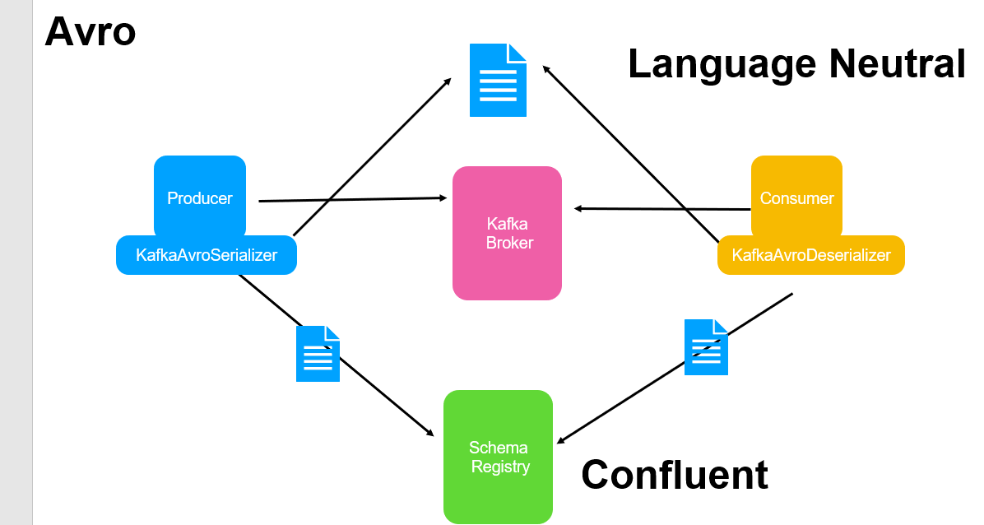

Schema :

Namespace is like package in java

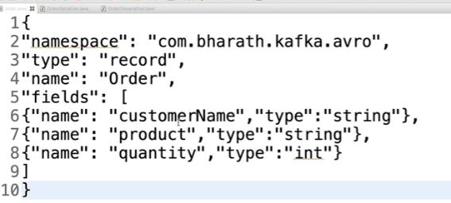

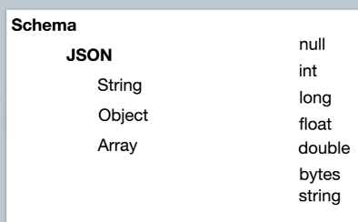

**Schema Registry**

**These schema change over time** as per business need and when it happens the downstream consumer application deserializer need to know about latest schema files that is where schema server registry come in. schema registry should maintain **version** of schema.

**Confluent** provides open source implementation of schema registry

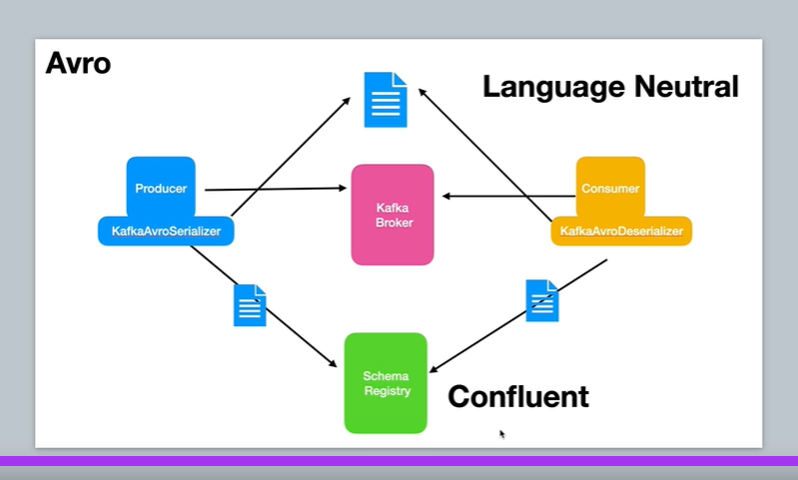

**The magic behind the scene**

**Magic behind the scene** once we start using schema registry and avro serializer and deserializer

**Producer side :-AvroSerializer (magic start)----**

not only convert data into bytes it also ensures that data is compliance with the schema file created.

It will take schema file very first time we are using it and it pushes it to the schema registry using the info we provide configure the schema

Registry url in producers and avroSerializer uses that information pushes the schema to the schema registry.

The schema registry will store this file and it will version it and use a term called subject.

A subject is just a scope within which schema evolves over time.

The avroSerializer will take the unique id that is assigned to schema by the schema registry and it will store it in the header section of the record.

It will put the data also into record and then record will be send to kafka broker

**Consumer side :- AvroDeserializer**

This guy will look schema id in the header section of the record , it connect to schema registry using schema registry url we provide on consumer fetches the schema , validates the data that came in against this schema. And as the schema change over time the version will be maintained by schema registry. Always latest schema version id will be added in record consumer will validate the data as per id come in

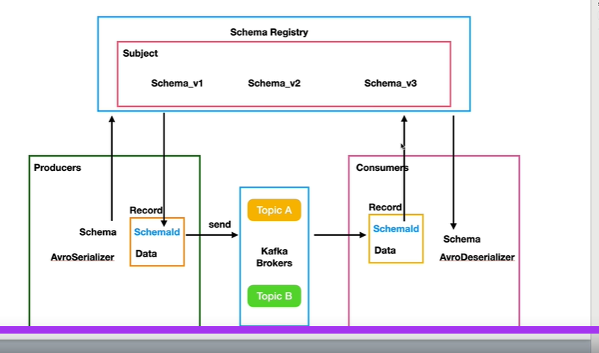

**Note :**

**Schema registry store all these schema behind the scene**

**Launch Confluent Schema**

KafkaAvroSerializer will push schema to schema registry and kafkaAvroDeserializer will pull schema from schema registry

Confluent is cloud based implementation of entire kafka entire ecosystem not just zookeeper

**Confluent download**

<https://www.confluent.io/get-started/?product=software>

**Create Avro**

**Start confluent:--**

confluent local services start

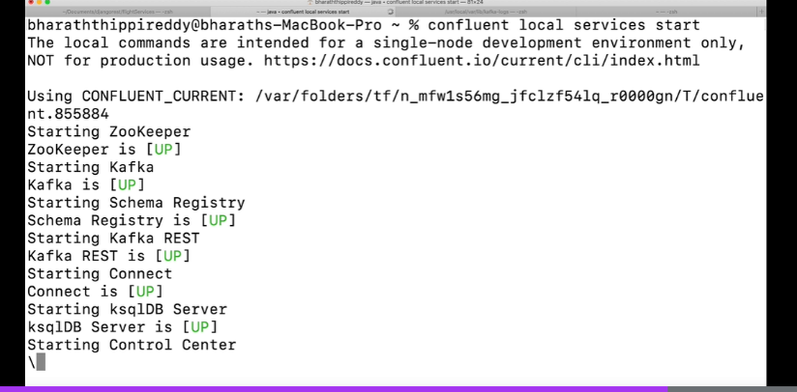

Namespace will use as package name

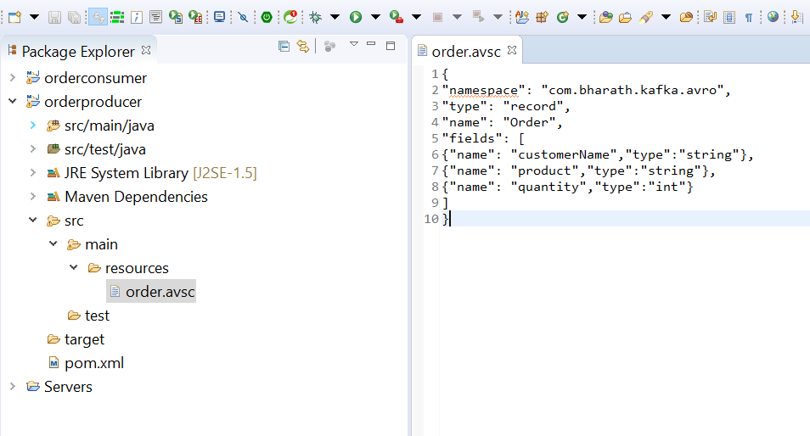

**API Walkthrough**

Will generate a order pojo using the schema file and plugin

**Configure Maven Avro Plugin**

**Objective :-** will generate a java class from avro file using avro maven plugin

Add these dependencies in pom.xml

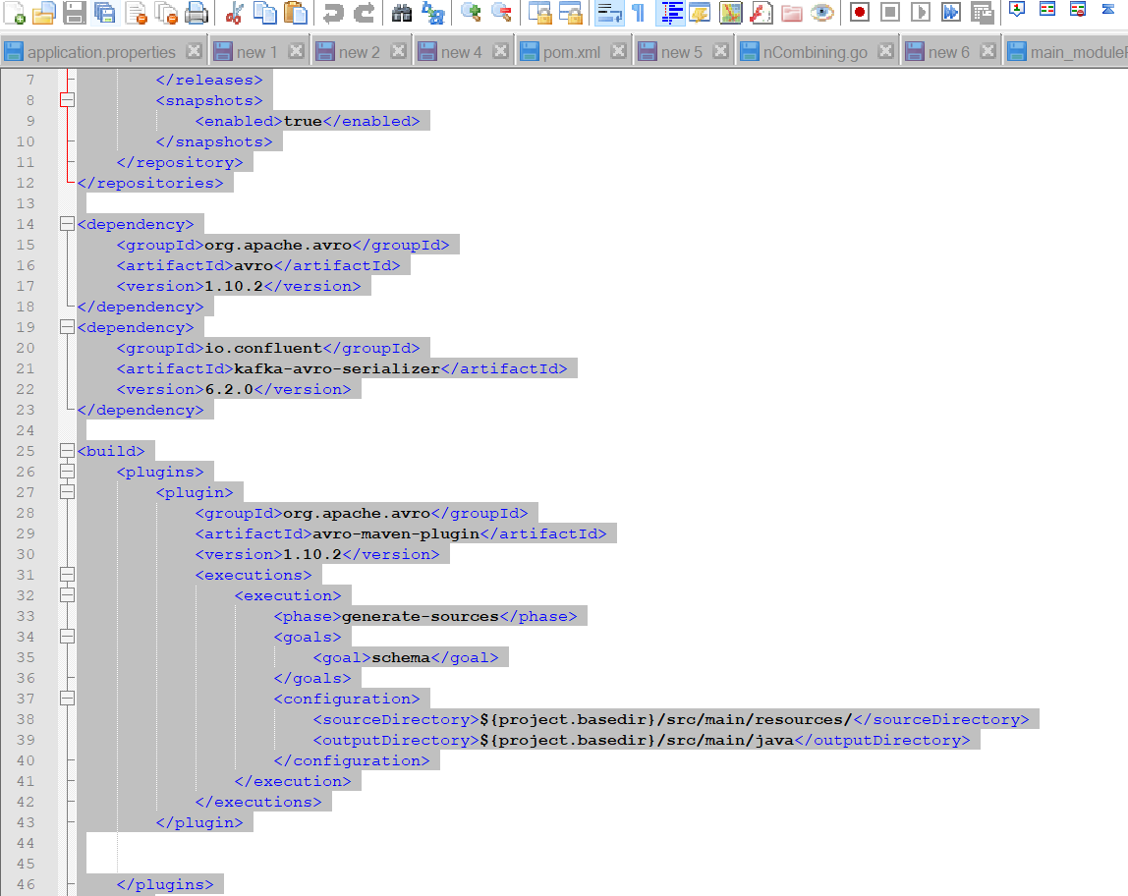

Maven install:--- it will create Order class from avro file

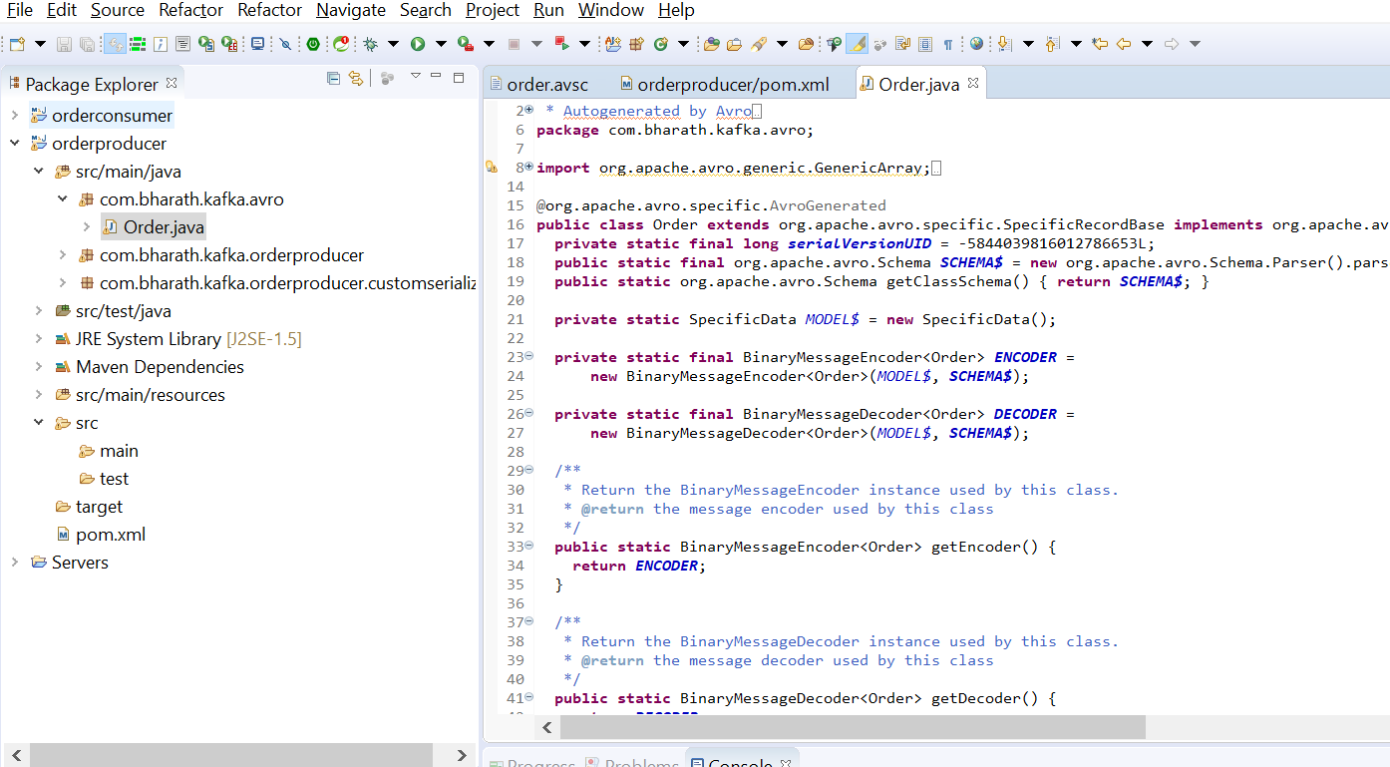

**Create Producer**

Will create Kafka producer that will use AvroSerializer to serialize the Order.java which is created from avro file

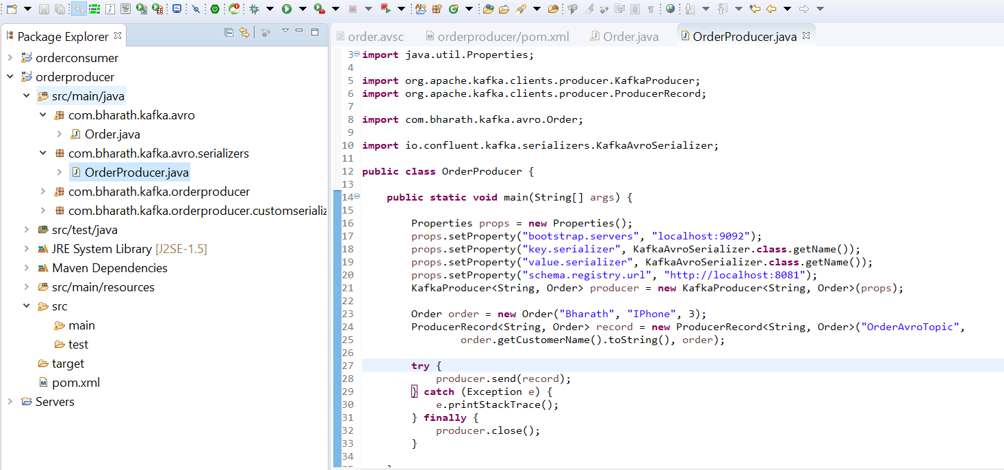

**Create Consumer**

Kafka consumer will use avroDeserializer

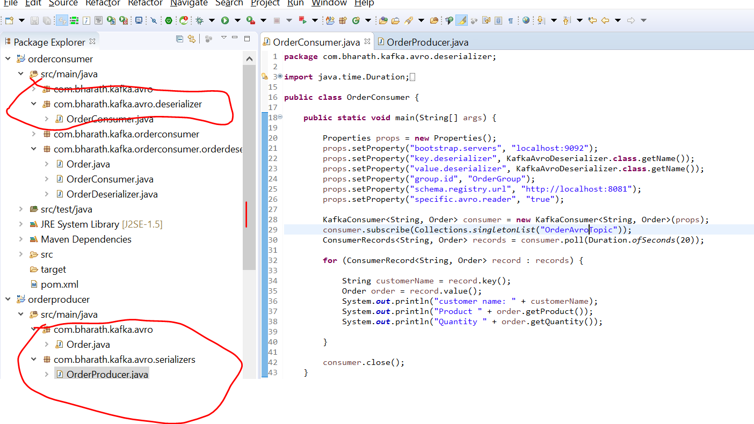

**Test**

**avroSerializer will send schema to schema registry**

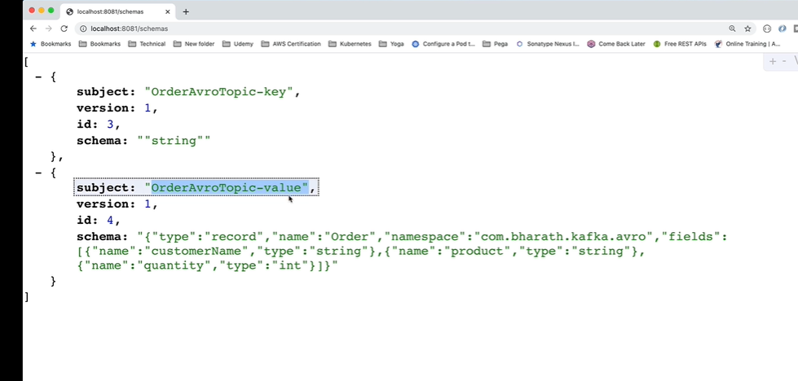

Consumer will use this schema to validate the data

**GenericRecord Type**

So far we have used with specific object type (Order). Avro also support generic record

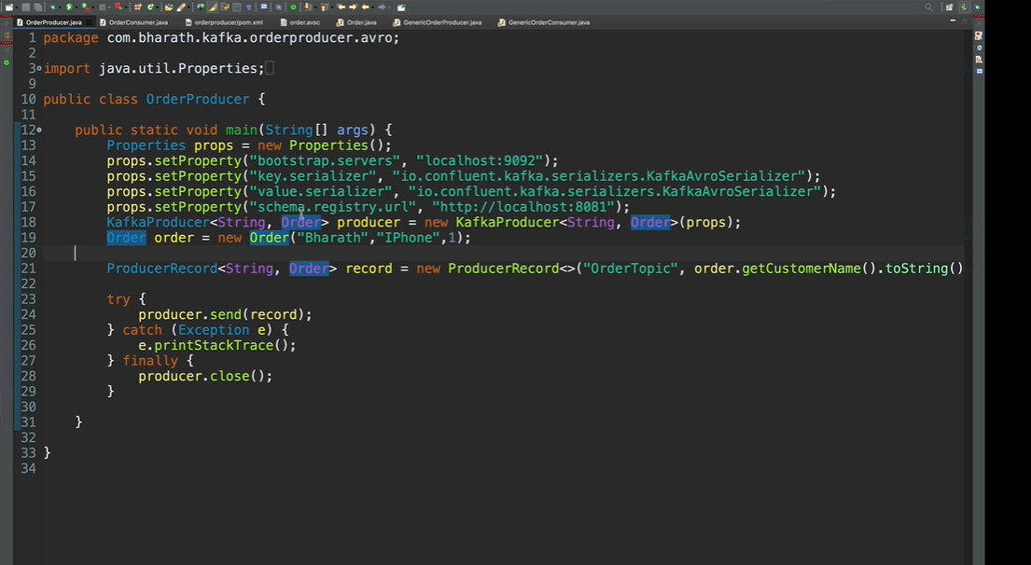

**We can point it to a file or we can pass entire file as string**

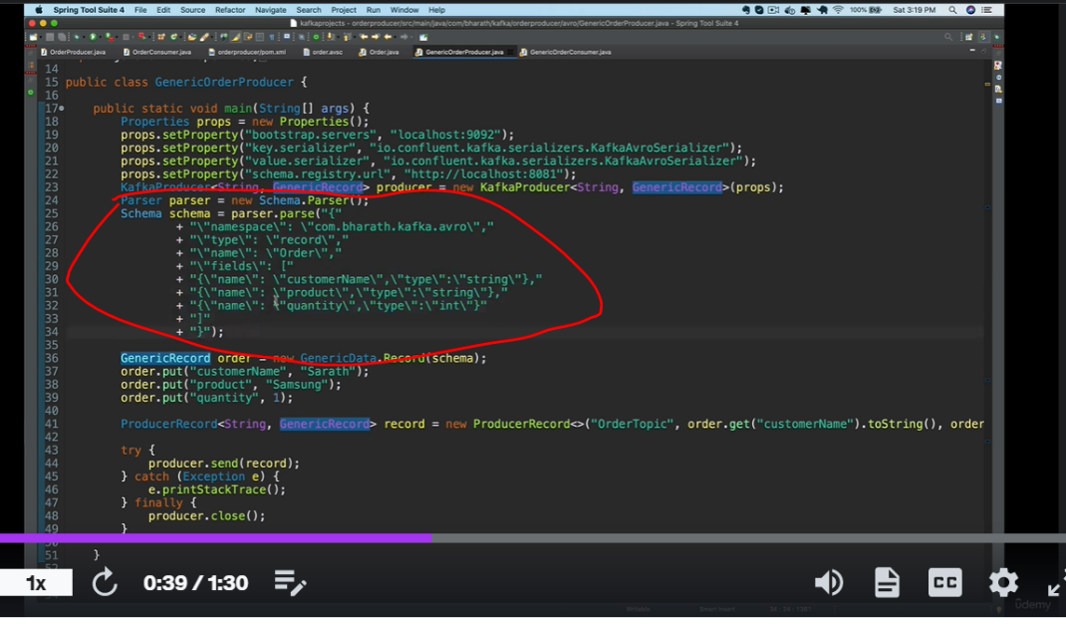

**Create a generic Record Producer**

Generic record has get() that takes a key

One class only

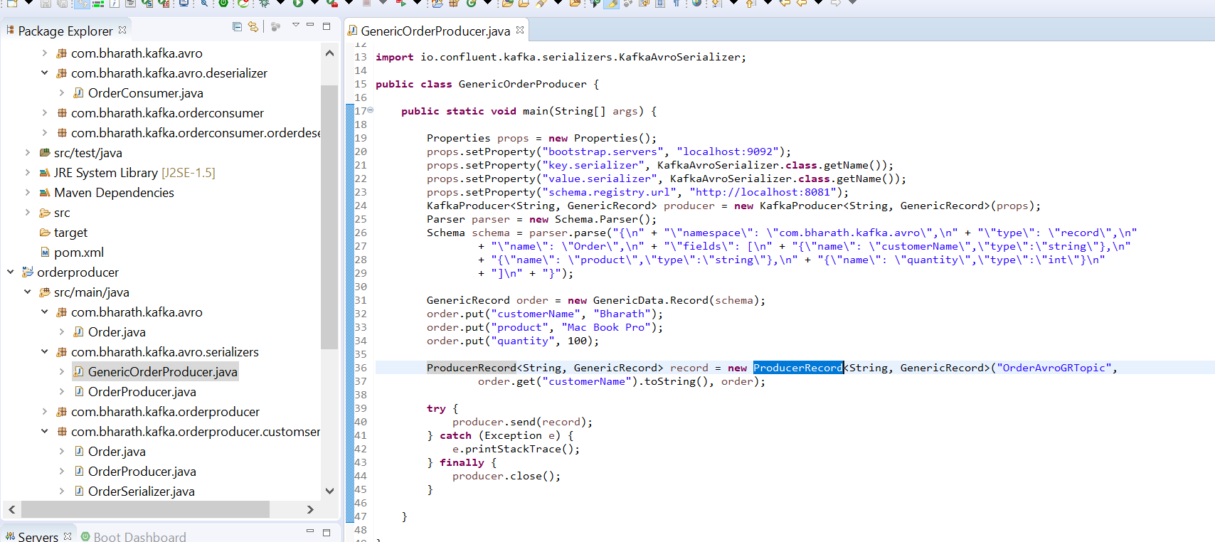

**Create a consumer**

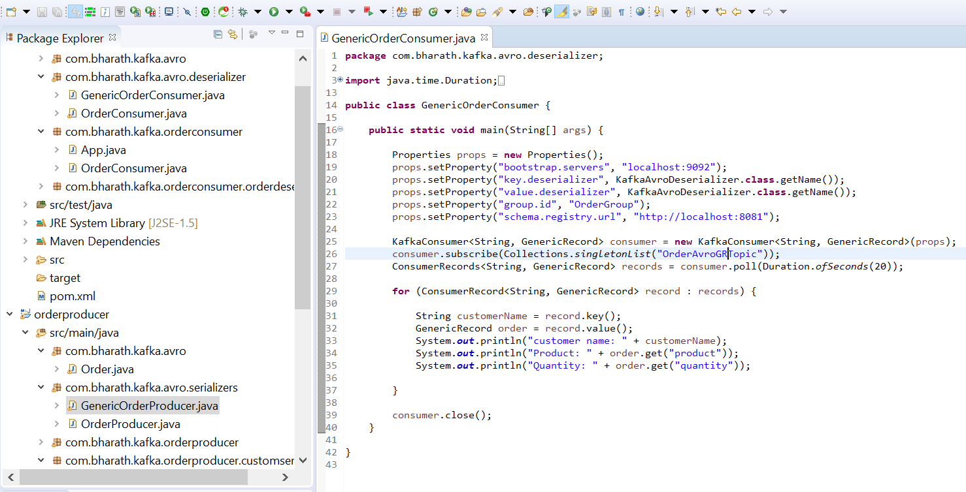

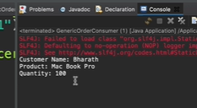

**Schema Evolution**

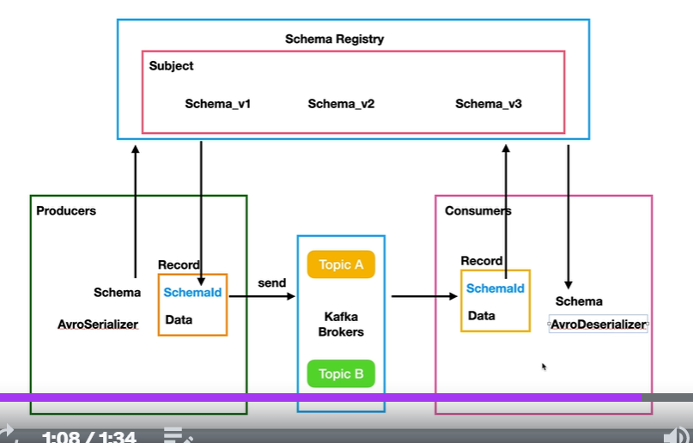

**Note**

When schema changes then schema registry will maintain schema_v2 but consumer can also read previous schema_v1

Where it get failed

**Schema compatibility**

As the schema change over time downstream always not ready to use the latest schema that is where schema compatibility

Come in picture

That’s why we can use schema compatibility rules and if producer break the rule it will get exception

**Consumers in real time**

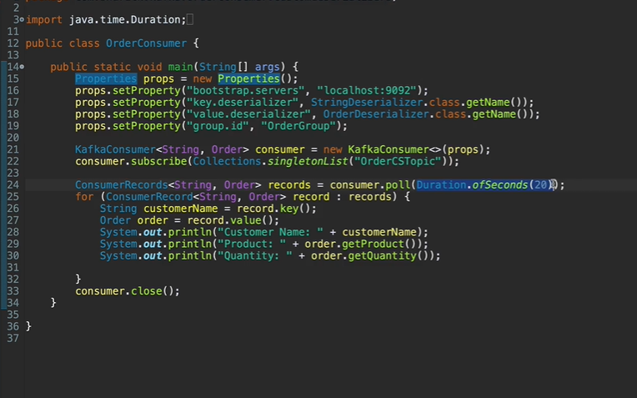

Polls method not only fetches record from topic but it also do partition rebalancing behind the scene.

If there is no record come for this duration then consumer will die.

Consumer in real time application are long run process they never end

**Now this is infinite running process even if this die another consumer will take the process**

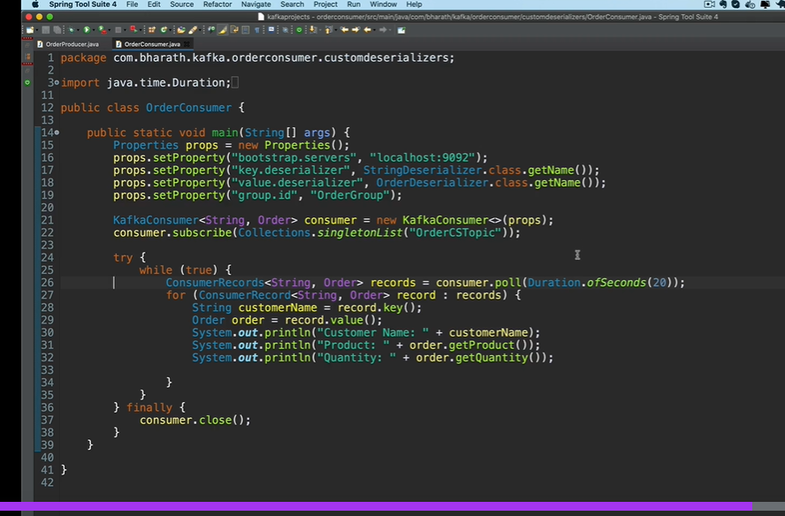

**More about Producers**

**Objective :-** how to create own custom partition

**Create a topic**

**So far kafka create topic automatic for us if it doesn’t create and it create with single partition**

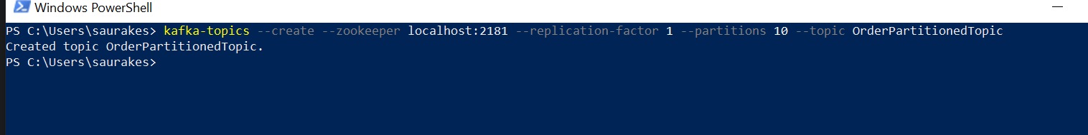

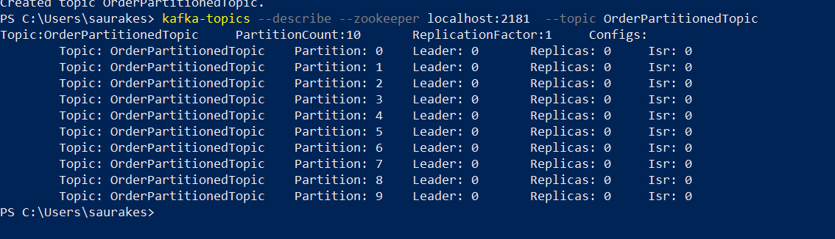

**Create custom Partitioner**

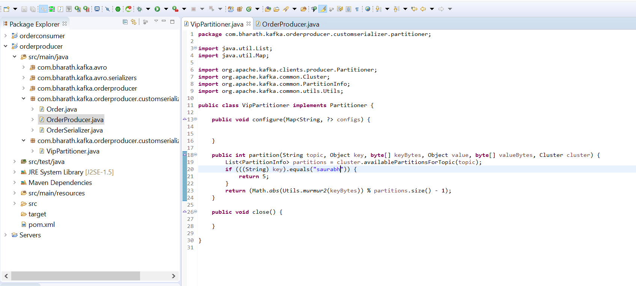

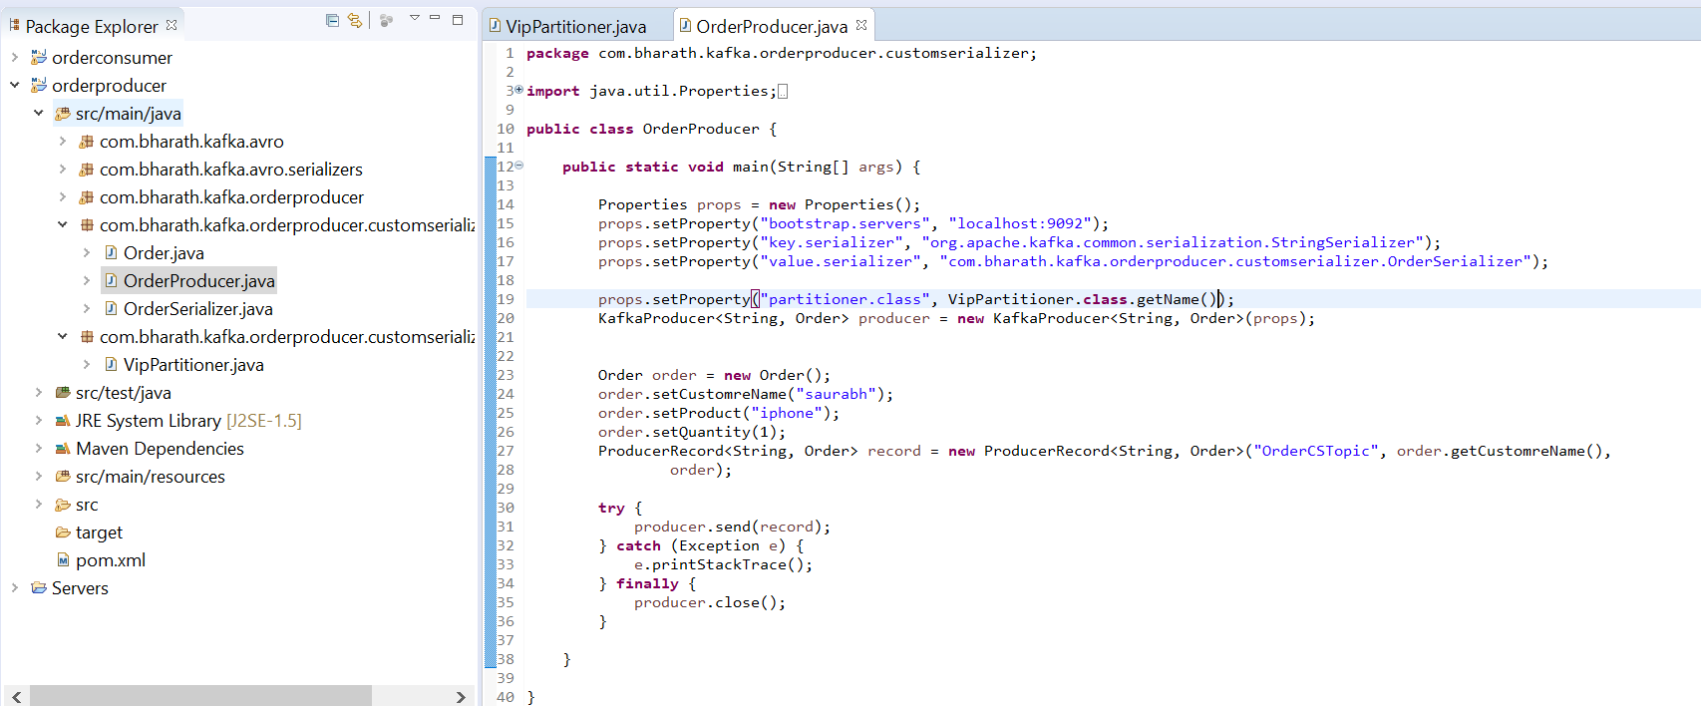

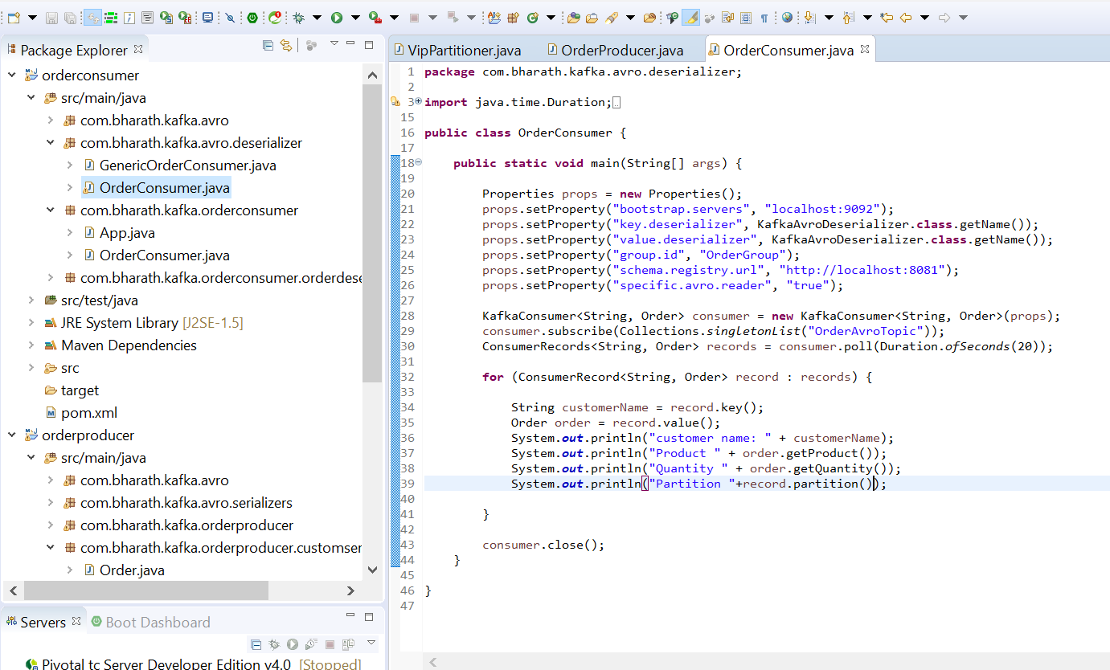

**ProducerConfig Class**

**Note :-**

These are mandatory field uses everywhere so instead of hardcoding kafka give ProducerConfig class

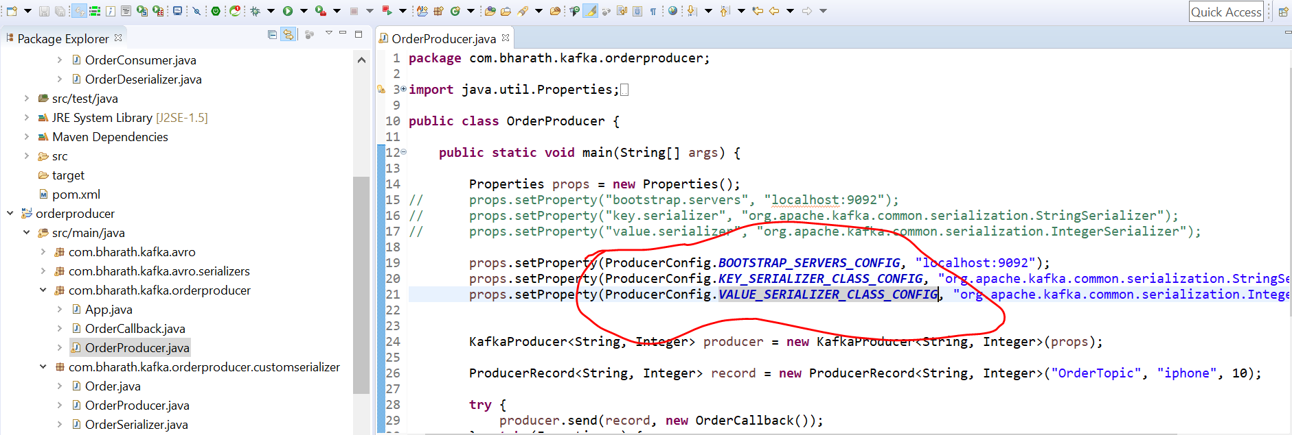

**Acknowledgements and more**

**1-props.setProperty(ProducerConfig.ACKS_CONFIG, "all"); ----**0,1,and all three value are there

0 : the producer send a message and it immediately considered the mess is sent successfully . It wont wait for response from the broker

1 :- the producer receive a successful response from the broker only if leader replica successfully receive the message

All :- the producer receive a acknowledgement from the broker only when all the replicas receive the message but here producer has to wait to deliver all the message to the replicas

**2-props.setProperty(ProducerConfig.BUFFER_MEMORY_CONFIG, "343434334");**

If the application is too fast then it can be blocked therefore we can increase memory

**3:- props.setProperty(ProducerConfig.COMPRESSION_TYPE_CONFIG, "gzip");**

By default message are not compressed only when we set this value then only message is compressed

1. **props.setProperty(ProducerConfig.RETRIES_CONFIG, "2");**

Producer will retry if there is some error . By default producer wait for 100 m/s for retry

**5- props.setProperty(ProducerConfig.RETRY_BACKOFF_MS_CONFIG, "400");**

want to wait for 400 m/s--millisecond

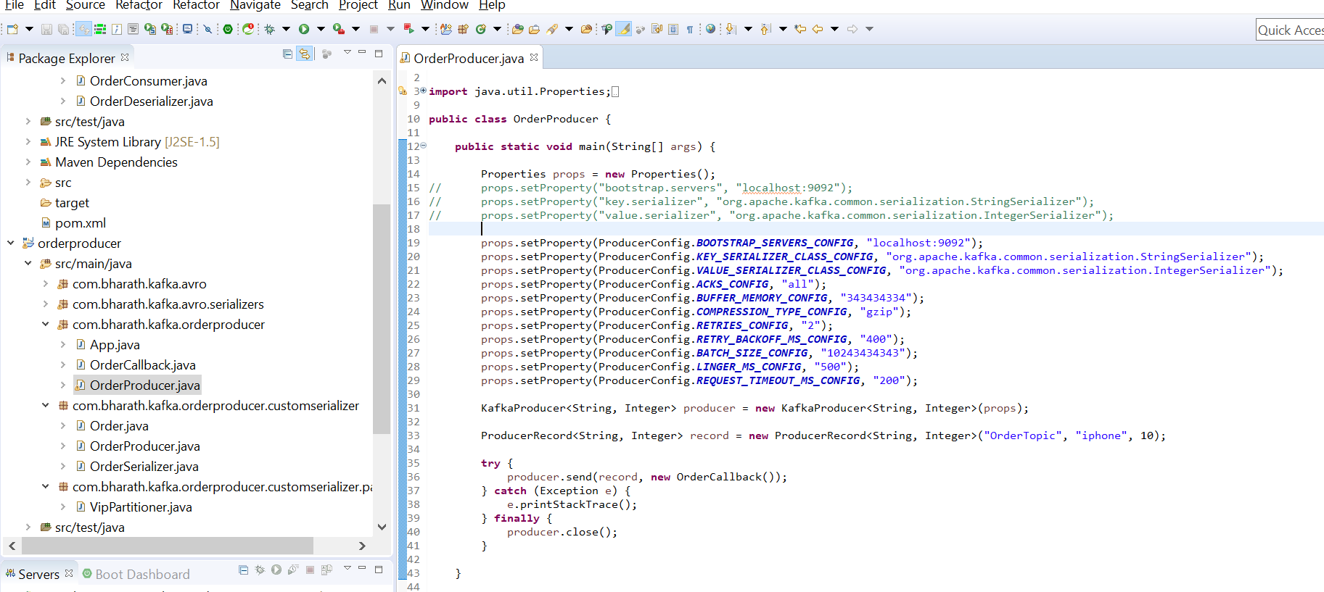

**Three more properties**

**6-props.setProperty(ProducerConfig.BATCH_SIZE_CONFIG, "10243434343");**

This is memory size we want to allocate for batch. Having a higher number here is good. This number is in bytes

How big the message is we should allocate this property

**7-props.setProperty(ProducerConfig.LINGER_MS_CONFIG, "500");**

The producer will wait for 500 millisecond before it handsover of message to a sender thread although it is available.

That give a chance to fill the batch with few more messages

**8-props.setProperty(ProducerConfig.REQUEST_TIMEOUT_MS_CONFIG, "200");**

This is the time for which producer wait for a response from the broker

Message Delivery and transactions

**Objective :-**

how to achieve that is there is no duplicate message

1. Will learn how to configure them advantages and disadvantages

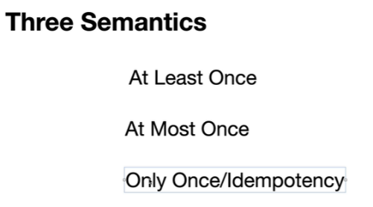

1. **Will see transaction sending all the message or sending no message**

It support three message delivery semantic

**At least once delivery**

If the message is received by the broker once and it is write to leader and follower of partition and acknowledge is back to producer and all are hap**py**

**Problem :**- while sending back acknowledge to producer by broker if it is fails then producer will retry to send same message again and as result

Message duplication occur. If we are ok with message duplication then we can go for **default** which is **At least once delivery**

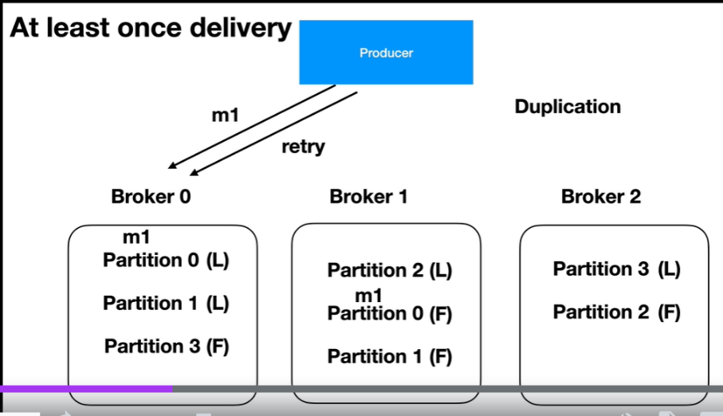

**Atmost once delivery :**

Here message should be deliver atmost once not more than that. We can do it using retry on producer side will set retry to 0 that is producer will never retry.

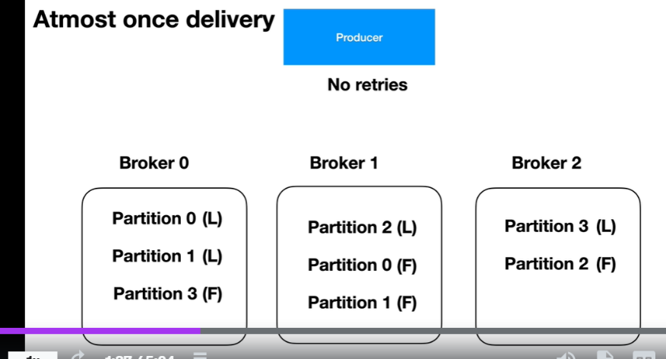

**Most desired exactly Once semantics**

This is where we enable.idempotence by using a producer configuration.

Once we send it true the magic happened behind the scene . The producer send method will generate a unique sequence number for every message

So it is unique within a given partition the broker will receive it . It maintains the message sequence number and along with that it generate a unique producer id for each producer instance which will use by the producer everytime it send a message. Now broker will reject message if producer is sending message again with same seqNum

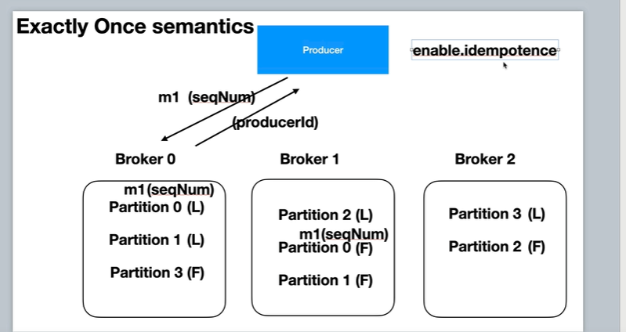

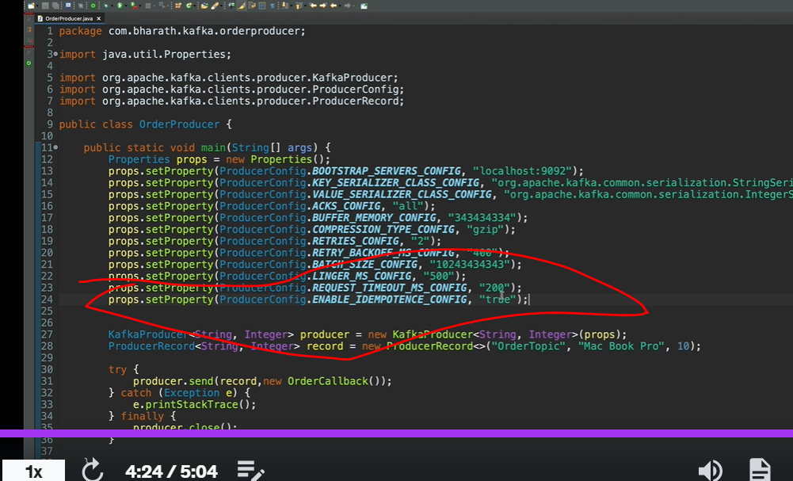

That’s all we need to do all the magic happen behind the scene

**Still duplication can happen if multiple instance of producer running and they are sending same message**

**Transactions**

The transaction in kafka is just like a d/b transaction. We commit all record in transaction or we roll back.

producer.initTransactions(); will do lot of thing

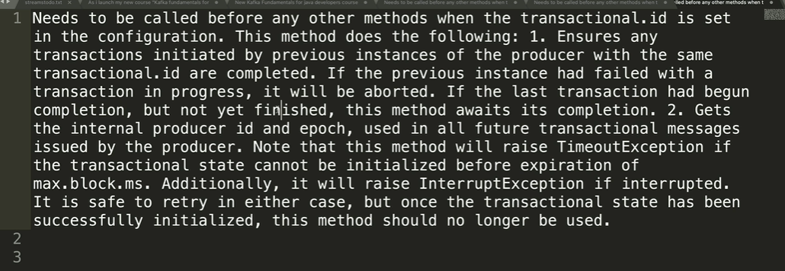

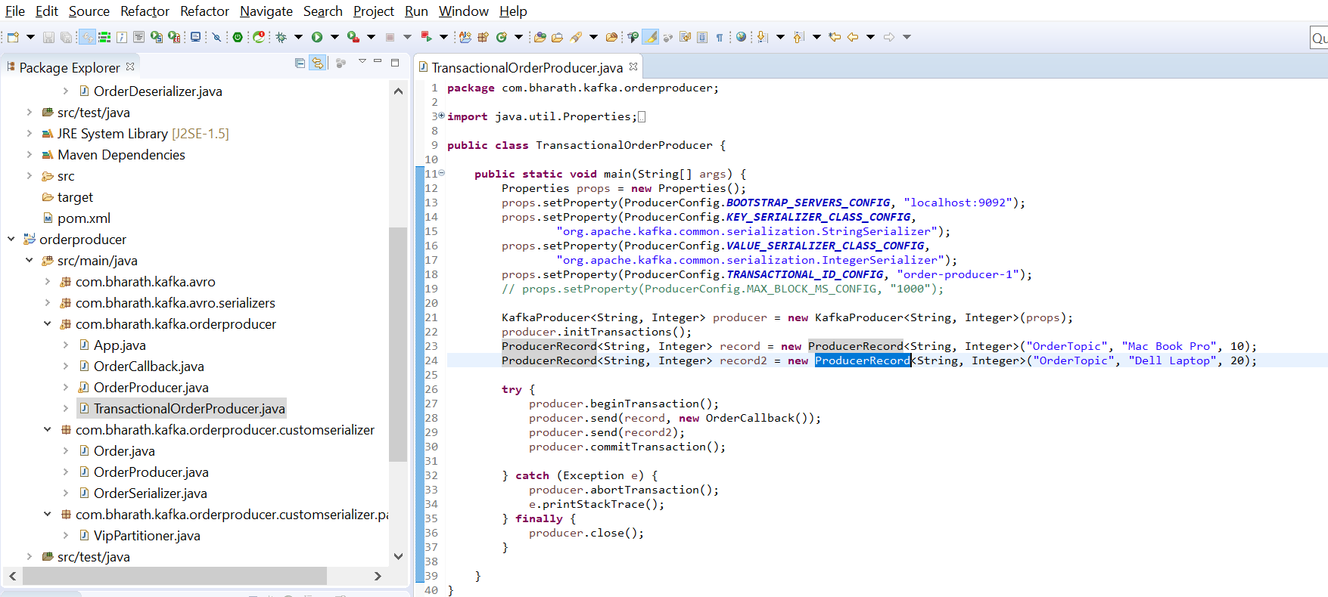

We don’t need to use callback here

More about Consumers

**A consumer group is a set of consumers that jointly consume messages from one or multiple Kafka topics. The leader of a group is a consumer that is additionally responsible for the partition assignment in a consumer group. Rebalancing is just that — the process to map each partition to precisely one consumer.**

**Consumer Group**

**Consumer group , group of consumer that can read from same topic but different partition in the topic.**

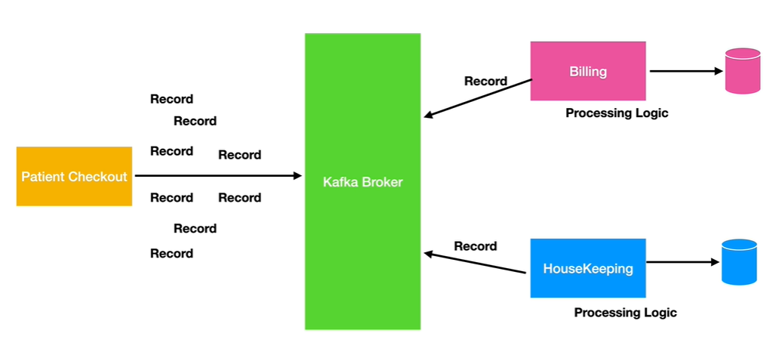

The power of kafka come from it scaling availability . Topic is broken down into multiple partition and then we can have a consumer group

With one or more consumers that can consume from the partition of that topic. We can increase the consumer in consumer group as the load increases. The consumer will split the partition among themselves.

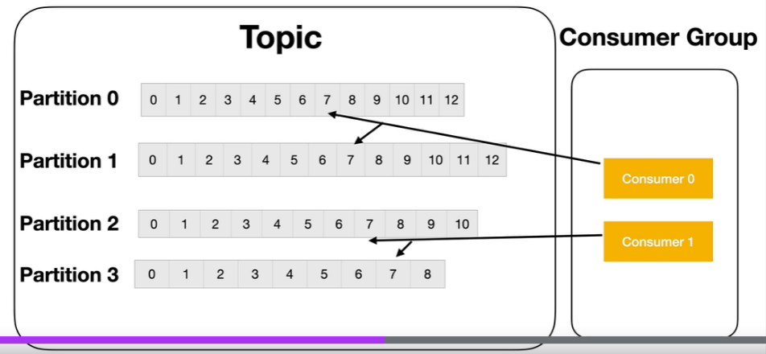

It is our responsibility to create enough partition to keep the consumer busy.

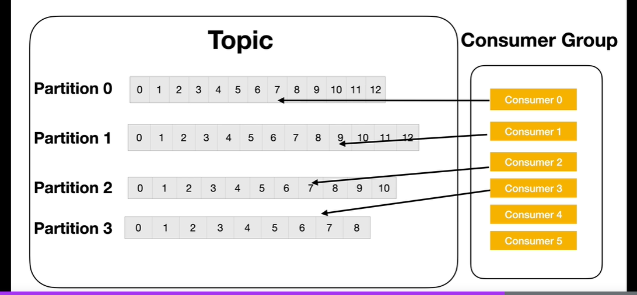

Using consumer group multiple application can consume from the same topic and have their own copies of data

And they can do load balancing through consumer group

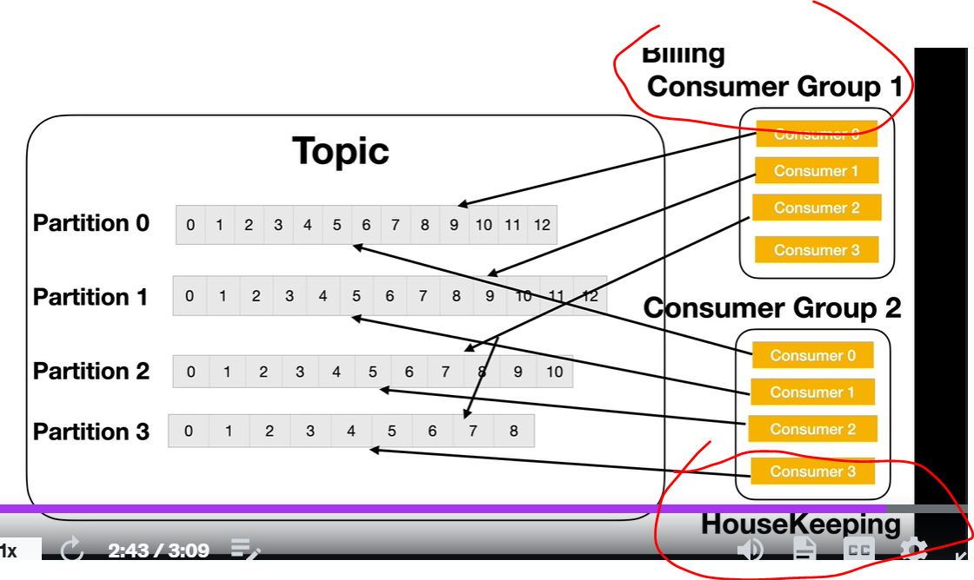

**Consumer group rebalancing**

**Objective :-** wt is rebalancing ?

Let us say a topic having 4 partition and consumerGroup with 3 consumer consuming from 4 partition.

**When a consumer is added to the consumer group or consumer leaves the consumer group . Moving partition ownership from one consumer to another**

**Consumer is called rebalancing**

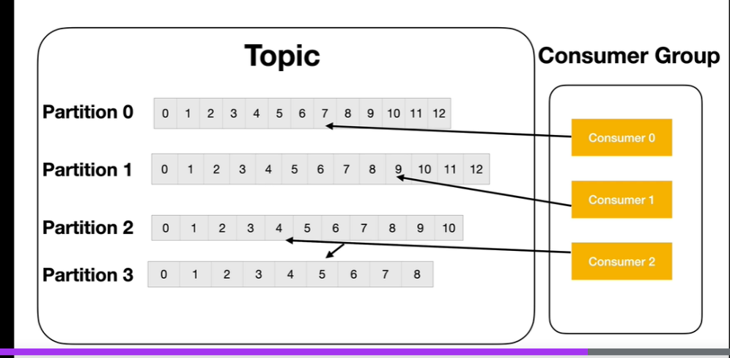

**How rebalancing work**

To understand how rebalancing work we need to understand how ConsumerGroup work

When a new consumer group is created kafka allocates one the broker as consumer group coordinator.

When a new consumer join the consumer groups. It does so by sending a join request to group coordinator.

Group coordinator at this point send all the partition details to the very first consumer and makes it consumer group leader

When another consumer join by sending join request the group coordinator will trigger a rebalance while doing that it will handover current partition details

And also consumer details to the group leader

**Note :**- it is group leader who does the rebalancing. All the logic is already inbuilt. Leader will assigned all the the partition to the list of consumer that are available in it and leader hands over to the group coordinator then it will assigned partition to consumer. Only group leader and group coordinator have all partition details and other consumer will get Details only their partition

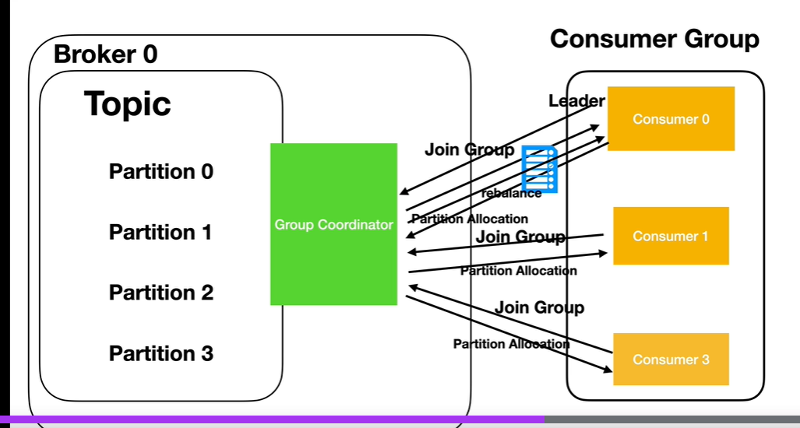

**When the rebalance process happens the consumer group do nothing because group leader will assign all the partition to the consumer and the consumer will sit idle that why we need to ensure that to avoid rebalancing**

**Offset Commit**

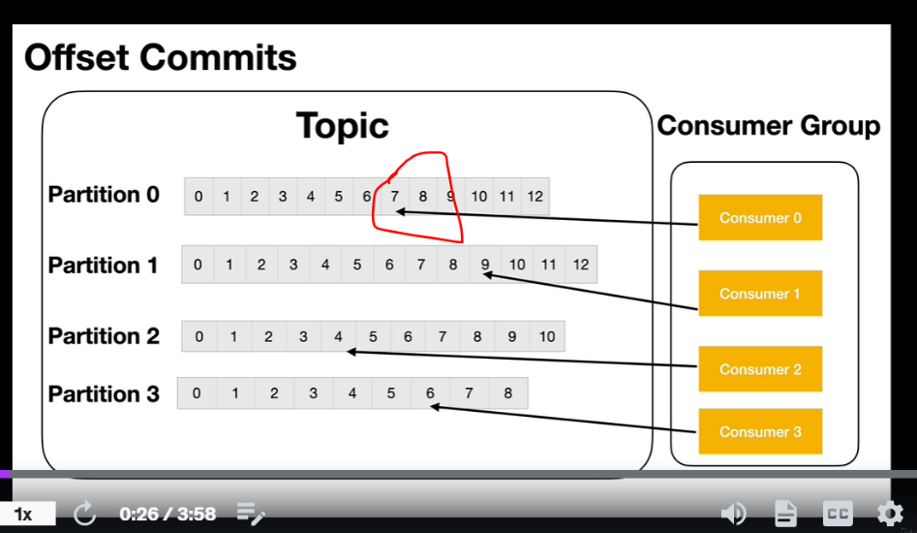

**In earlier kafka wont keep track which offset consumer reached.**

**Now if rebalacing** occur new consumer don’t know from which offset need to start that is where offsets commit come in picture

Although kafka internally doesn’t track of offset that is already consumed by previous consumer .It allows consumer api to do it.

The consumer can commit offset how much it consumer processed it to a special topic called _consumer_offsets inbuilt topic that comes with kafka.

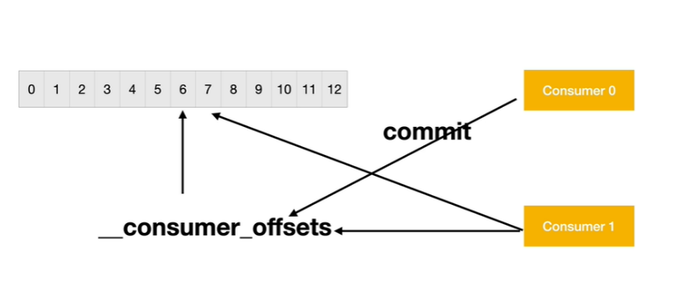

Consumer will commit in _consumer_offset now if rebalancing happen new consumer will see _consumer_offsets and it will start from next offset

**Two issue will arise**

**1-**

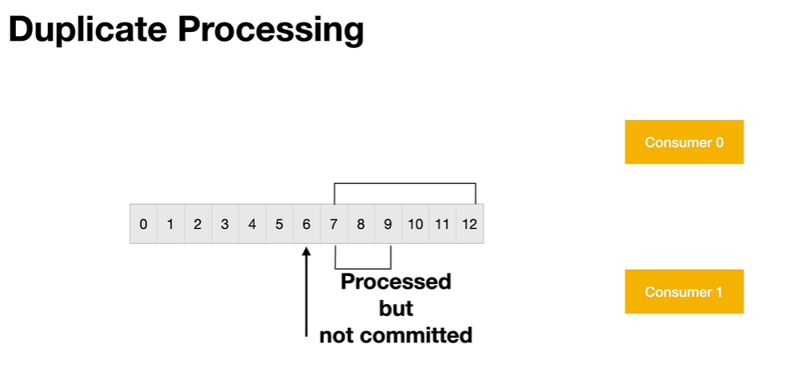

**Duplicate processing :-** previous consumer commit to offset 6 but still it processing till 9 but didn’t commit now rebalancing happen then next consumer will start from 7 so processing of duplicate message occur

1. Committed but not processed will miss some record here.

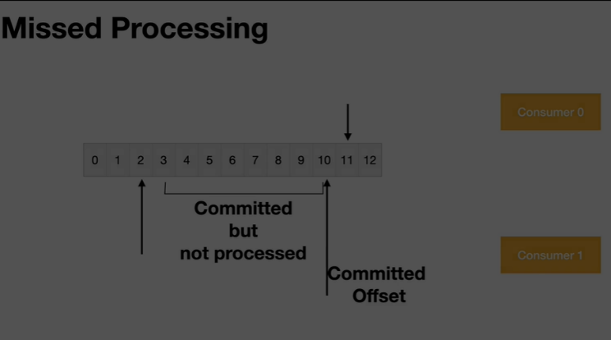

We will learn now below topic and how to minimize above problem

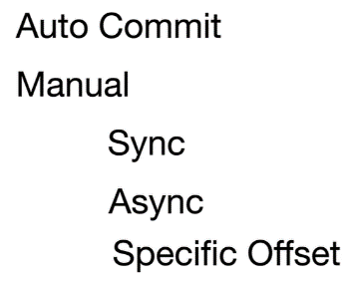

**Auto Commit**

**Objective :-** how auto commit work and issue with it

But default auto commit enabled. The default auto commit time interval is every 5 second. It doesn’t mean after every 5 second auto commit occur.

**It depends on poll method , when poll method occur it check 5 second and auto commit occur.**

We can change time interval also of auto commit

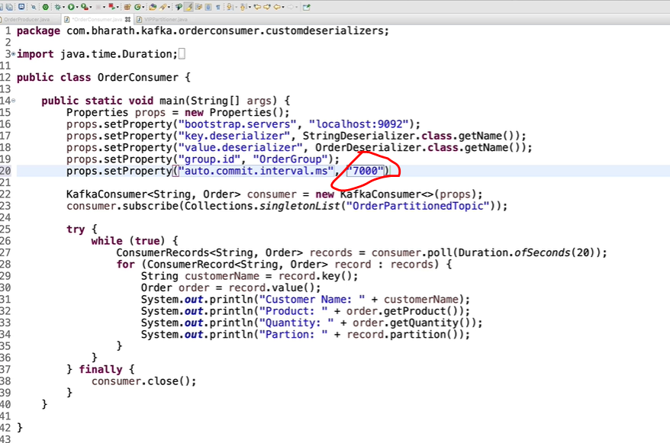

Note :--

Just like poll method , close method also do commit

**Point :-**  the problem of auto commit come with **rebalancing**

**Duplicate process will happen let use assume that in second it processed 400 message but at this time rebalancing happen since it doesn’t commit**

**So next consumer will process it from starting**

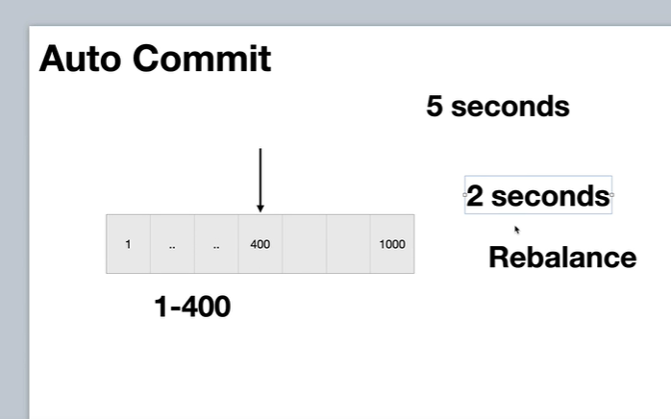

**Note :-** we can reduce the value of auto commit

**Sync Commit**

**Here poll will do auto commit based on time interval**

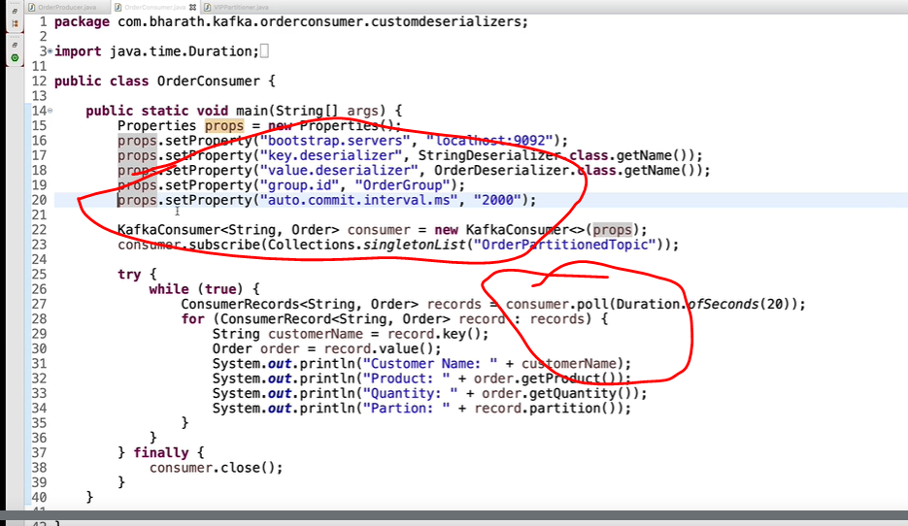

**Note :**

**Poll method will return the offset**

**And commitSync will commit entire current offset**

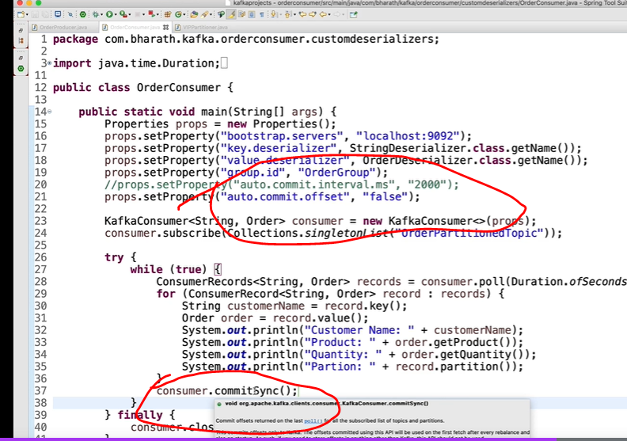

Still rebalancing problem is there suppose processing 100 message , 20 message processed but at this time rebalancing happen then next consumer

Will start it from beginning and duplication of message occur but now more control once message is processed will commit it at that time

**Async commit**

**Consumer.commitSync** block the consumer application until the broker response back to the commit request degrading the performance of our application

That is where we can use commit Async. While the commit still is in progress the next poll will be happen it will not block

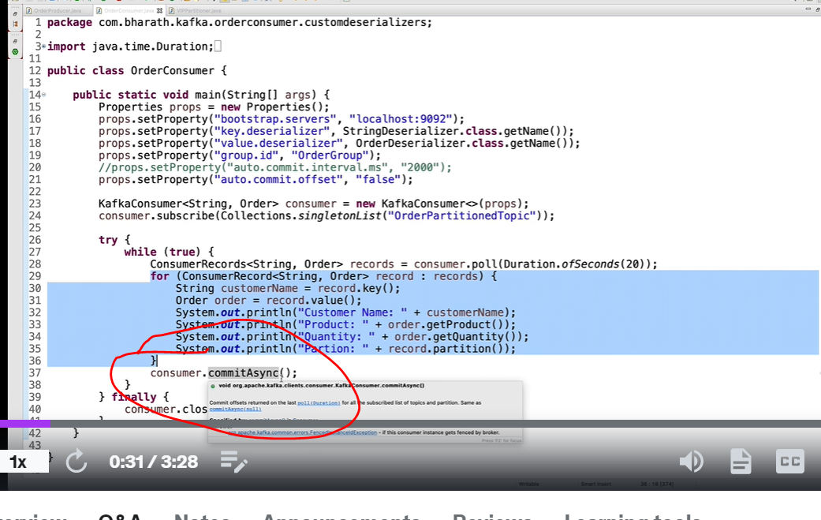

**CommitAsync method wont retry if commit fails while commitSync use to retry**

**Reason**

**Now order**

1001-2000

0-1000

Now if rebalacing happen then next consumer will start from 1001 which is already processed that’s in **commitAsync retry don’t occur**

**CommitAsync also use callback method**

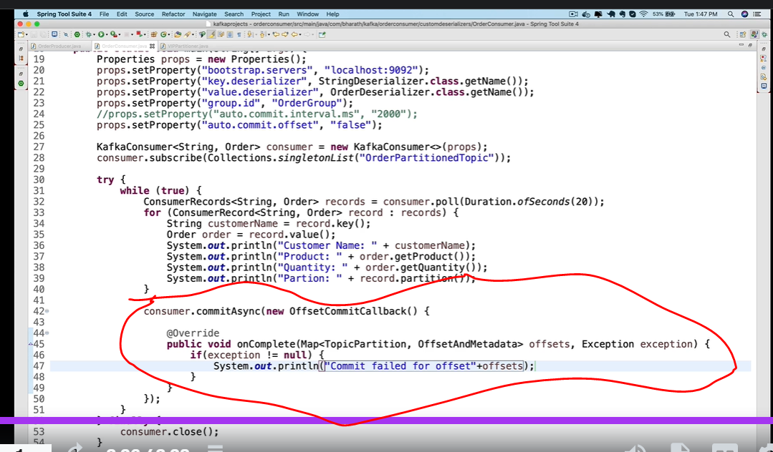

**Commit Custom offset**

One d/a of commit sync and asyn we need to wait to processed all the message before commit async. If rebalancing is happen other consumer need to process again then

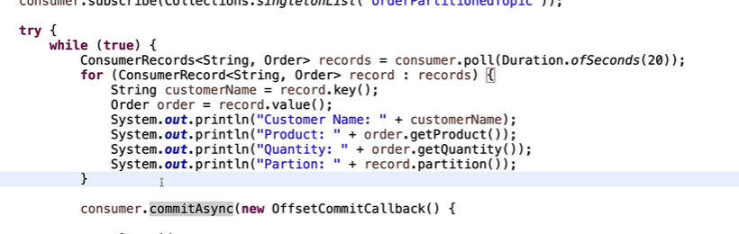

For every 10 record it will do a commit we can write logic like this

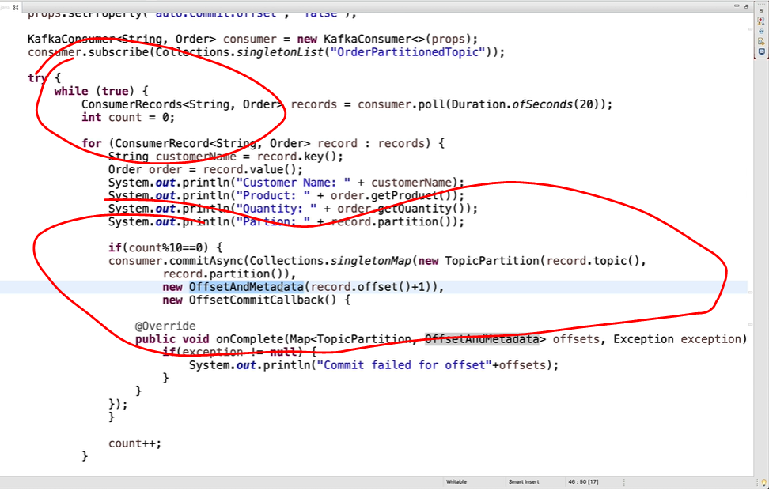

**Create a rebalanceListener**

So far we have learn how to minimize commit when rebalance happens

Will learn how to use consumer RebalanceListener to take a step further

**Consumer RebalanceListener** is aspecial class with methods and those method will be invoke when a rebalance happens

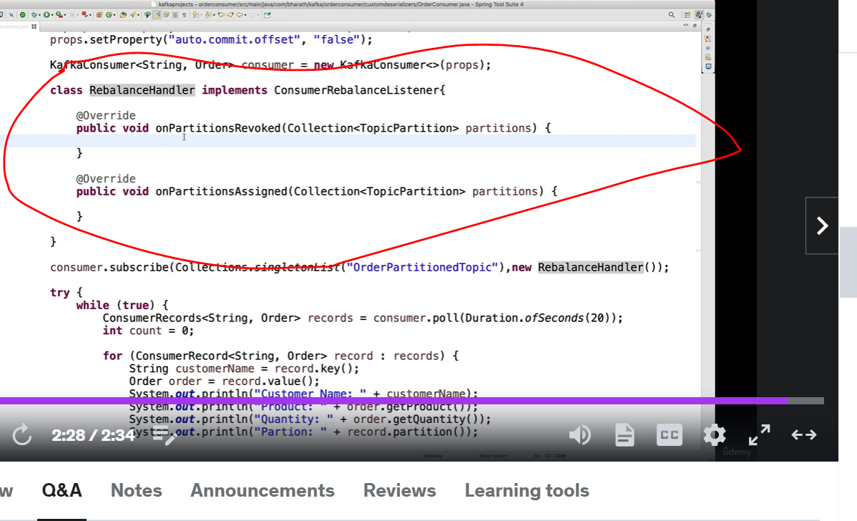

On rebalancing this consumerRebalancerListener invoked and we can write commit logic in onPartitionsRevoked

**Commit Last offset processed**

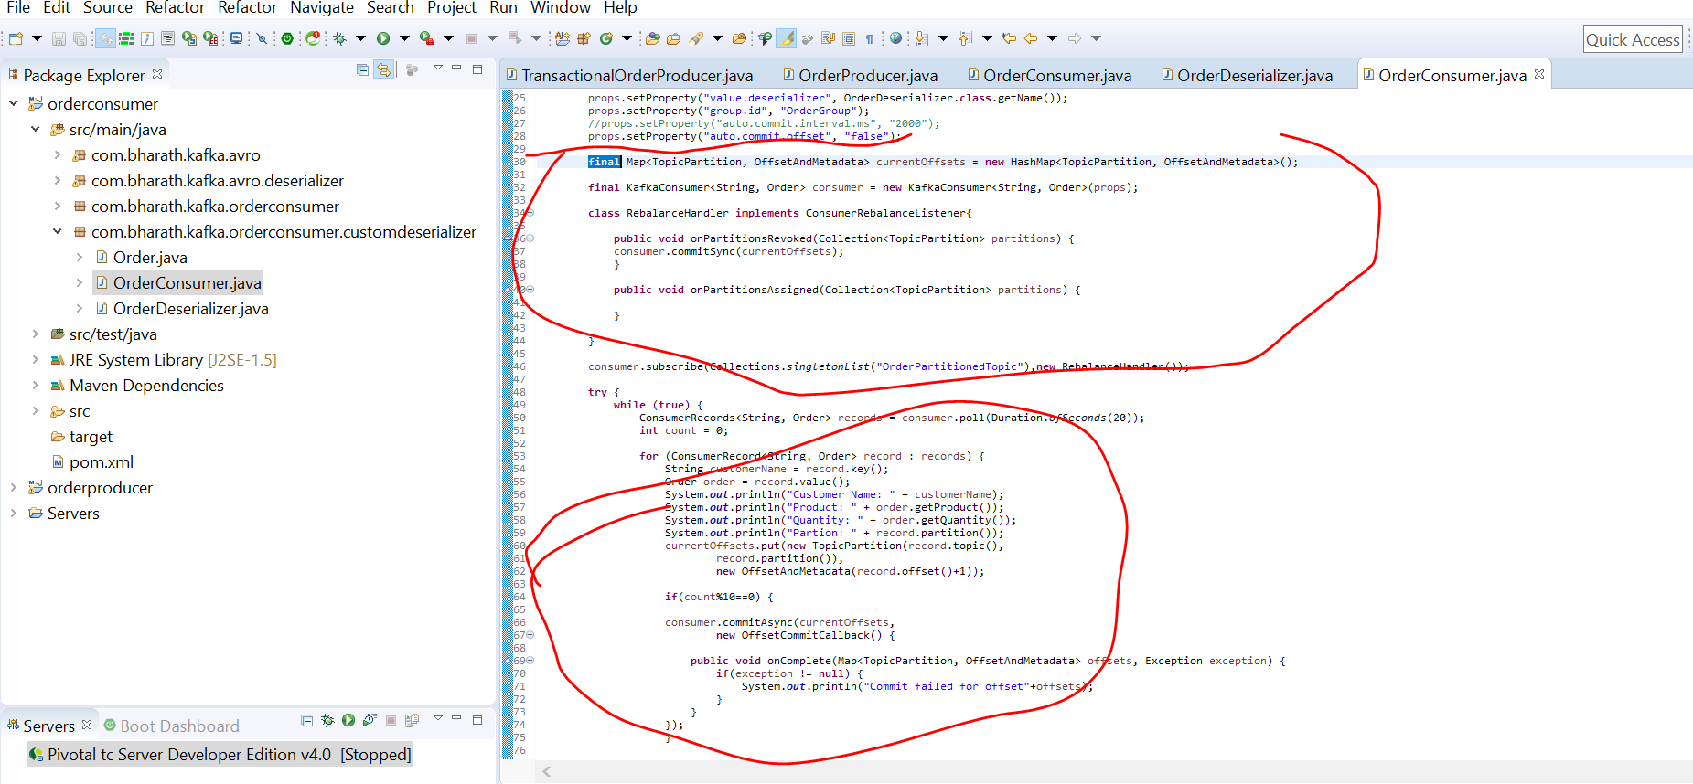

Here if rebalancing happens still we have offset details and that we can commit in onPartition()

**Using ConsumerConfig class**

**Objective :-**

to learn more about consumer

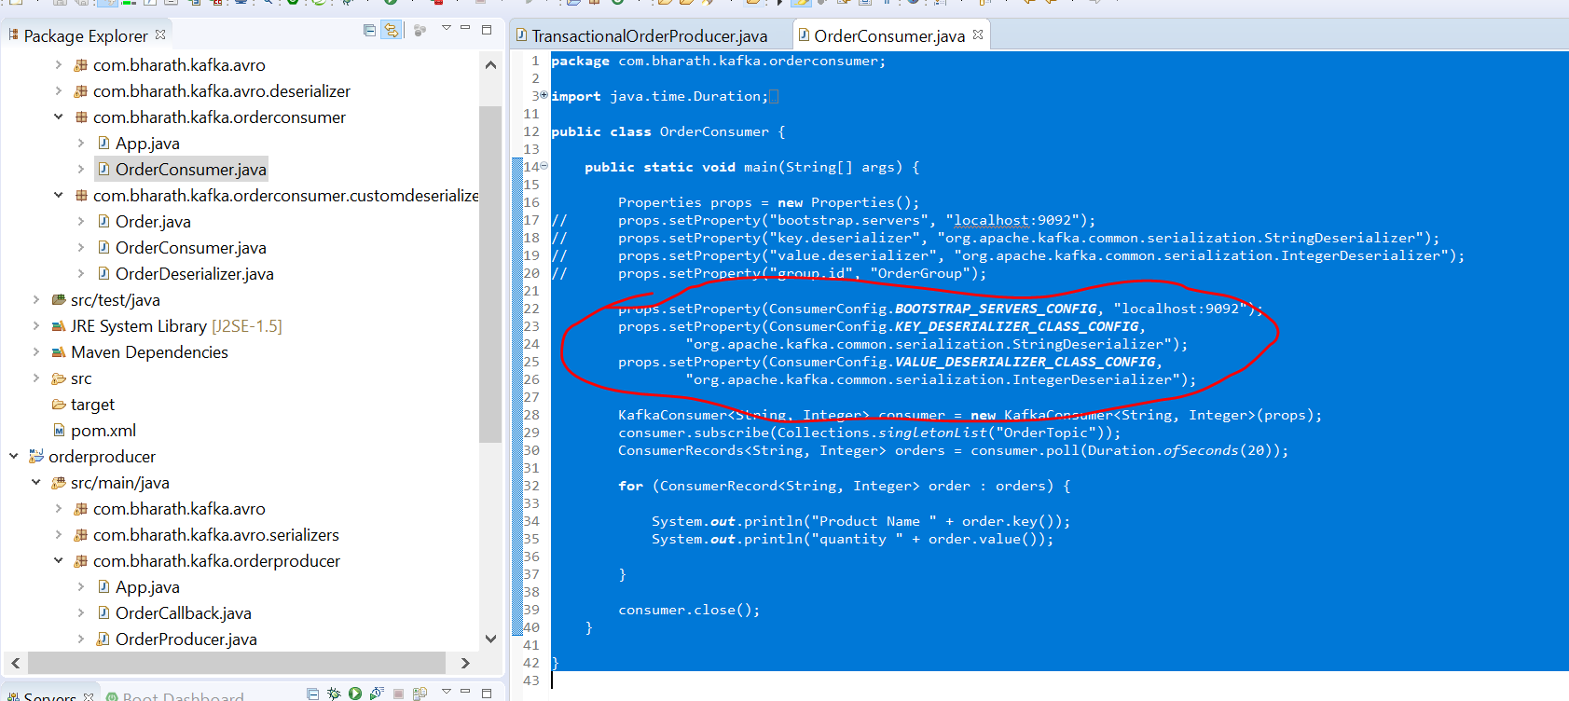

**Min Fetch Size and Timeouts**

**props.setProperty(ConsumerConfig.FETCH_MIN_BYTES_CONFIG, "102412323");**

This tell tha kafka broker to wait until it has so much of data to send. By default 1 mb . The higher the number the better it is.

**props.setProperty(ConsumerConfig.FETCH_MAX_WAIT_MS_CONFIG, "200");**

By default 500 millisecond. Kafka broker will wait for 200 millisecond before it sends the data.

**Note :-** whichever property come first kafka broker will send all message to consumer

**props.setProperty(ConsumerConfig.HEARTBEAT_INTERVAL_MS_CONFIG, "1000");**

Consumer will send heartbeat to broker after a second

**props.setProperty(ConsumerConfig.SESSION_TIMEOUT_MS_CONFIG, "3000");**

Suppose consumer didn’t send heartbeat to broker then wait for 3 second but if it didn’t send then consumer will considered as dead

**Note :** good practice the heartbeat should be 1/3 rd of session timeout

**Four more properties**

**//30 partions,5 consumers,6MB - 12MB**

**props.setProperty(ConsumerConfig.MAX_PARTITION_FETCH_BYTES_CONFIG, "1MB");**

Default 1 mb space for each partition but recommended to give more space

How many bytes per partition the broker returns to consumer

**props.setProperty(ConsumerConfig.AUTO_OFFSET_RESET_CONFIG, "earliest");**

It will process all the records from the beginning of the partition

**props.setProperty(ConsumerConfig.CLIENT_ID_CONFIG, "OrderConsumer");**

This can be use by both producer and consumer and it will use for logging purpose by broker

**props.setProperty(ConsumerConfig.MAX_POLL_RECORDS_CONFIG, "100");**

These are the number of record the poll should return

**props.setProperty(ConsumerConfig.PARTITION_ASSIGNMENT_STRATEGY_CONFIG, RoundRobinAssignor.class.getName());**

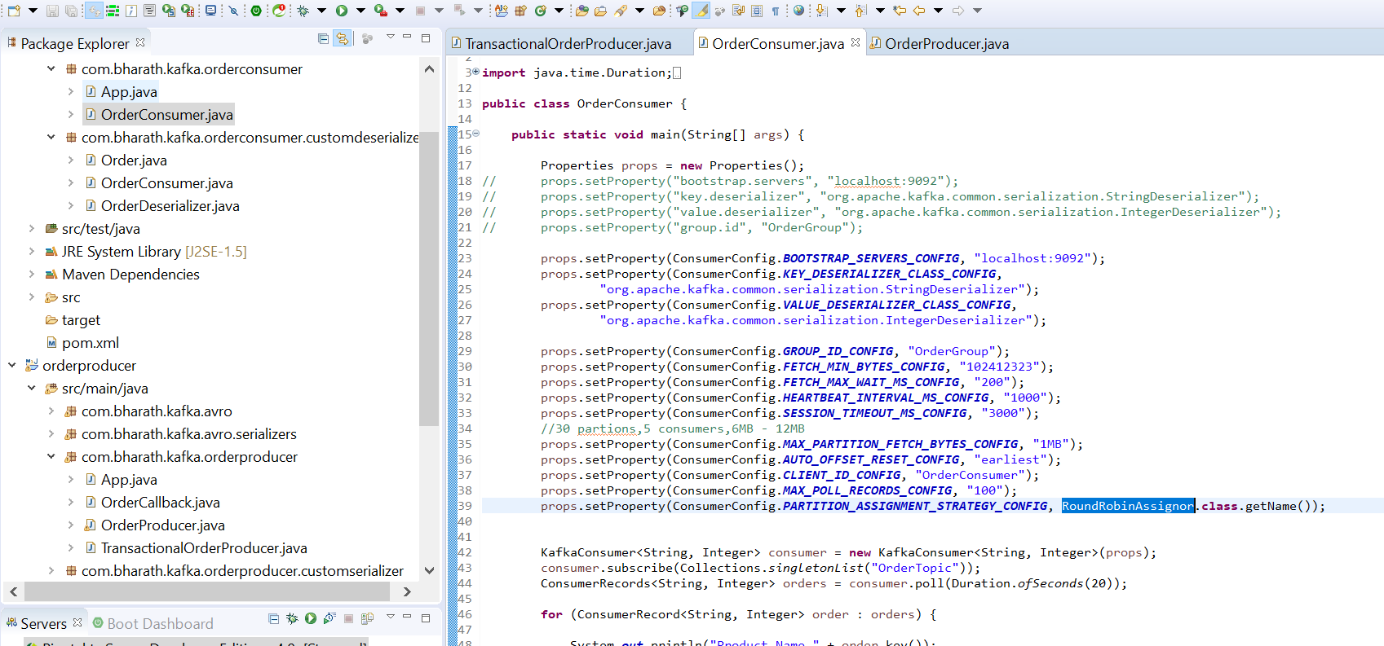

**Partition assignor strategy**

**Default is rangeAssignor for partition**

In range assignor consumer will get partition from topic in sequence

It never equally divide , the first consumer get more partition then second consumer

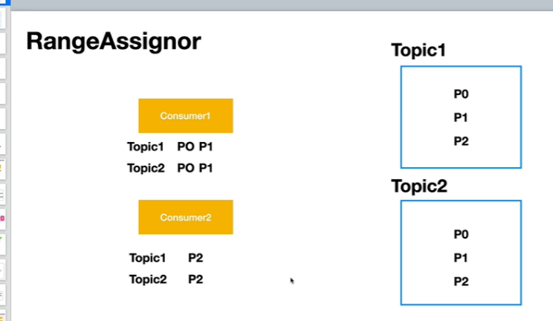

**RoundRobinAssignor :-**

It will combine the partition of both the topic , then it will start assignment

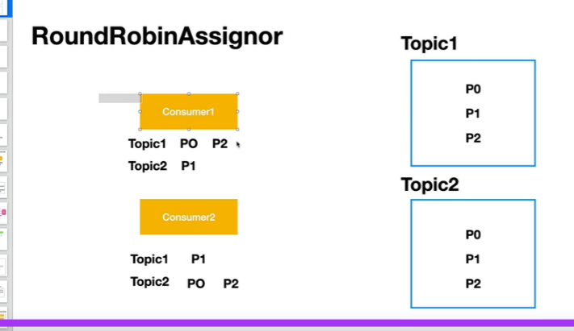

*Create a simple consumer*

So far we created consumer which is a part of group

Create a consumer which don’t belong to consumer group , this also allow by kafka which is rare

**Requirement** :- want to create single consumer where we don’t want rebalancing

partitionFor :- this method will take a topic and return all partition that topic have

Consumer.assign(partitions)---will get all partition info and now it will consume

**Create a simple consumer**

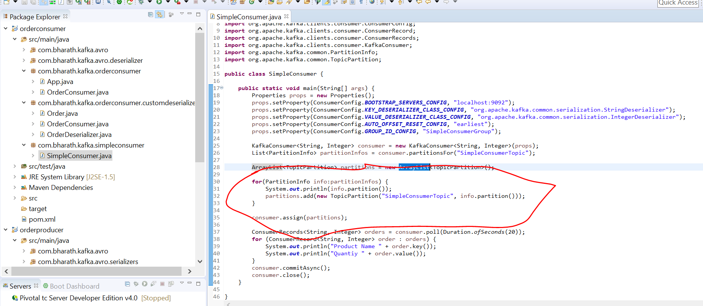

**Create a producer and test**

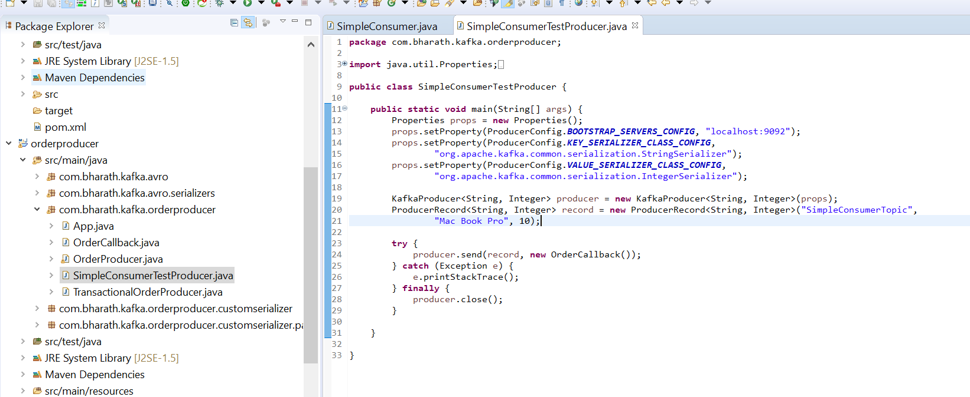

Note :-

**We still need to provide group id**

**We cant add simple consumer to existing consumer group**

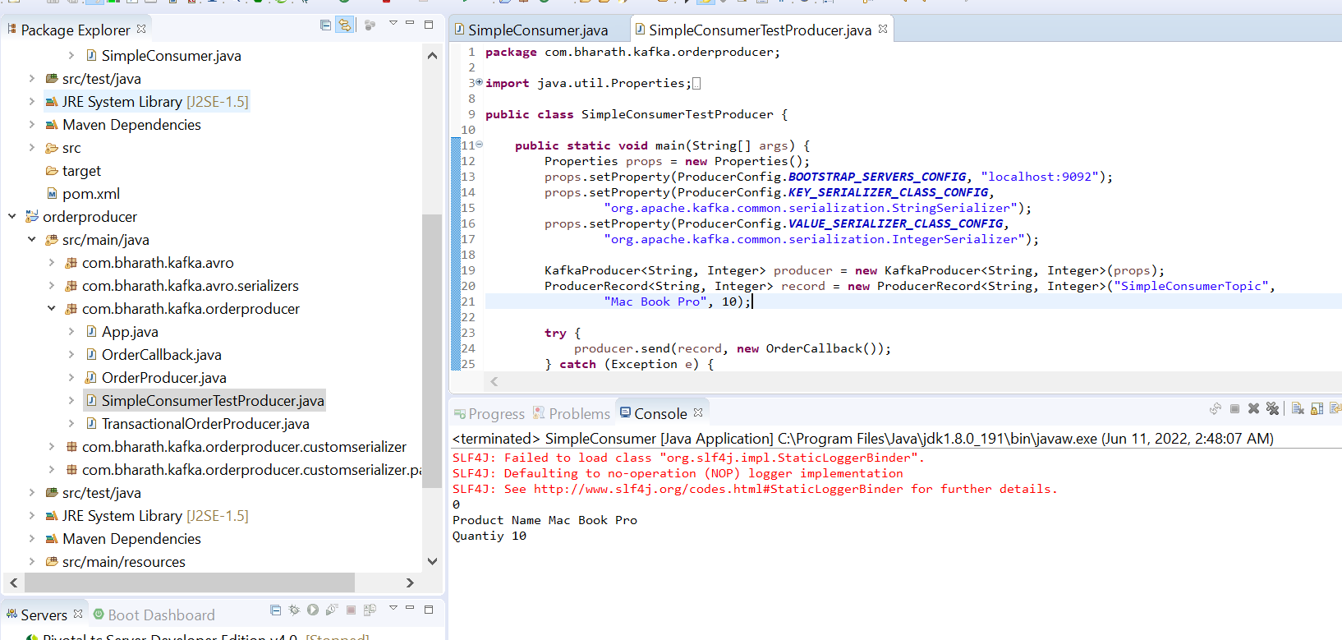

Stream Processing

In big data like hadoop the first data stored in d/ b which we called datalake we then use tools that will pull this data analyse the data and generate report.

We call this process near real time because there is a slight time delay between data being pulled, analyzed and report being generated

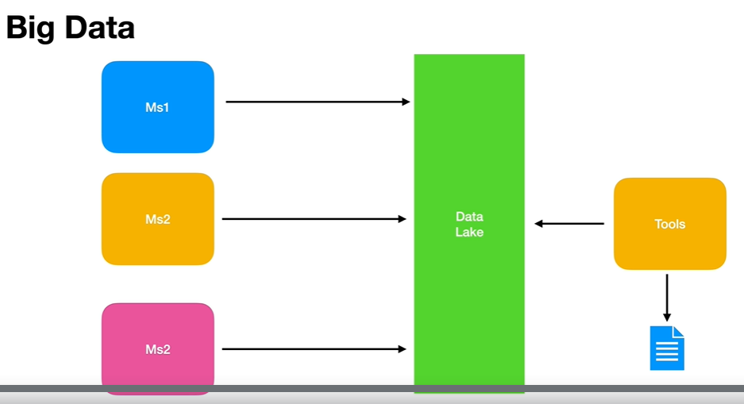

Data streaming where as continuous floe of business event or data unlike big data we don’t store in datalake , it is data in motion.

The data stream doesn't have predetermined beginning or ending . We can apply processing and generate report right away in real time

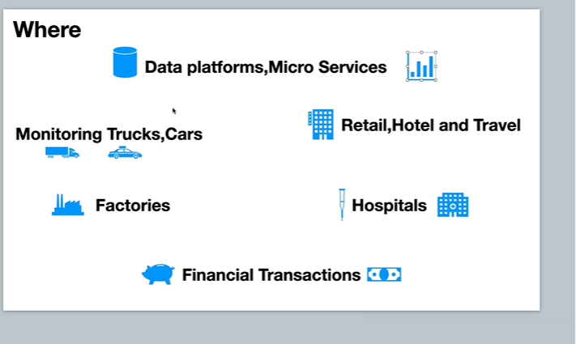

In hospital we can monitor health of a patient and take intelligent decision and in hotel and travel it can use for recommendation and more

In all above real time stream processing apply to analyze the data right away and generate the report.

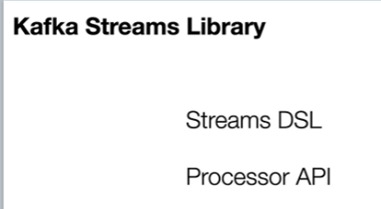

Stream dsl is very easy to use and make all transformation on data as it flows

What is stream DSL?

The Kafka Streams DSL (**Domain Specific Language**) is built on top of the Streams Processor API. It is recommended for most users, especially beginners. Most data processing operations can be expressed in just a few lines of DSL code.

**Usecase and api**

**Kafka-streams uses kafka client library**

**Objective :-**

data will flow from input topic to output topic and in b/w two we will apply transformational logic

There are four mandatory property for stream

1. Provide unique application id
2. Bootstrap server config :- it points to broker details

since in streaming we have both producer and consumer therefore we need to provide

1. SERDE_CLASS(serializer and deserializer), serdes.string ---Serde is a factory class

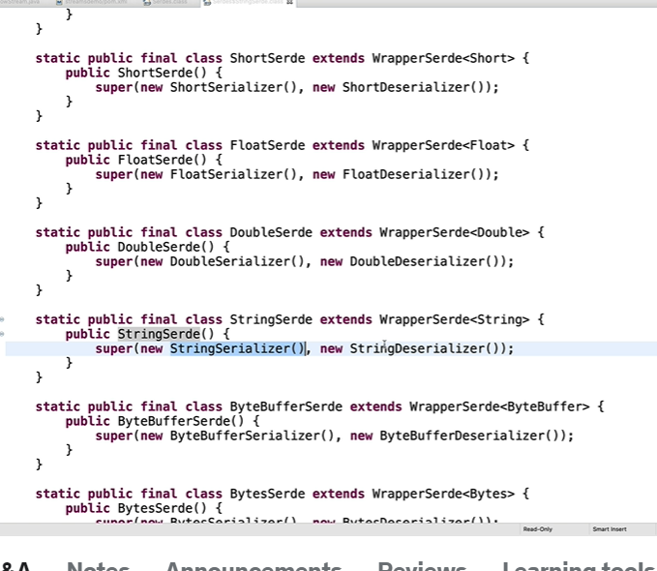

**Note :** here internally stringSerde wrapper of StringSerializer() and StringDeserializer()

**Step 2)** create a topology

Step 3) kafkaStream act as client pass topology and props and start the stream

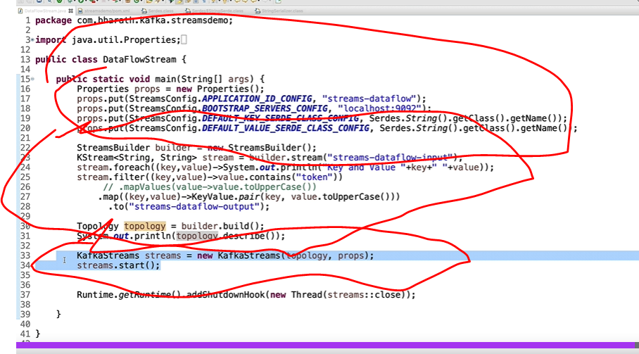

**addShutdownHook** :--- will close the stream

**Create topic**

kafka-topics --create --bootstrap-server localhost:9092 --replication-factor 1 --partitions 1 --topic streams-dataflow-input

kafka-topics --create --bootstrap-server localhost:9092 --replication-factor 1 --partitions 1 --topic streams-dataflow-output

**Create project**

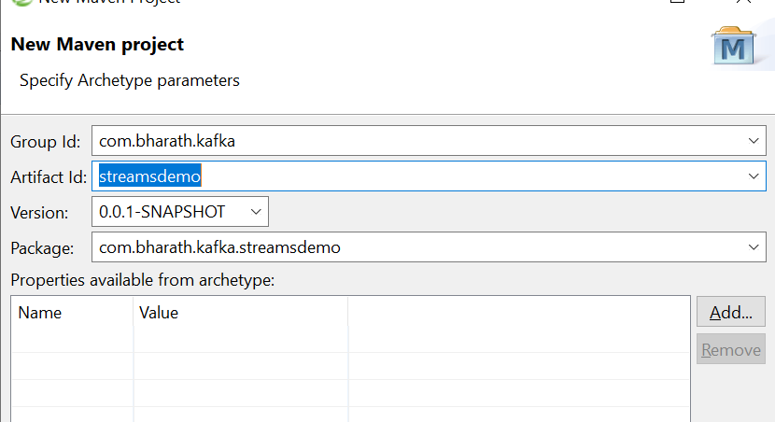

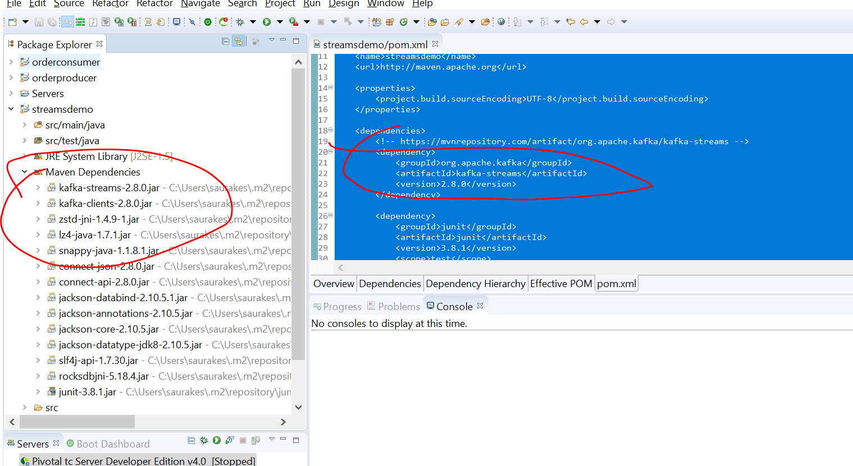

**Configure Properties**

Broker info using bootstrap server config



**Create topology , start and stop stream**

StreamBuilder can be look as topology builder

Logic :- we read from topic and render them on console

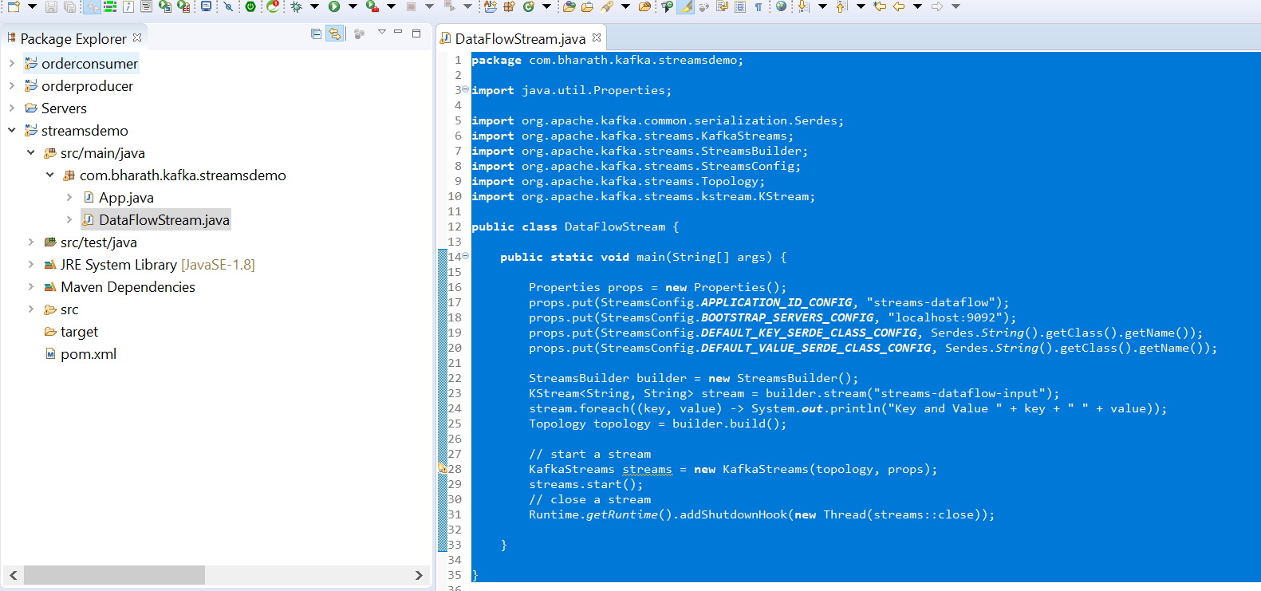

**Test**

**Input :**

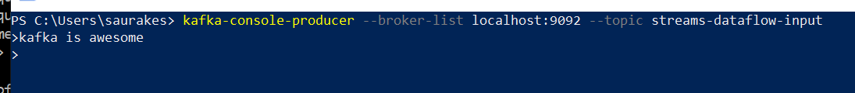

**Output**

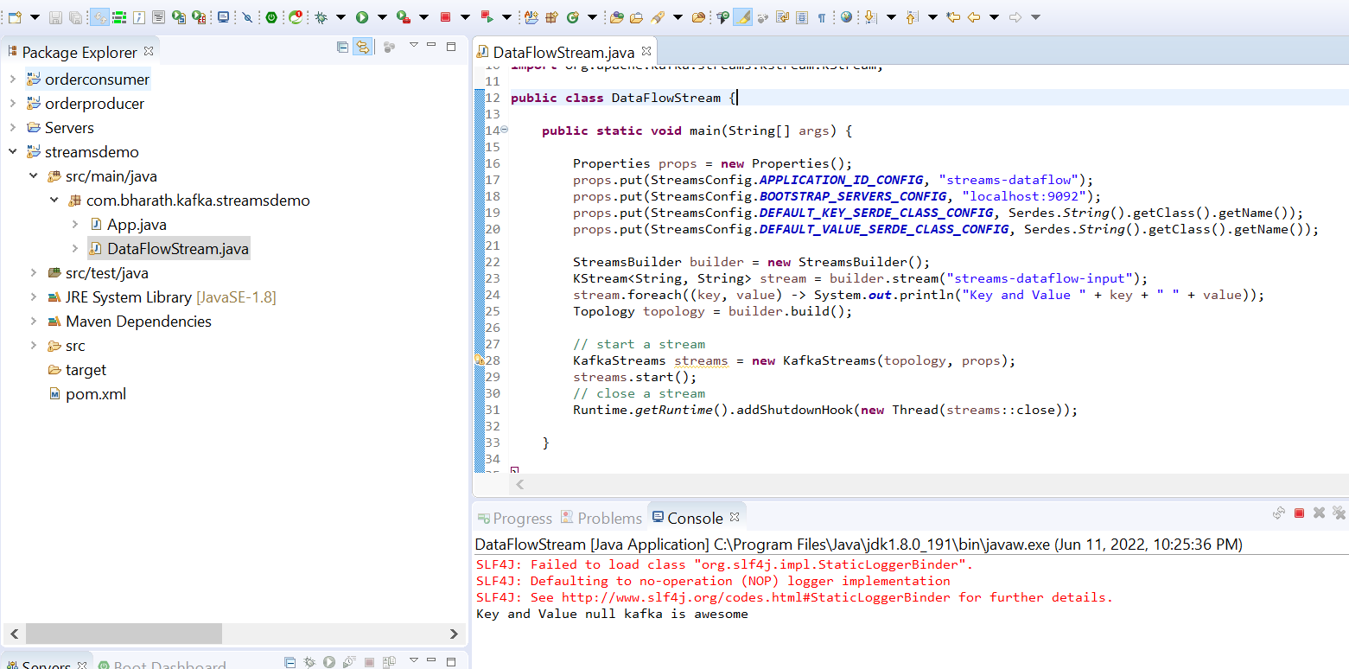

**Describe Topology**

**Requirement :**

How to check our topology logic is correct

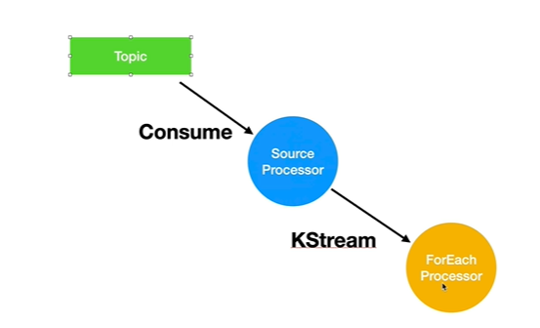

We need to comment start and stop and now we convinced our topology is correct

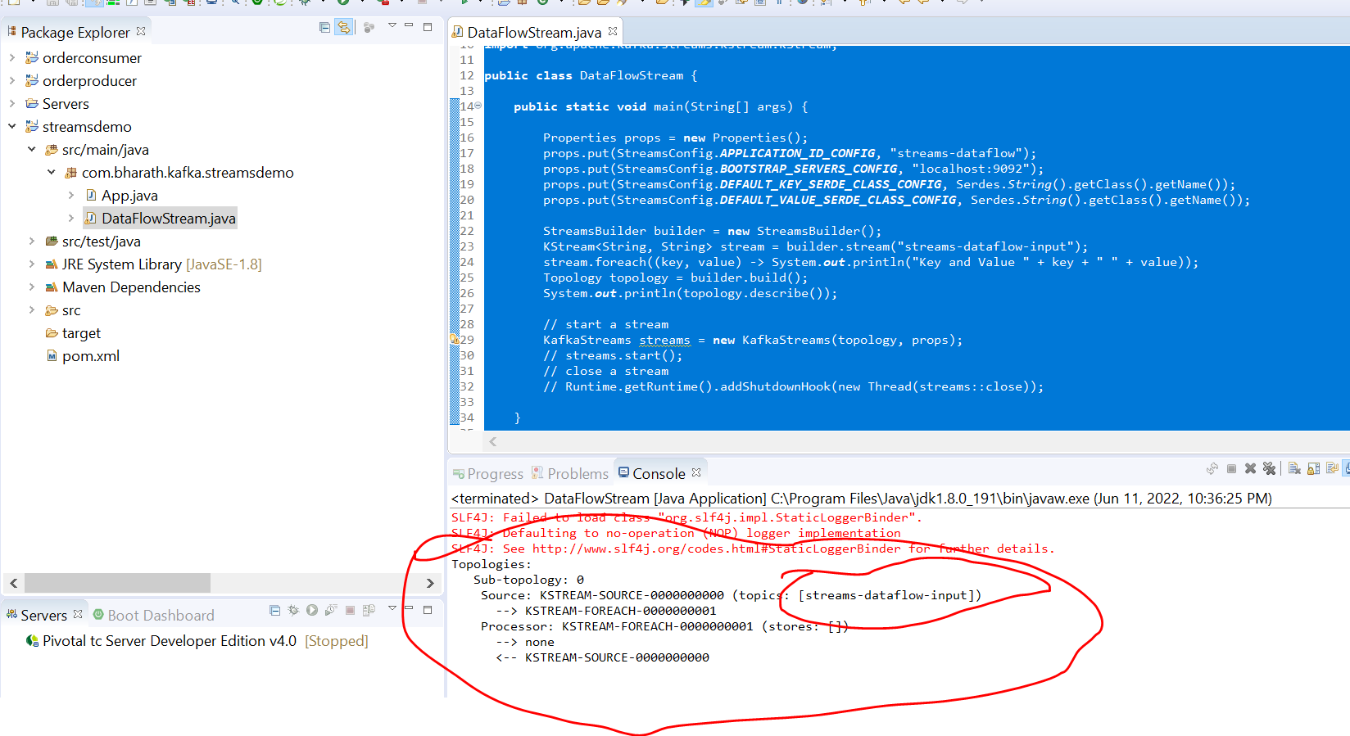

**Write to output topic**

**Objective :-** writing a stream to output topic

Write in one topic and getting in other topic

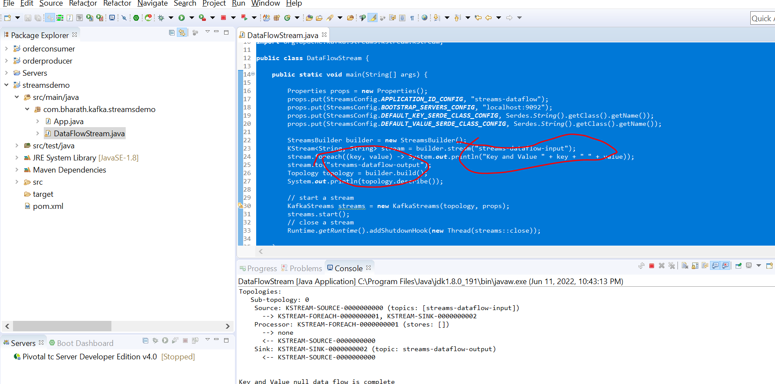

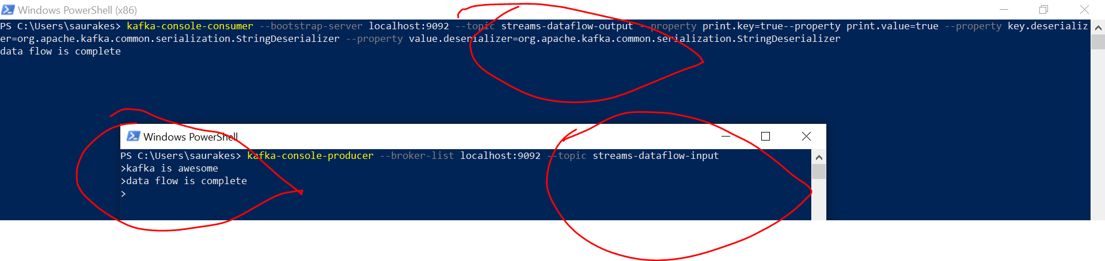

**forEach and to** are terminating method that they are done with the work

**Use Filter Method**

If input contain token then only it will write into output topic

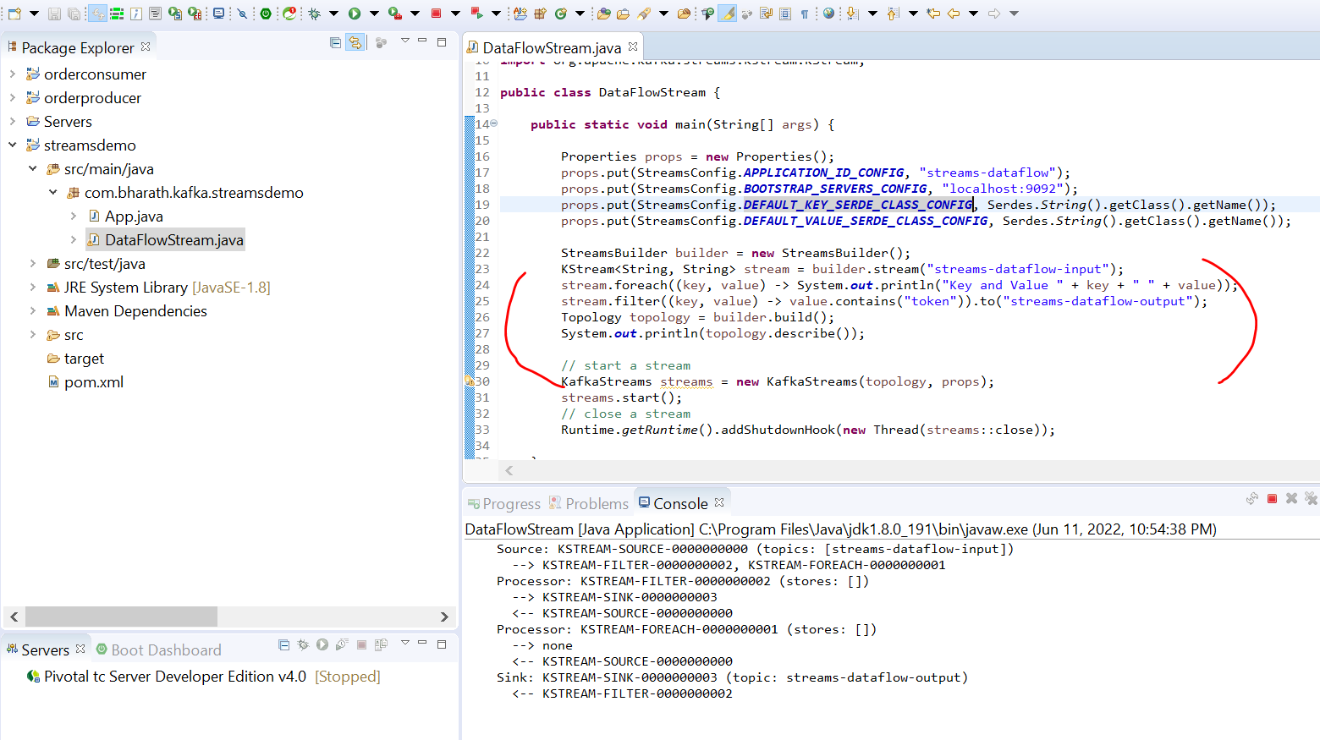

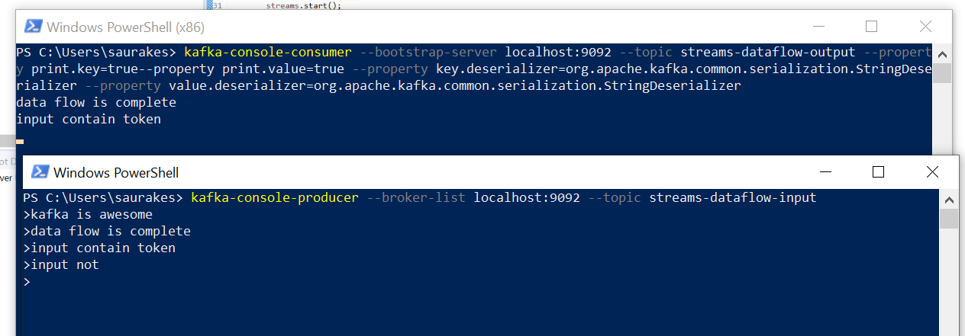

**Use Map Method**

**mapValues :---**

transform the value into different value depending on value mapper logic we implement

The mapValue receives a value mapper which is functional interface with single methos which receive a value

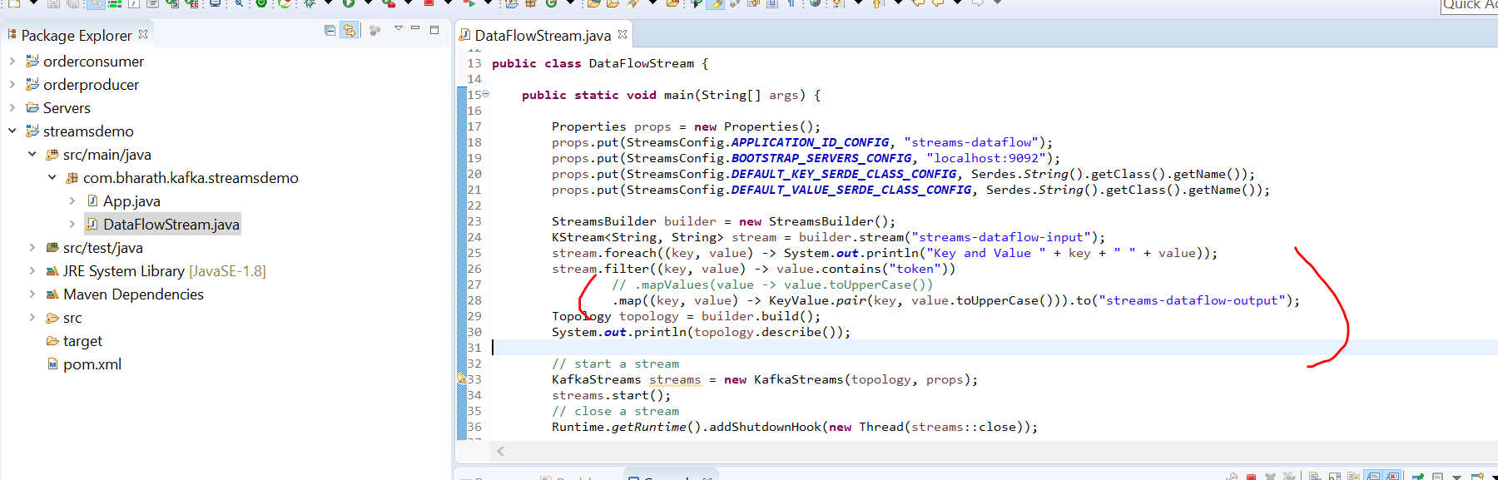

**Word Count Usecase**

**Requirement :**

Input in topic one

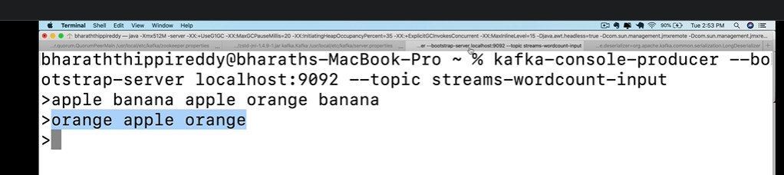

Output in topic :-

we need to maintain a word count

**Ktable**

Ktable is representation of update stream or change log. Ktable is store in local store that is created automatically.

Ktable will maintain state for us as new word come in message

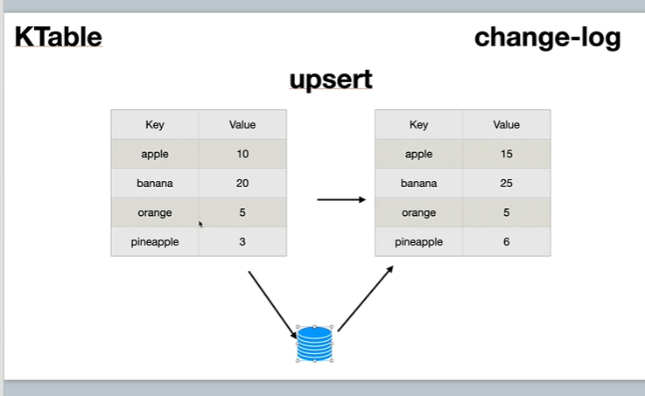

**Upsert operation :** means update or insert , if key is not there then it will insert, if key is there then it will update

**Note :**

when we invoked count method then internally Ktable magic is happen behind the scene

What is KTable used for?

A KTable is **an abstraction of a changelog stream, where each data record represents an update**. More precisely, the value in a data record is interpreted as an “UPDATE” of the last value for the same record key, if any (if a corresponding key doesn't exist yet, the update will be considered an INSERT).

**Create topics**

kafka-topics --create --bootstrap-server localhost:9092 --replication-factor 1 --partitions 1 --topic streams-wordcount-input

kafka-topics --create --bootstrap-server localhost:9092 --replication-factor --partitions 1 --topic streams-wordcount-output

**Implement Word Count and Aggregate using groupBy and count**

Computational logic will differ that is topology remaining is same

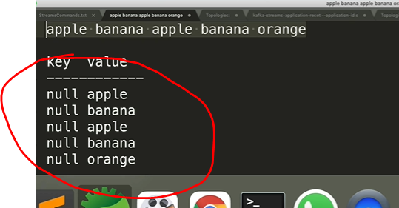

Note :-

we need to achieve below one from first line for this we use flatMap

flatMap can return multiple records back

Note :- groupBy in kafka stream works only on keys

We override the value on stream

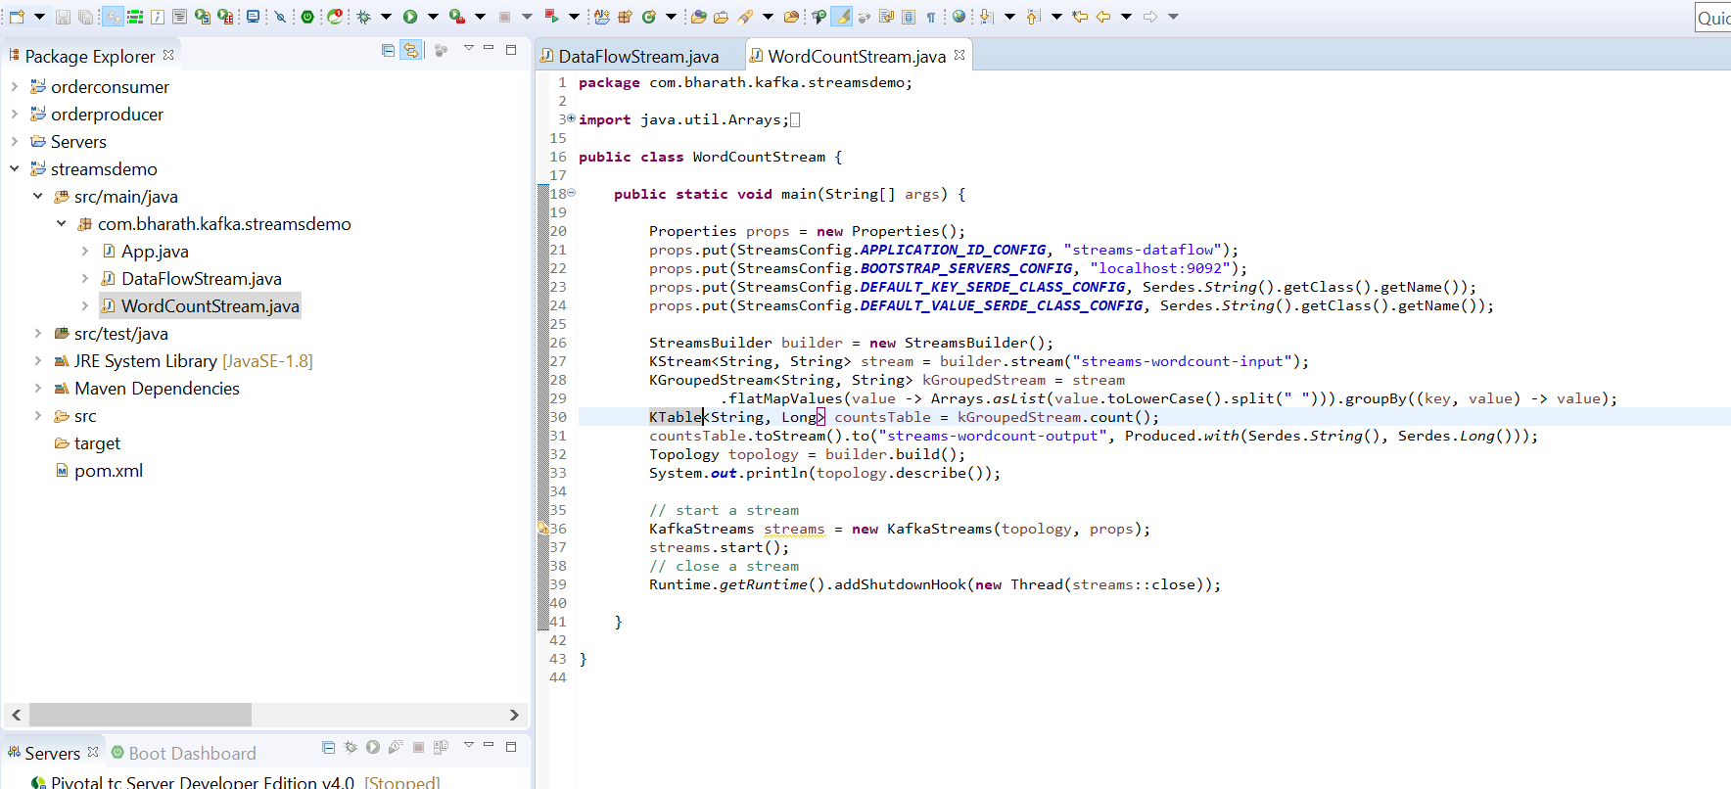

**Test**

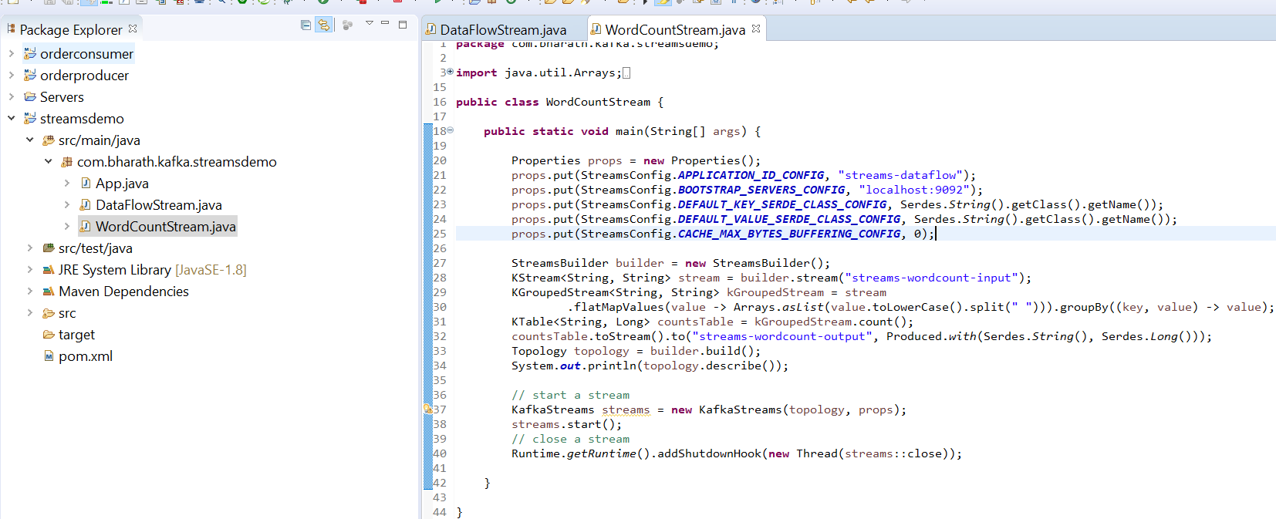

kafka-console-producer --broker-list localhost:9092 --topic streams-wordcount-input

kafka-console-consumer --bootstrap-server localhost:9092 --topic streams-wordcount-output --from-beginning --property print.key=true --property print.value=true --property key.deserializer=org.apache.kafka.common.serialization.StringDeserializer --property value.deserializer=org.apache.kafka.common.serialization.LongDeserializer

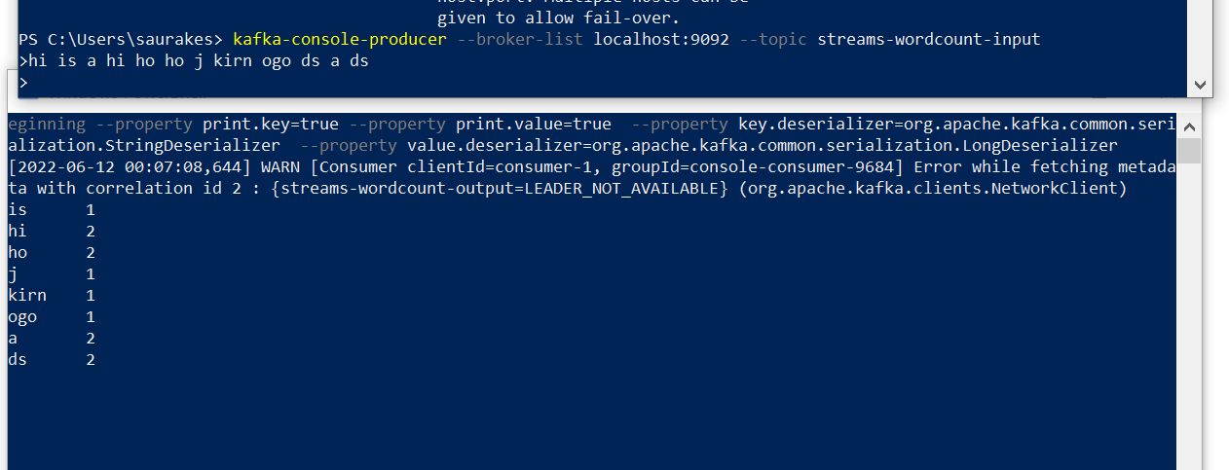

**Spring boot and kafka**

**Introduction**

We write lot of boilerplate code and repeat this across producer and consumer **that is where spring kafka modules come in**

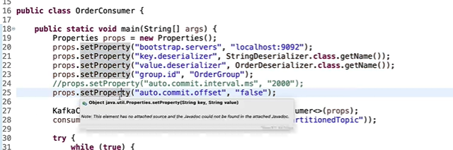

**Spring-kafka :---**

it is an abstraction on top of kafka client library and it makes super simple for us to create both producer and consumer.

**On producer side** will use **KafkaTemplate** , will inject this bean and start sending message

**On consumer side** 2 imp things **@KafkaListener** and listener container

Internally kafkaListener will do all the things which we written like polling

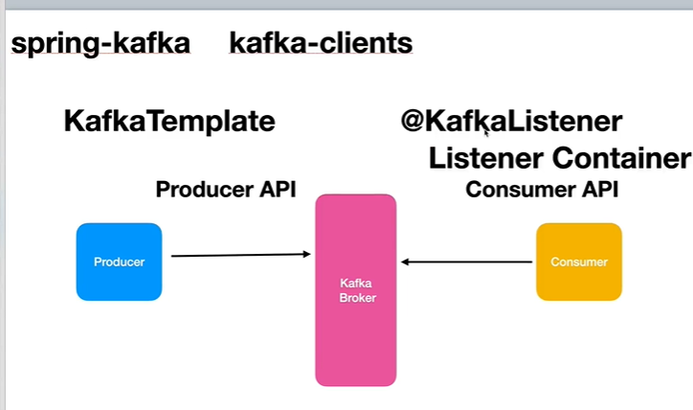

What is Spring Kafka?

The Spring for Apache Kafka (spring-kafka) project **applies core Spring concepts to the development of Kafka-based messaging solutions**. It provides a "template" as a high-level abstraction for sending messages. It also provides support for Message-driven POJOs with @KafkaListener annotations and a "listener container"

**API Walkthrough**

**Objective:**

1. Will create userProduce spring boot project and will add spring-boot-starter-web dependency and spring-kafka dependency
2. will expose a restful endpoint through which will receiver user data that restful endpoint will use then kafka producer api

and write a data to a topic

***Create producer project***

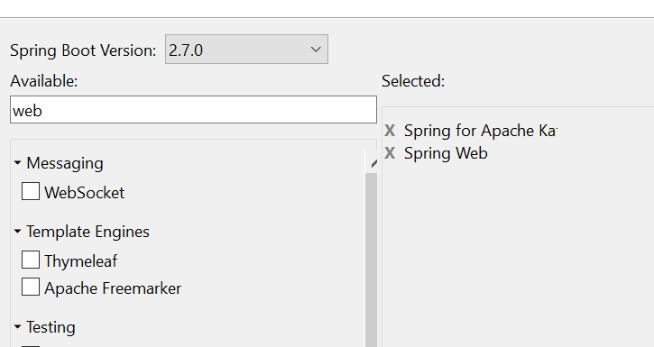

**It will also create spring kafka test**

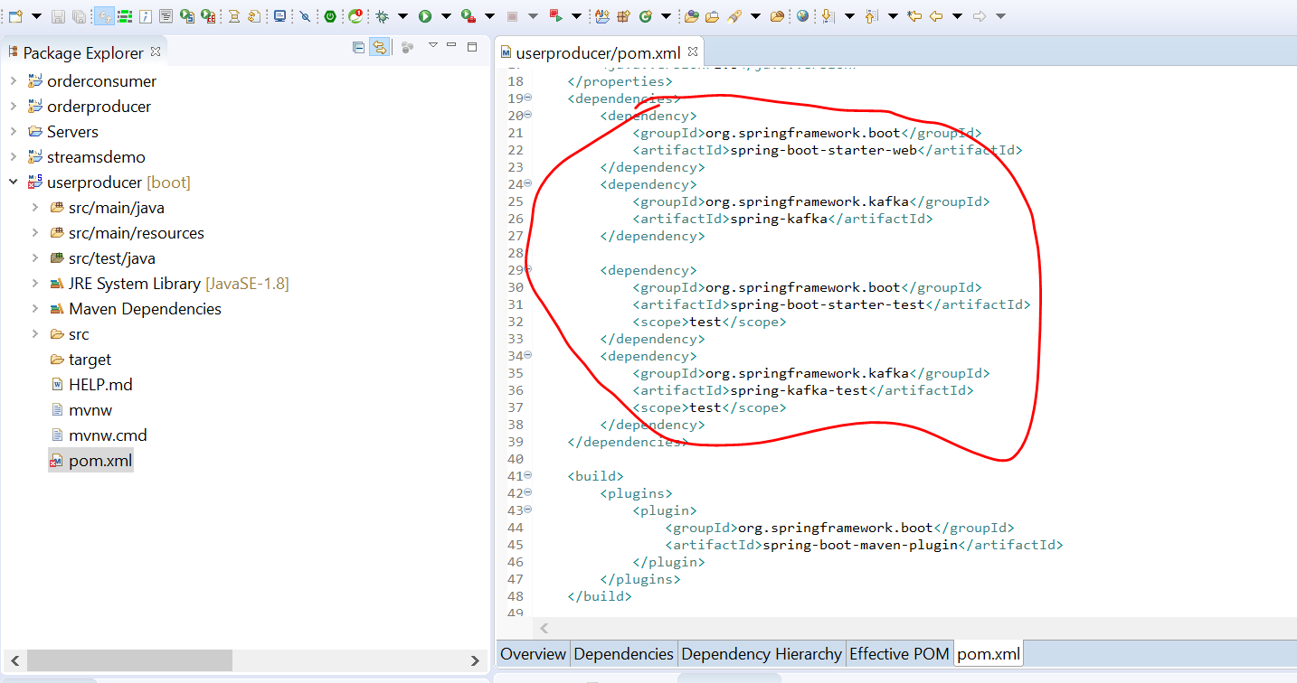

**Create The producer service**

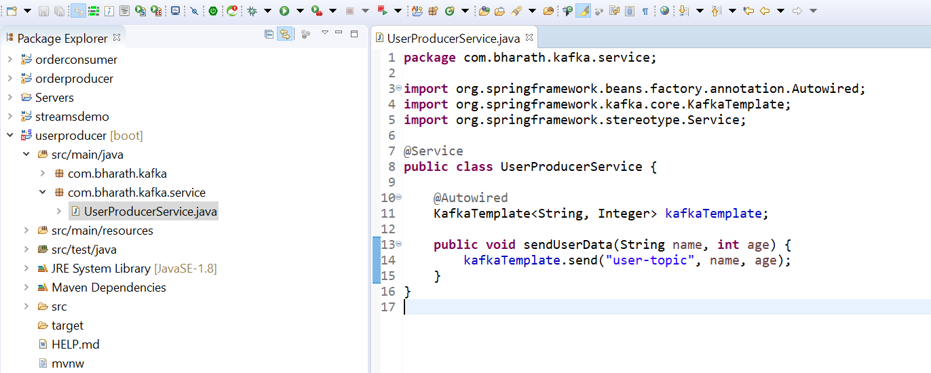

**Create the restful endpoints**

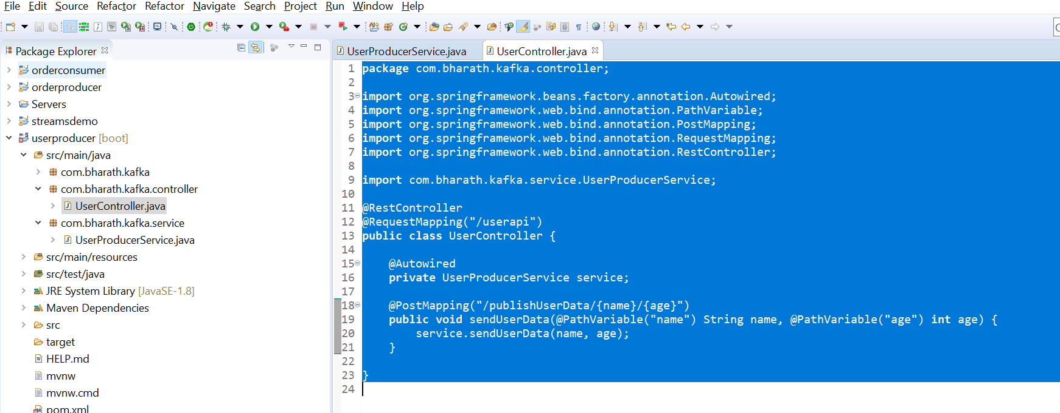

**Create The consumer**

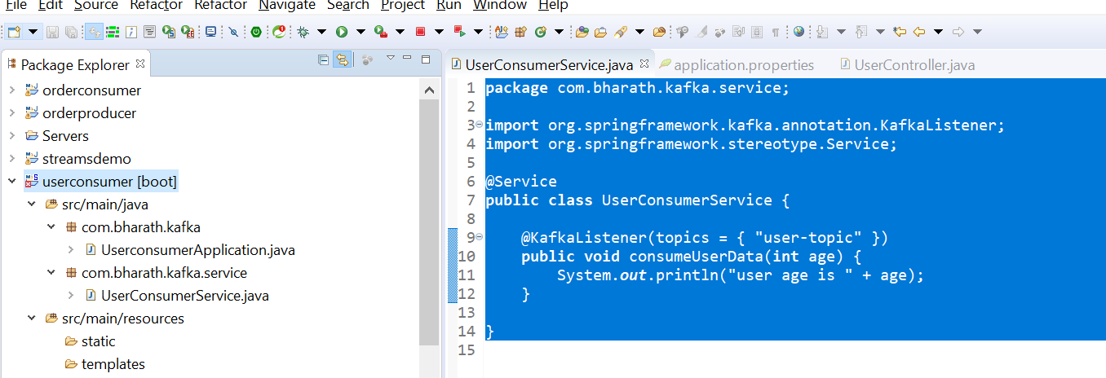

**The configure properties for both producer and consumer**

**Producer side:**

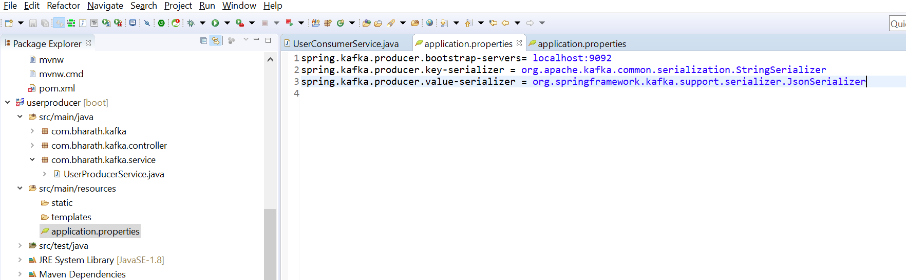

**Consumer side**

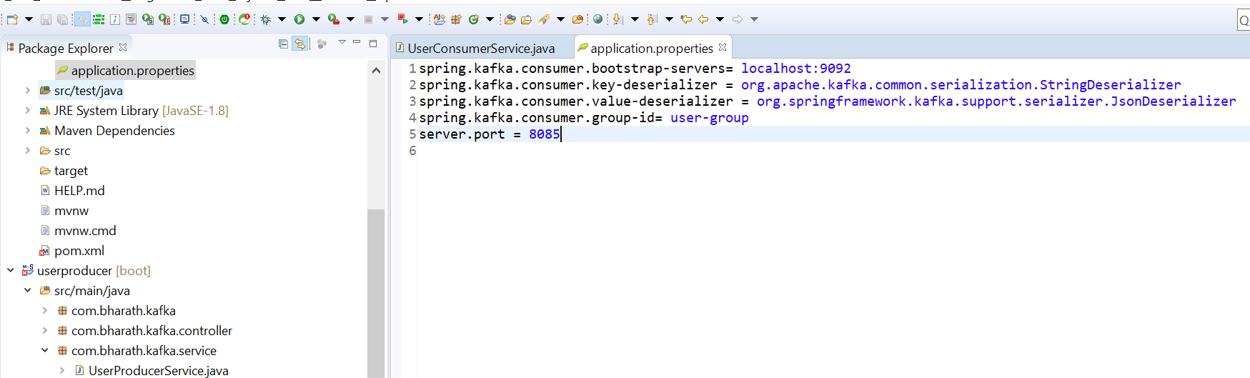

**test**

**Start userProducer and userConsumer**

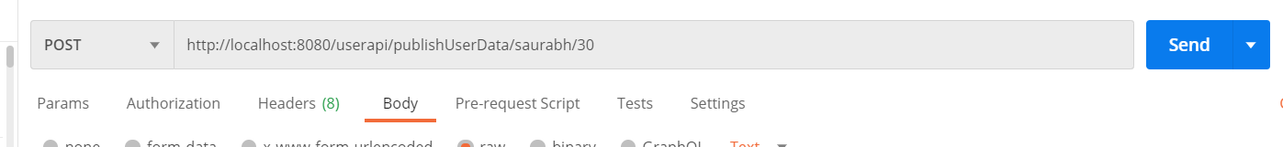

**Output**

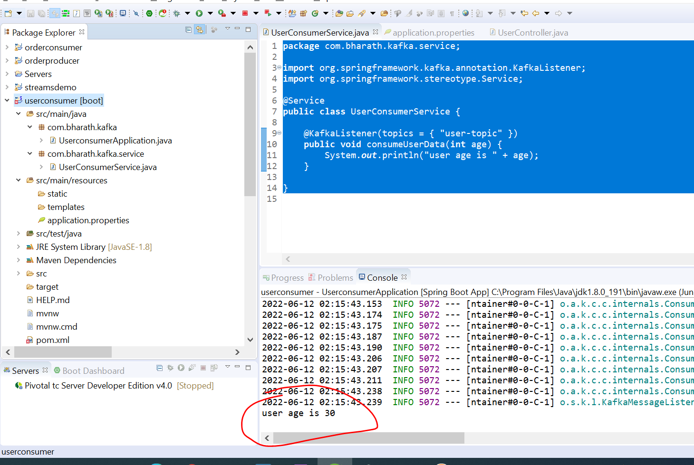

**Use object type**

**Requirement :-** how to send out own object type instead of simple type

Create pojo

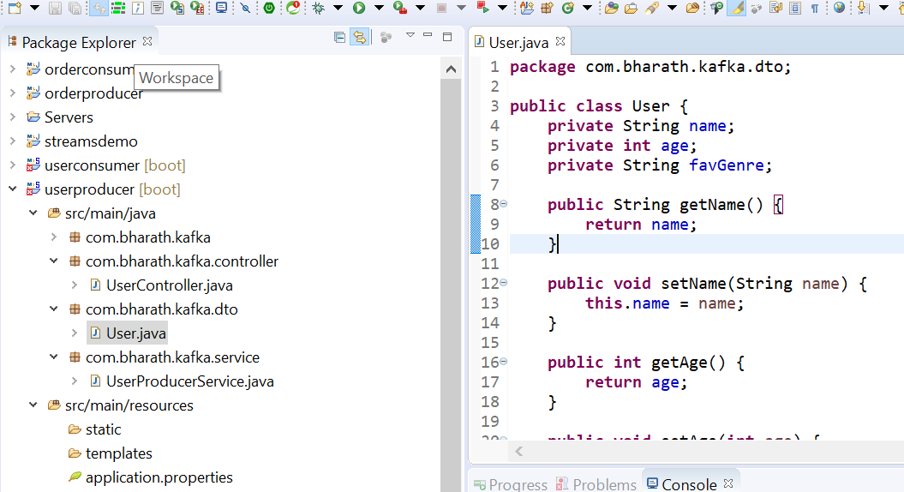

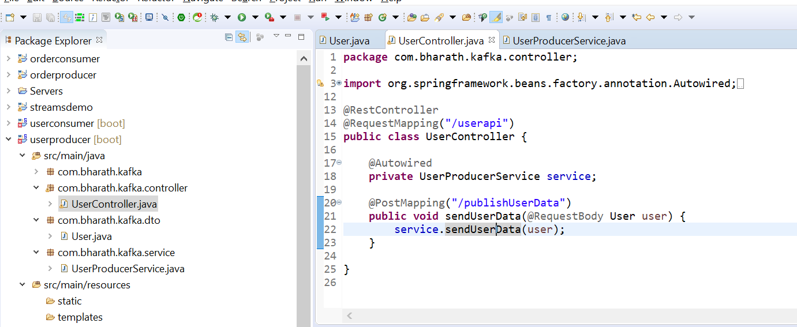

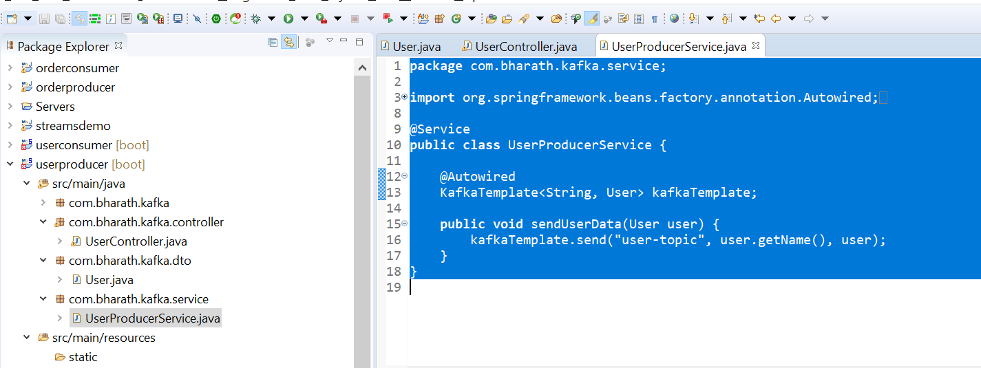

Note:-

We don’t need to write custom serializer , spring write for us jsonSerializer

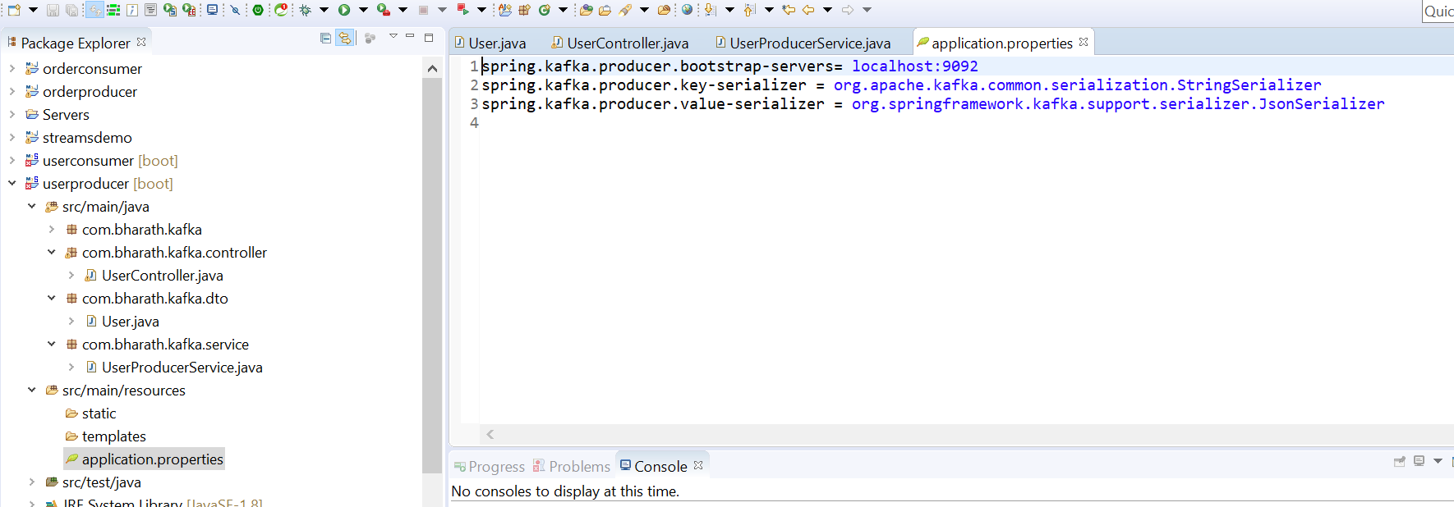

**Configure JsonDeserializer**

**Consumer side**

1. Copy the entire pkg from producer to consumer

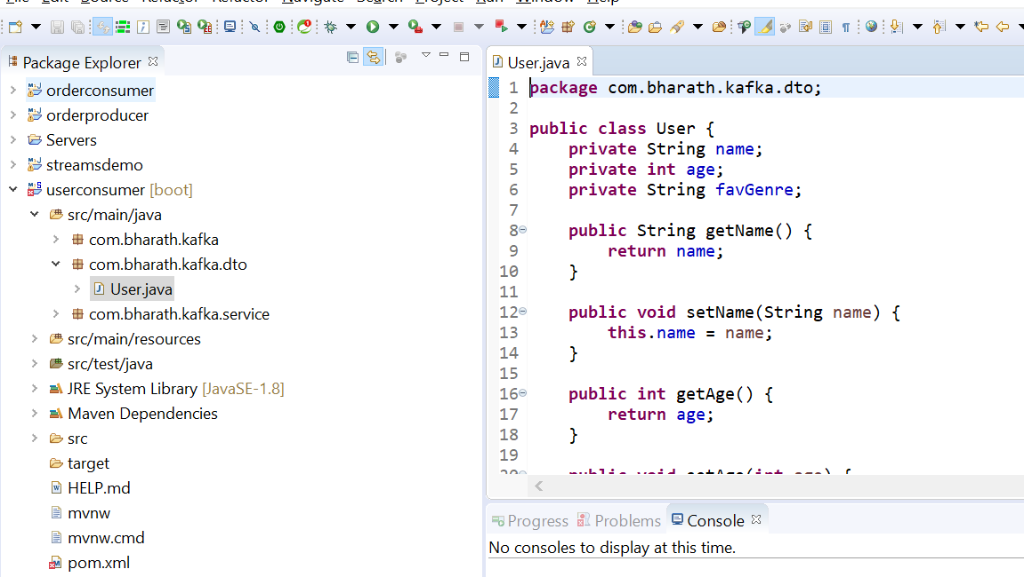

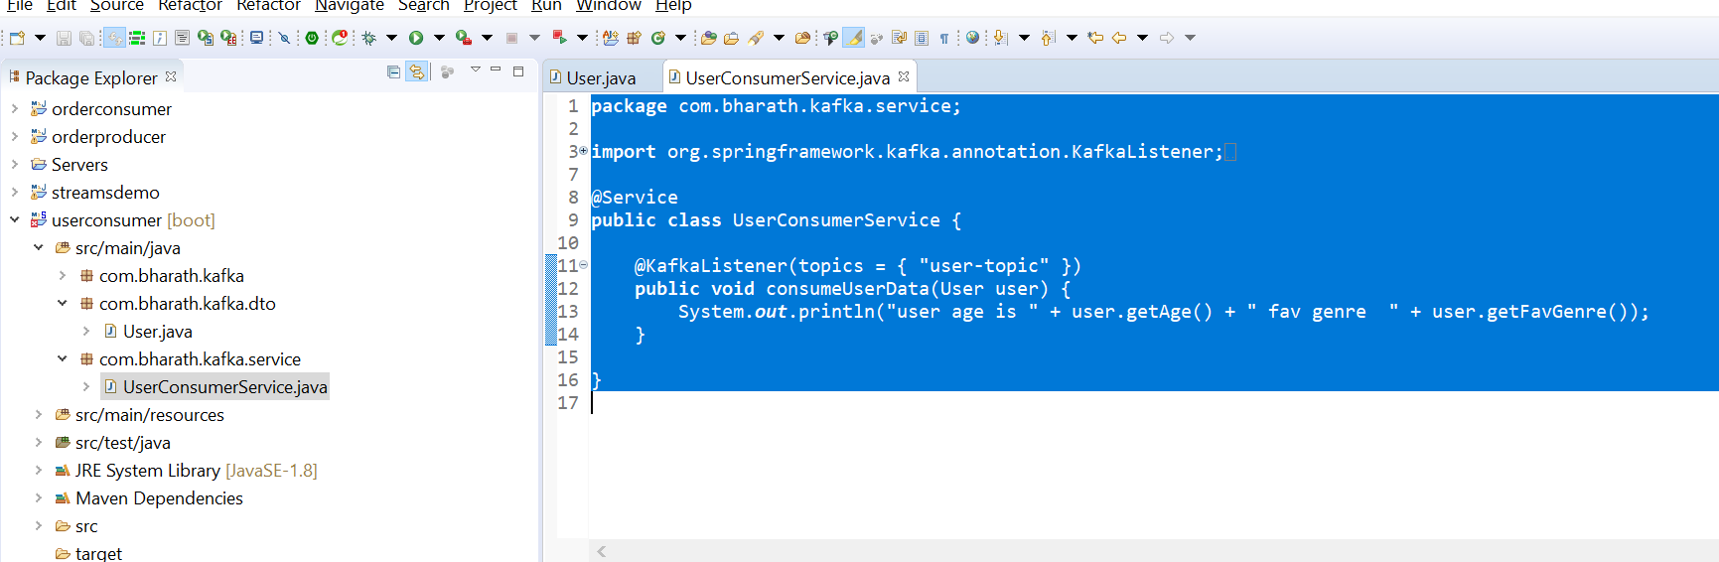

**Note :**

jsonDeserializer don’t trust all the dto

Want to trust all the pkg put *

spring.kafka.consumer.properties.spring.json.trusted.packages=*

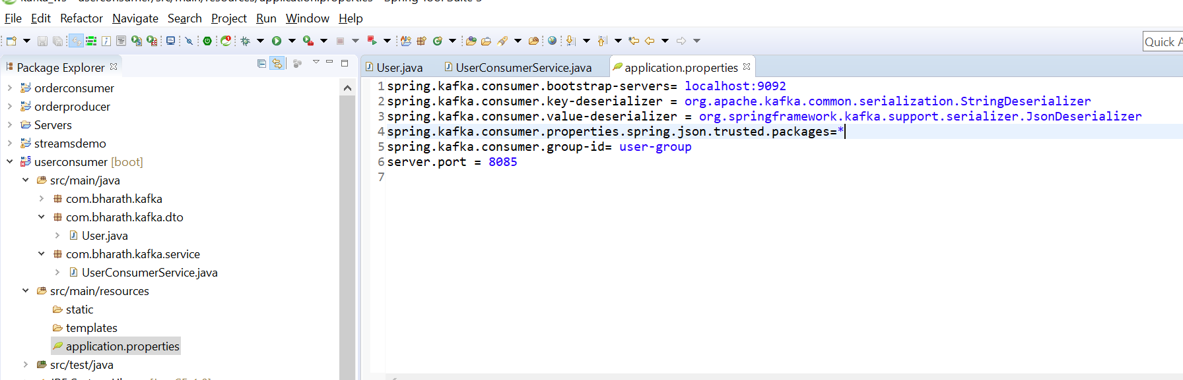

Test

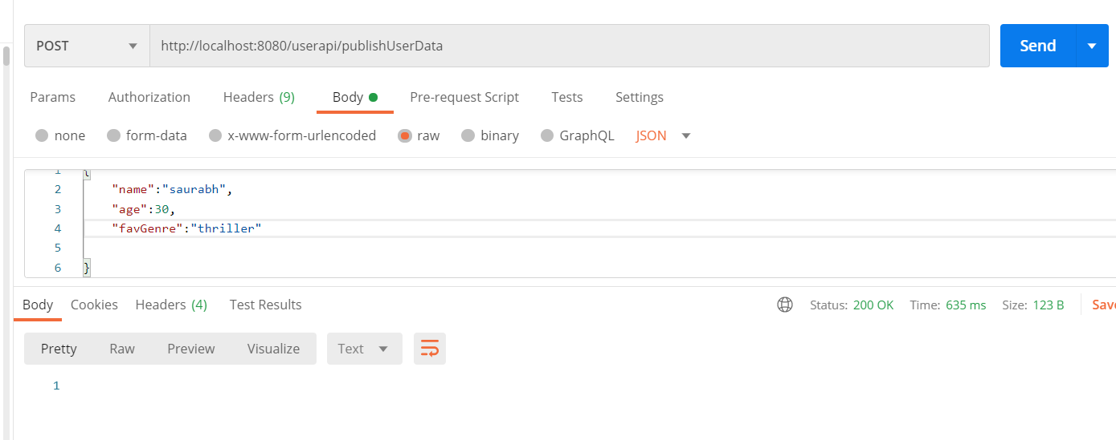

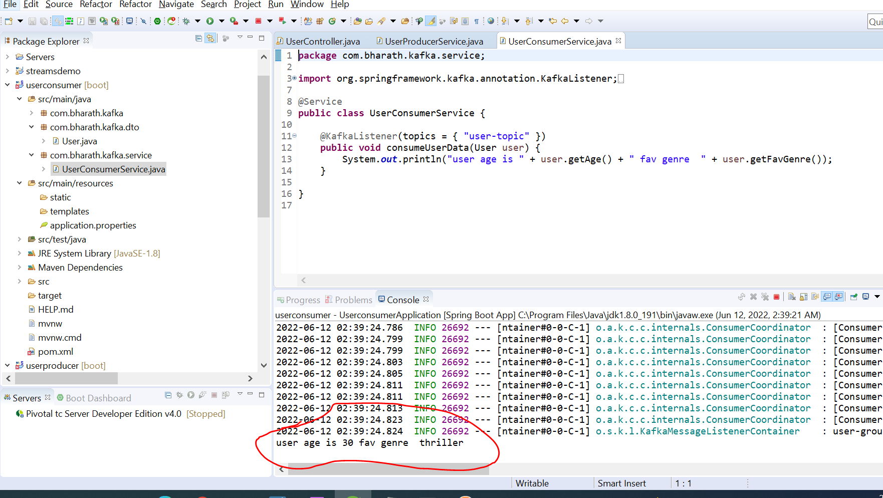

v